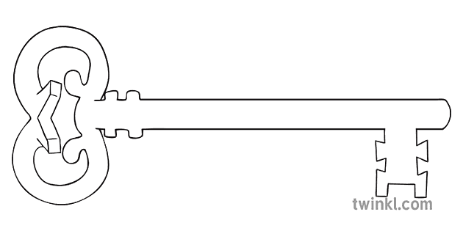

**Design Technology & Music**

As designers, we will be looking at games that use electrical circuits. We will be then be designing and creating our own. We will also continue to practice our drawing and sketching skills.

As musicians, we learn the song ‘Lean on Me’ and use glockenspiels to play a simple melodic accompaniment. We will also be practicing ready for the Lancaster Music Festival next half term.



**P.E.**

As sports people, we will be taking part in invasion games. We will continue swimming at Salt Ayre pool each Friday, starting this term with lifesaving skills.

**Computing**

As computer scientists, we will learn how to use spreadsheets for calculations, creating graphs and even producing a budget plan. It is also Online Safety Day.

**Latin**

As linguists, we will continue to expand knowledge of Latin words and how they impact on our language today.

**Maths**

As mathematicians, we will continue to secure all times tables to 12x12 for quick and confident recall.

We will continue to practice using calculations (addition, subtraction, multiplication and division) to solve problems and we will move onto shape and fractions.

**Curriculum Enrichment**

Poetry Performance

Anglo Saxon visitor

Online Safety Day

**Year 4**

**Spring Term 1 2025**



Sparks Might Fly

**Science**

As scientists, we will focus on the generation and use of electricity. We will explore circuits, switches, conductors and insulators. There will be investigations to help explore theories and support our work in design technology.

**PSHE**

As caring community members, we will learn about looking after money. We will consider the importance of saving money and using a budget. We will also learn about loans and interest. Finally, we will learn about what is meant by ‘sustainable living’.

**RE**

As theologians, we will be covering ‘Galilee to Jerusalem; looking at the miracles of Jesus, how He fulfilled the prophecy of the Messiah and how this can guide and influence us today. As part of this we will study the Sacraments of Reconciliation and the Sick, and the meaning of the Nicene Creed as part of the Mass.

**History**

As historians, we will continue the timeline after the Romans left Britain and study the Anglo Saxons. This will include meeting a ‘real’ Anglo Saxon! Skills will be developed to question and explore evidence using artefacts, and comparing life as a child in Anglo-Saxon times to how children lived in Roman times.

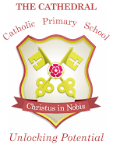

Unlocking potential together

in faith and love.

**English**

As readers and writers, we will begin by looking at poetry that creates images of winter. We will then use a novel for a theme, using ‘Raiders’ as a text that links with our Anglo Saxon study in history. Finally, we will investigate persuasive writing and use what we find out to help us to write our own persuasive letters.