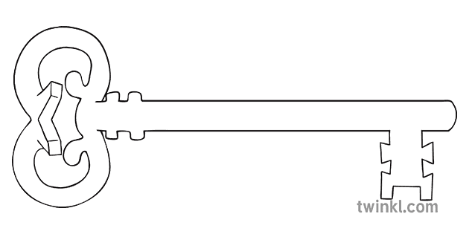

**Art & Design & Music**

As artists we will start by developing our sketching skills. Then we will use the colourful work of the Japanese artist Yayoi Kusama as inspiration for our own painting.

As musicians, we will be preparing to perform as a part of the Lancaster Schools Singing Festival. There are lots of songs to learn!



**P.E.**

As well as swimming, we will develop skills for playing invasion games and net/wall games, with a focus on throwing and catching a range of balls with accuracy.

**Computing**

As computer scientists, we are using this half-term to consider how we present work for different reasons, using word-processing and formatting techniques.

**Latin**

As linguists, we will spend time reviewing what has been learnt in the first half of the year. We will then move on to learn some rhymes and songs in Latin.

**Maths**

As mathematicians, our focus continues to be securing all times tables to 12x12 for quick and confident recall. We will secure written methods for multiplication and division before moving onto our lengths and measures topic. Throughout the half term, we will practise telling the time using analogue and 24-hour digital clocks.

**Curriculum Enrichment**

Lancaster Singing Festival

World Book Day events

Geography field trip to River Lune flood defences

Easter Reflection (led by Y3&4)

**Year 4**

**Spring 2 Term 2024**

**Sparks might Fly**

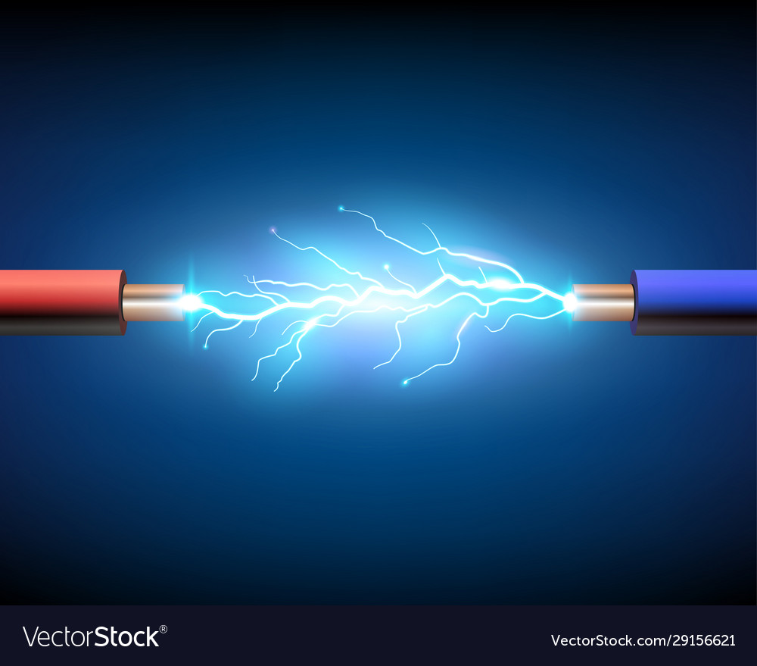

**Science**

As scientists, we will be looking at states of matter. Exploring solids, liquids and gases, their properties and how they behave will be investigated. We can then see how this knowledge can be applied to the ‘real’ world. We will also be investigating how the water cycle works.

**PSHE**

As caring community members, we will learn about how rules and laws help to keep us safe. We will consider where to seek help when we are uncomfortable or unhappy with a person’s behaviour and we will revisit what bullying behaviour is and what to do about it.

**RE**

As theologians, we will learn about what happens at Mass and explore the meanings of some prayers and parts of the Mass. As we approach Holy Week and Easter, our learning will turn towards the events in the life of Jesus that led to his crucifixion and resurrection and what these mean to Christians.

**Geography**

As geographers, we will continue to learn about rivers. We will use a range of maps to explore rivers of the UK and the world. We will then focus on the River Lune and use maps, aerial photographs and a walk to the River Lune to find out more about the stages of our local river.

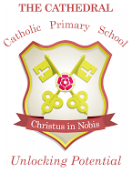

Unlocking potential together

in faith and love.

**English**

As readers and writers, we will be looking at books by Michael Morpurgo. Stories with issues and dilemmas will be the focus for our writing, followed by using the events of Holy Week as a stimulus for writing diary entries and newspaper reports (linking to RE and Computing).