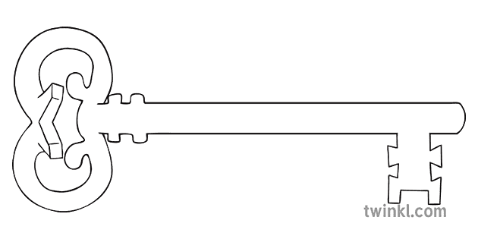

**P.E.**

As sports people, we will develop skills for throwing, catching and batting and apply them in playing rounders. We will continue to swim each Friday morning at Salt Ayre.

**Art & Design & Music**

As artists we will be using watercolours to create different effects. To help with this, we will be looking at the work of the Impressionist artists who used water to inspire their work.

As musicians, we will listen to and appraise music from different eras. We will revise musical vocabulary and revisit using glockenspiels to play simple melodies read from staves.



**Computing**

As computer scientists, we will be using Internet search engines to research effectively and safely. We will also have a go at some simple animation techniques.

**Latin**

As linguists, we will be using Roman schools and learning as a focus to think about writing and stories. We will even learn to play a Roman board game!

**Maths**

As mathematicians, we will continue to secure all times tables to 12x12 for quick and confident recall. We will revisit and extend previous learning about shapes and their properties before moving on to looking at different number sequences. The children will spend time exploring and using different types of measures.

**Curriculum Enrichment**

Residential Visit to Castlerigg Manor

Art Exhibition

Ascension Day Mass

May Procession

Sprots Day

**Year 4**

**Summer 1 Term 2024**



**Science**

As scientists, we will continue to explore properties of solids, liquids and gases – lots of experiments to do!

We will then move on to looking at habitats and how these impact on the flora and fauna that live in them. This will support our upcoming learning when we study Morecambe Bay.

**PSHE**

As caring community members, we will reflect on what makes a good friendship. Acknowledging that even the best friendships sometimes have hiccups, we will look at how to resolve conflicts peacefully. Following this, we will move on to consider personal boundaries and how to respect these for ourselves and others.

**RE**

As theologians, we will learn about what happened to Jesus’ apostles before and after the Holy Spirit came at Pentecost. We will reflect on the power of the Holy Spirit in the lives of Jesus’ followers and the goodness this brings. We will then move on to our Reconciliation topic and consider the importance of forgiveness.

**Geography**

As geographers, we will develop mapping skills this half term, particularly in learning how to recognise Ordnance Survey symbols and use four-figure grid references. We will use these skills to study the area around Morecambe Bay, and look at natural and man-made features shown on maps in this area.

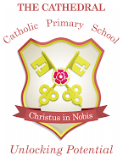

Unlocking potential together

in faith and love.

**English**

As readers and writers, we will begin by looking at the story of the Mousehole Cat and looking at the effect of language and the power of illustrations. Following this, we will read ‘Made by the Moon’ – a myth about Morecambe Bay, written by a local author. We will use this as a model to write our own myth with a local setting.