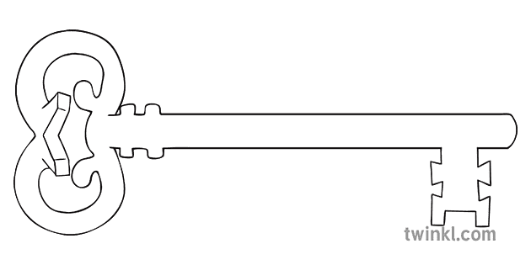

**P.E.**

As sports people, we will develop skills for throwing, catching and batting and apply them in playing rounders. Some children will continue to swim each Friday morning at Salt Ayre.

**Art & Design & Music**

As artists we will be using watercolours to create different effects. To help with this, we will be looking at the work of the Impressionist artists who used water to inspire their work.

As musicians, we will listen to and appraise music from different eras. We will revise musical vocabulary and revisit using glockenspiels to play simple melodies read from staves.



**Computing**

As computer scientists, we will be using Internet search engines to research effectively and safely. We will also have a go at some simple animation techniques.

**Latin**

As linguists, we will be using Roman schools and learning as a focus to think about writing and stories. We will even learn to play a Roman board game!

**Maths**

As mathematicians, we will continue to secure all times tables to 12x12 for quick and confident recall. We will revisit and extend previous learning about shapes and their properties before moving on to looking at different number sequences. The children will spend time exploring and using different types of measures.

**Curriculum Enrichment**

Residential Visit to Castlerigg Manor

Art Exhibition

Ascension Day Mass

May Procession

Sprots Day

**Year 4**

**Summer 1 Term 2025**



**Science**

As scientists, we will continue to explore properties of solids, liquids and gases – lots of experiments to do!

We will then apply this to understanding how the water cycle works in nature, and then how this affects the Earth’s various eco-systems.

**PSHE**

As caring community members, we will reflect on what makes a good friendship. Acknowledging that even the best friendships sometimes have hiccups, we will look at how to resolve conflicts peacefully. Following this, we will move on to consider personal boundaries and how to respect these for ourselves and others.

**RE**

As theologians, we will learn about what happened to Jesus’ apostles before and after the Holy Spirit came at Pentecost. In the unit ‘To the Ends of the Earth’, we will study the central beliefs of the Apostles’ Creed and the apostolic church. Finally we will describe some ways in which the church continues the work of Jesus.

**History**

As historians, we will explore the events leading up to and around the Lancashire Witch Trials of 1612. After investigating a range of primary and secondary sources, we will use what we have learnt to debate and discuss the question ‘Should the Pendle Witches Have Been Killed?’

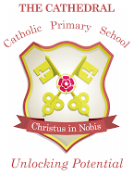

Unlocking potential together

in faith and love.

**English**

As readers and writers, we will begin by looking at the story of the Mousehole Cat and looking at the effect of language and the power of illustrations. Following this, we will be looking at examples of explanation texts. We will use the skills we have learnt to write our own explanations about the water cycle.