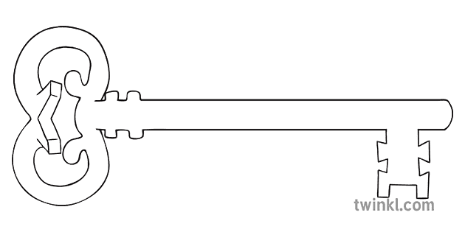

**Morecambe Bay**

**Year 4**

**Summer 2 Term 2025**

**Curriculum Enrichment**

HRE Week

Refugee Week

Morecambe Bay Visit

St Peter and Paul Feast Day

Performance Afternoon

Art Exhibition

**RE**

In our Dialogue & Encounter unit, we will look a St Paul’s commitment to announcing the Gospel to the world. We will loo at the different communities that make up the Catholic Church as well as other Christian communities that all work for the common good. We will also have time to look at the Muslim faith and the role of the Five Pillars of Islam in this faith.

**Geography**

We will complete our Morecambe Bay topic, looking at physical and human features of the bay and our local area, showing them on our own maps and also a visit. Following this, we will move on to look at the Mediterranean area and compare it to Morecambe Bay.

**P.E.**

We will develop skills for throwing, catching and batting and use them in rounders. We will also have the visiting expertise of the Wigan Warriors Rugby League Team on Thursdays!

**Art & Design & Music**

As artists, we will be exploring the Impressionists and using watercolour techniques. We will also be designing, planning and sewing a bookmark.

This half term, we will continue to work at reading notes on a stave to support our singing. We will also learn about pitch, rhythm and timbre, ready for the Performance Afternoon.



**Computing**

As computer scientists, we will review our learning from this year, especially safely searching the Internet, presenting information effectively and some simple animation.

**Latin**

As linguists, we will continue to learn how Latin has impacted on our life and language by exploring the school and life of children in Roman Britain.

**Maths**

As mathematicians, we will continue to secure all times tables to 12x12, ready for the Year 4 multiplication check. We will secure learning linked to statistics, time and measures, and apply our learning in different types of problem-solving contexts. This will also help us to revise addition, subtraction, multiplication and division.

**Science**

As scientists, we will be exploring different types of habitats and what makes them suitable for different types of flora and fauna. We will explore the habitats around Morecambe Bay and our local environment. This will then be used as a basis for classifying plants and animals. We will also look at the environmental impact on habitats.

**PSHE**

During HRE week, we will reflect on our individual gifts and talents and thank God for them. We will identify different types of feelings and how we deal with them. We will recognise that we all grow and develop at different rates and name the different female and male body parts. Finally, we will look at how a baby grows in the womb.

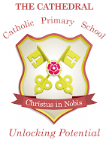

Unlocking potential together

in faith and love.

**English**

We will use the skills we have acquired in English this year to research and write an information leaflet about Morecambe Bay. Following this, we will discuss and prepare to debate an issue linked to Morecambe Bay. Finally, we will practise our writing skills in a series of short writing activities linked to poetry, limericks and haikus.