08 September 2023

Dear Parents and Carers,

I am pleased to inform you that swimming lessons at Salt Ayre are will go ahead for year 5 this academic year.
The first session will be on Friday 15th September and sessions will be every Friday morning after that. (Please see full dates below)

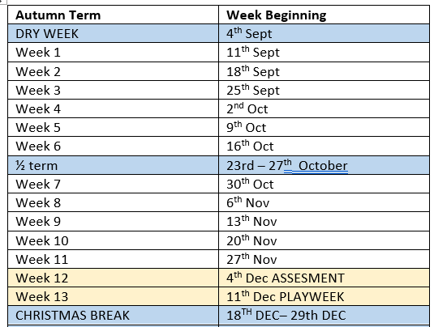

Please find attached some information from Salt Ayre about what your child will need for swimming as well as Goggles permission letter. Your child must have the correct swimwear to participate in lessons and the permission slip must be returned if they wish to wear goggles.
Swimming is a compulsory requirement of the National Curriculum not an optional element and we therefore expect all pupils to participate in lessons each week. If your child is unable to swim due to a medical reason please send a note a or call the school office to let us know. If they feel unwell but are coming to school still, please send their kit and we will make decision once we get to the pool.

If you have any questions or issues please email me or ring the school office.

Many thanks,

Mrs Benson

