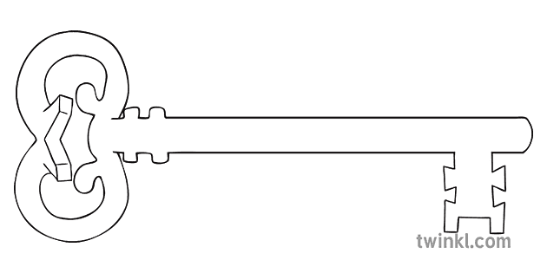

**Year 5**

**Spring 1 - 2025**

Inventors and Inventions



**Music -**

This half term, we are developing our own music based on ‘In the hall of the Mountain King’ by Edvard Grieg.

**Latin**

We will continue to practise and extend our Latin vocabulary and understanding.

**Art**

This half term, we will learn about the work of Andy Warhol and use this to develop our own artwork, focusing particularly on use of interesting colours and different types of paint.

**PE**

As athletes, this term our focus will be on developing skills for invasion games, with a focus on hockey. Children will also learn how to prepare a sequence of moves to create a dance on the theme of ‘Earthlings’.

**Computing**

As computer scientists, we will be taking our knowledge of coding further and learning how to write simulations in code as well as how to use strings of code.

**Maths**

As mathematicians, we will be building on previous place value learning and securing mental and written methods for +, - and x. We will practise converting between metric measures. In geometry, we will learn how to reflect and translate shapes, how to read coordinates and skills for drawing and measuring angles.

**Curriculum Enrichment**

***Whole School Mass for the Start of Term***

***Cyber Fairy Tales Workshop***

***Jubilee RE/Art Day***

***Poetry Performance***

***Ancient Greece Workshop***

***Our Lady of Lourdes Celebration***

***Online Safety Day***

**Science**

As scientists, we will be studying the movement of Earth, the Moon and other planets in relation to the Sun and to each other. We will learn about the Earth’s rotation and how this creates day and night.

**PSHE**

As caring community members, we will be learning about money and how we can spend and save wisely. We will learn about tax, interest, debt, loans and finance and how to manage money to protect yourself financially. We will also find out about what it means to set up an enterprise.

**RE**

As theologians, we will be looking at what it means to be part of a Christian community and how being a Christian impacts on a person’s life. This will include looking at different Christian denominations in Lancaster. Following this, we will learn about Moses, the Passover and the Exodus as told in the Bible.

**History**

As historians, we will be using a range of sources of evidence and images of artefacts to find out about the Ancient Greeks. We will learn about the impact of Alexander the Great on the Ancient Greek empire, the first Olympic Games and the legacy of Ancient Greece, particularly the introduction of democracy.

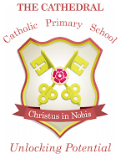

Unlocking potential together

in faith and love.

**English**

As readers and writers, we will be studying non-fiction writing this term. We will use what we learn to help us to write a non-fiction booklet linked to history which contains a range of text types including, information text, explanation text and persuasive writing.