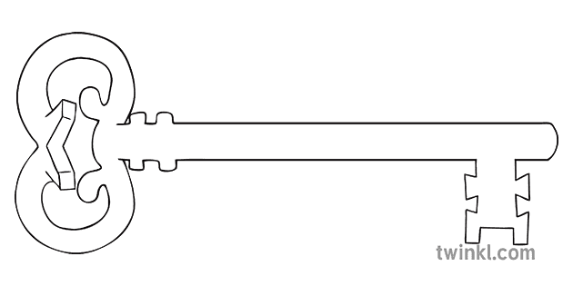

**PE**

In gymnastics, we will be developing sequences with a partner using counter balances and counter tension. In orienteering, we will develop skills in planning routes to get round a course.

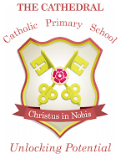

Unlocking potential together

in faith and love.

**Year 5**

**Spring 2 Term 2025**

Inventors and Inventions



**Music**

We will start to learn the ukulele – please practise this at home every week.

**Latin**

As linguists we will practise and extend our previously learnt vocabulary in order to become more fluent.

**Design & Technology**

As designers, we will investigate the use of cam mechanisms to create movement in a model. We will then design and make our own moving toy for a younger child, using cams.

**Computing**

As computer scientists, we will be taking the skills learnt in previous units and applying them to create, test and evaluate a computer-based game.

**Maths**

We will begin with geometry – translating shapes and measuring angles. In our fractions unit, we will learn how to calculate with fractions before moving on to solving fractions problems. In our measures unit, we will learn how to calculate area and volume. Finally, in statistics, we will look at mode, median and range of data.

**Curriculum Enrichment**

Year 5 Class Mass and Ash Wednesday Mass

World Book Day

Reconciliation Service

Big Lent Walk for CAFOD

Borwick Hall Visit

Holy Week Reflection

**Science**

As scientists, we will be studying forces and learning about some famous scientists involved in the discovery of forces. Our focus will be on gravity, friction, air resistance and water resistance.

**PSHE**

In PSHE, we will be thinking about our role in the community and how rules and laws contribute to community life. We will consider different types of anti-social behaviour, the impact it has on people’s lives and how these problems can be addressed. We will also reflect on stereotypical views and how these can be challenged.

**RE**

As theologians, we will learn about what happens at Ash Wednesday Mass and how this marks the beginning of Lent. We will learn about the significance of Lent for believers before moving on to consider the Ten Commandments and Jesus’ commandment as guides for our life. Finally, we will look at the sorrowful mysteries of the Rosary.

**History**

As historians, we will continue our studies of the Ancient Greeks by using primary and secondary sources to investigate and evaluate aspects of Ancient Greek life and culture. We will look particularly at the Olympic games, Greek architecture and the legacy of Ancient Greece.

**English**

As readers and writers, we will be reading a science-fiction novel, “George’s Secret Key to the Universe” and use what we learn about creating settings and characters to support our own writing. We will work at improving our sentence openers and use of descriptive vocabulary when writing our own sci-fi story.