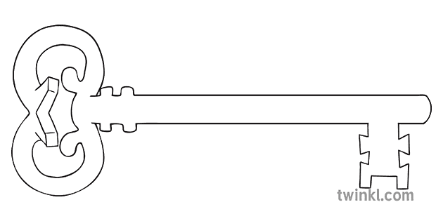

**Music**

We will continue to learn and practise the ukulele this term and develop singing in 2 parts.

**Latin**

As linguists we will practise and extend our previously learnt vocabulary in order to become more fluent whilst learning more about the history of Latin in Britain.

**Year 5**

**Summer 1 Term 2024**

**Ancient and Amazing Americas**



**Art**

To link with our rainforest learning, we will be creating 3D models of rainforest creatures. We will look at sculptures created by the artist Anthony Gormley and then use ideas from his structures to inform our own planning.

**PE**

Our PE day this half term will be **Tuesday** and Mr Lofthouse will work with Year 5 to develop throwing, catching and batting skills within the game of cricket.

**Computing**

As computer scientists, we will be developing the skills of computer aided design, exploring the effect of moving points when designing. We will design and make plans for a 3D model and print it to ensure its accuracy.

**Maths**

As mathematicians, our focus this half term will be on securing our understanding of different types of measures and converting between them. In our statistics unit, we will learn about different ways to present data, including bar charts, tables and line graphs and we will practise interpreting data presented in different ways.

**Curriculum Enrichment**

Easter Mass

Ascension Day celebration

May Procession

Visit to the Butterfly House

Art Exhibition

Sports Day

**Science**

As scientists, we will study and compare the life cycles of mammals, amphibians, insects, birds and plants. We will also look at the process of reproduction in some plants and animals, particularly focusing on different types of reproductive systems in plants.

**PSHE**

As caring community members, we will be learning about healthy relationships this half term.

As part of this unit we will cover: what a healthy relationship can look and feel like, how to recognise an unhealthy relationship, knowing when physical contact is acceptable and unacceptable and knowing how to keep personal boundaries.

**RE**

Our RE learning this half term will be a celebration of the transforming power of the Holy Spirit. Christians believe that the Spirit of God is active in each person and in a special way in the community of believers, which is the church. We will learn about how the Holy Spirit changed the lives of the first followers of Jesus and how the Spirit is at work in the Church today.

**Geography**

In geography, we will be learning about the Amazon Rainforest. We will use a range of online and digital maps and atlases to study the location of the rainforest and the Amazon River. We will then study the physical and human geography of the Amazon rainforest, including a consideration of human impact on rainforest life.

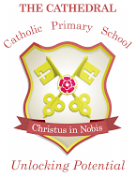

Unlocking potential together

in faith and love.

**English**

As readers and writers, we will link our learning this term to science and geography as we will study poems and imagery used to describe the rainforest and use this to support our own descriptive writing. We will then look at reading and writing stories from other cultures, focusing on stories set in the Amazon Rainforest.