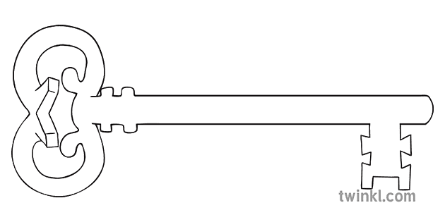

**Curriculum Enrichment**

HRE Learning

Visit to the Butterfly House

Father’s Day afternoon tea

Refugee Week

Art Exhibition - Hope

Visit to Lancaster Uni – Go Green Day

CAFOD Workshop

St Peter and St Paul Day

Visit Day to OLCC

Enterprise Week

**Music**

As musicians, we will continue to learn the ukulele and rehearse ready for a performance.

**Latin**

As linguists, we will be revising what we know and practising translating.

**Year 5**

**Summer 2 Term 2025**

**Ancient and Amazing Americas**

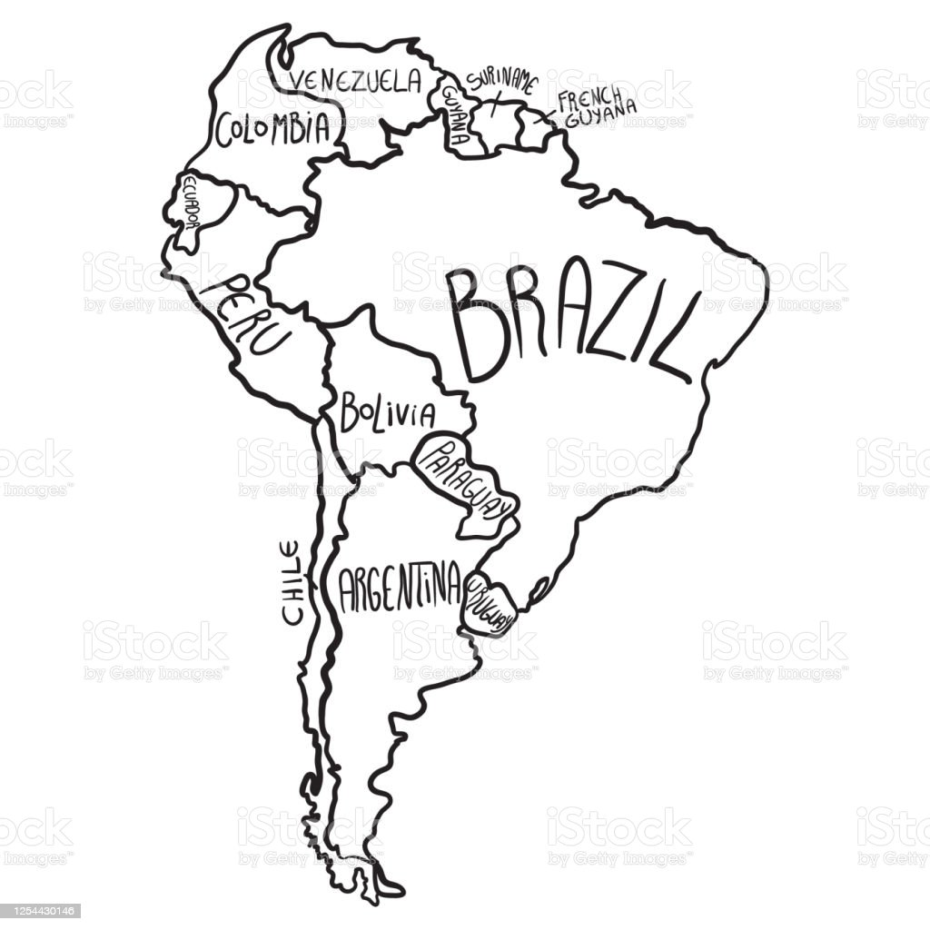

**Design & Technology**

As designers, we will research, investigate and analyse a range of existing bread products and use this to design and make a bread roll to accompany a family summer meal.

**PE**

As athletes, we will develop our striking and bowling skills around the game of cricket. We will also develop skills for running, jumping and throwing in athletics.

**Computing**

As computer scientists, we will learn how to use spreadsheets, including using formulae to explore variables. We will then learn how to use Powerpoint to create a presentation for an audience.

**Maths**

As mathematicians, we will revisit our written methods for addition, subtraction, multiplication and division and apply these in problem-solving and calculating fractions and percentages of quantities. In geometry, we will learn how to calculate missing angles in a shape and plot coordinates to make a shape.

**Science**

As scientists, we will complete our learning about the life cycles of plants and the different ways new plants are grown from a parent plant. We will learn about the changes humans experience as they develop to old age and link this to our learning about puberty in PSHE.

**PSHE**

As caring community members, we will be learning about the changes that happen (both physically and emotionally) during puberty and how these changes can be managed.

**RE**

This half term, we will learn about the Bible as the Word of God and how the Church helps Catholics read and understand more about the Bible. We will then go on to learn about the Jewish faith and particularly the place of Sacred Scripture in Jewish life and some Jewish beliefs expressed in the Shema prayer.

**History**

As historians, we will learn about The Maya Civilisation. We will use a range of evidence sources to learn about how and where they lived, their beliefs, their lifestyle and culture. We will then compare this to aspects of life in Viking Britain which we learnt about in the Autumn term.

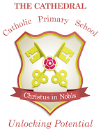

Unlocking potential together

in faith and love.

**English**

As readers and writers, we will study the features of persuasive writing and use this to write persuasive speeches linked to the issue of deforestation. We will then develop these into a debate. Later in the term, we will write our own information booklets linked to learning in science and PSHE.