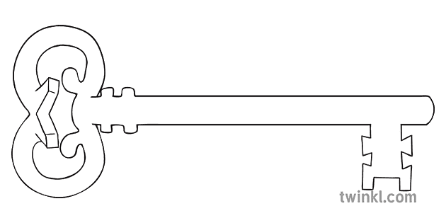

**Maths**

As mathematicians, we will build on and extend the learning done in Year 4. Children will need to continue to practise times tables as these will support their learning in new topics. This term, we will extend our understanding of place value to larger numbers and those with two decimal places. We will also learn how to measure and draw angles using a protractor.

**English**

As readers and writers, we will be studying Myths and Legends of the British Isles and how to write information texts. We will write our own legends based on one of those we have looked at and develop the use of varied sentence starters and detailed character and setting descriptions.

**Music**

We will practise reading music notation and play and compose a melody on a glockenspiel in the context of jazz music.

**Latin**

As linguists we will practise and extend our previously learnt vocabulary. We will introduce adjectives into our speaking and writing.

**Design & Technology**

As designers, we will research, investigate and analyse a range of materials and ways to join fabrics to make a Viking belt capable of holding coins.

**Computing**

As computer scientists, we will be learning how to stay safe online and why it is important to do so. We will consider our responsibilities as online users and how we can protect ourselves online.

**PE**

In PE, we will develop throwing and catching skills and strategies to use in netball. In gymnastics, we will learn how to use counter-balance and counter-tension actions in a sequence.

**Curriculum Enrichment**

Marvellous Me Week

Beginning of term Mass

Viking dress up day and workshop

Geography Field Trip in Lancaster

Lego workshop

Harvest celebration

Black History Day

**Year 5**

**Autumn 1 Term 2024**

**A Kingdom United**

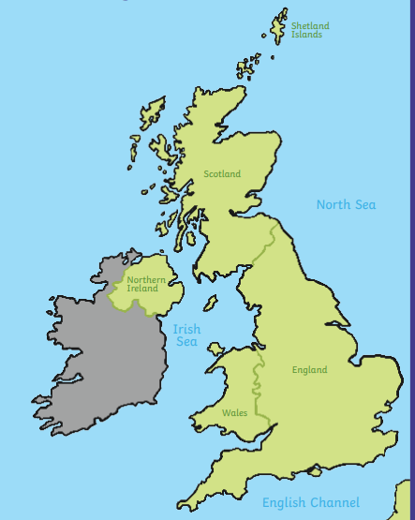

**Science**

As scientists, we will be using scientific vocabulary to describe the properties of materials. We will consider how objects are made with materials that are fit for their purpose and investigate materials that are best for thermal insulation and electrical conduction.

**PSHE**

As caring community members, we will be learning about how to keep ourselves safe, others safe and who we have around us to help us. This will also include some learning about First Aid. Following this, we will learn about the different pressures (media, social, peer) and how to resist these pressures.

**RE**

We will begin the year by reflecting on how each of us is unique and loved by God. We will learn about the roles of significant people in the Catholic Church and then reflect on the beauty of creation and our mission to look after it. Finally, we will start to study the significance of the sacraments for believers.

**History and Geography**

As Historians, we will be looking at The Anglo-Saxon and Viking struggle for The Kingdom of England. We will have a deeper look into how the Vikings lived and the lasting impact they had on Britain. In geography, we will learn about counties and cities of the UK and how to use Ordnance map symbols to find out about a place.

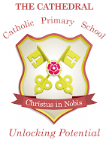

Unlocking potential together

in faith and love.