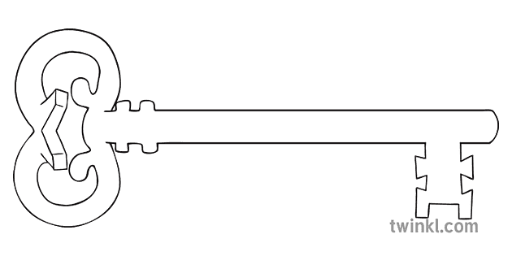

**History/Geography**

As historians and geographers, we shall continue to explore one of the world’s earliest civilizations -Ancient Egypt. Taking a look at the culture, lifestyle, wealth and health of these amazing peoples.

**Maths**

As mathematicians, we shall be recapping a whole range of topics, including: co-ordinates, time, volume, area and perimeter and Roman Numerals

**PSHE**

As caring community members, we shall be learning about positive and negative affects on mental health, influences on healthy eating and lifestyle, how images in the media can distort reality and that this can affect how people feel about themselves and how to reduce the spread of infection.



**Year 6**

**Spring 2 Term 2024**

History Detectives and Ancient Egytians

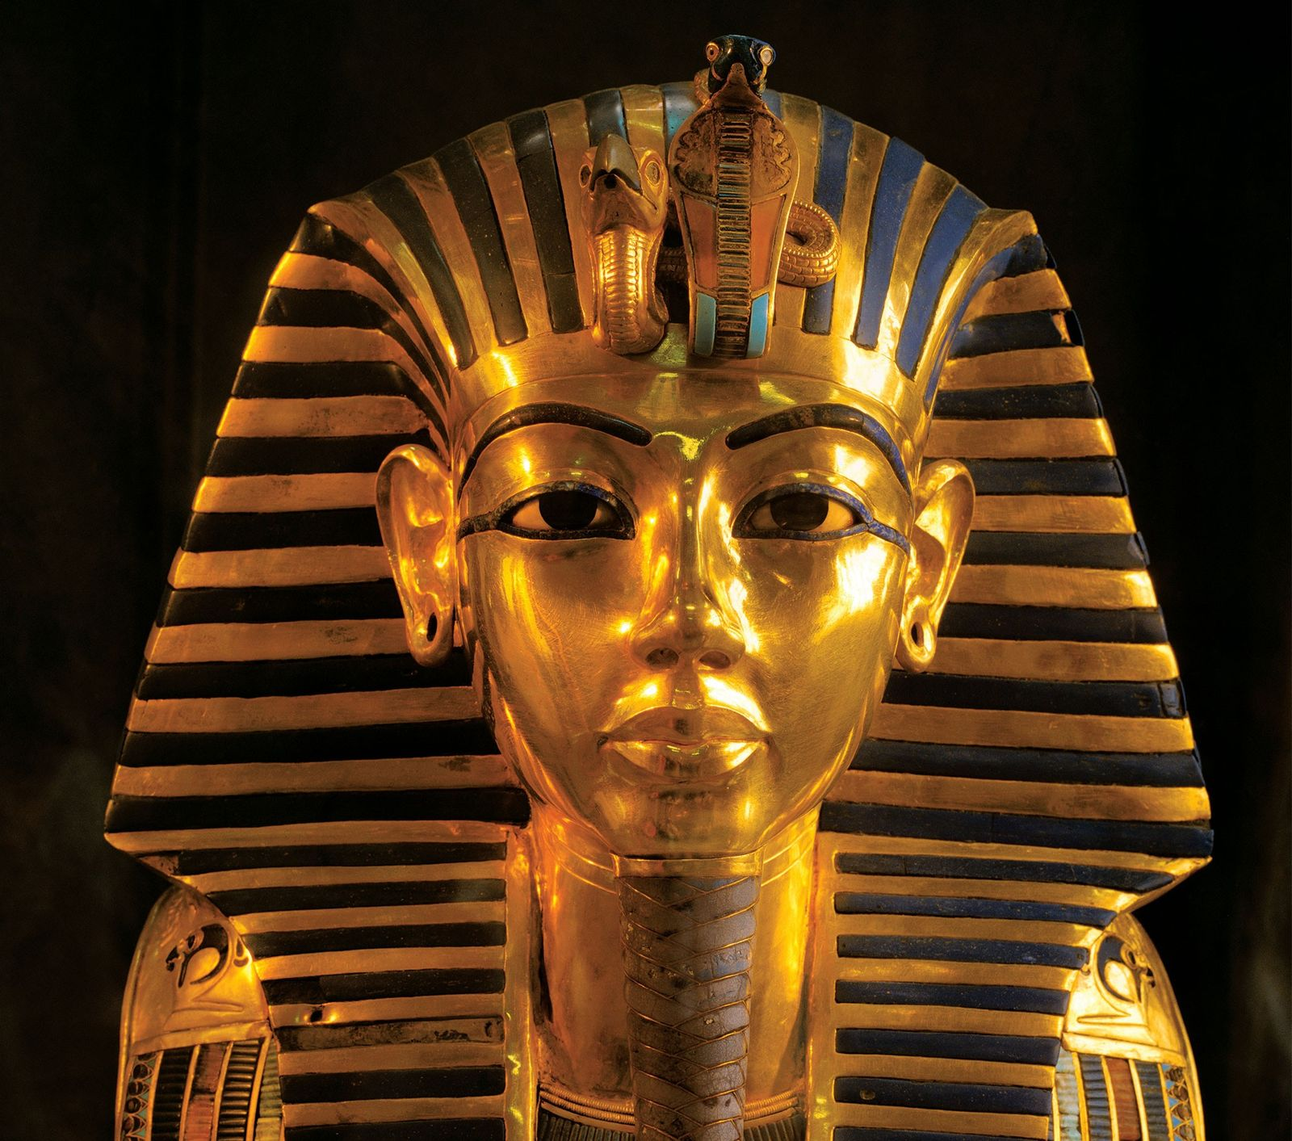

**Curriculum Enrichment**

VR headset tours

Mother’s Day Afternoon

World Book Day

Williamson Park OAA

**Science**

As scientists, we shall be learning and recapping our knowledge about light. We shall cover how it travels in straight lines, the differences between transparent, opaque and translucent and how shadows are made.



**Music**

As musicians, we will be singing traditional South African *Siyahamba* as well as listening to Western Classical Traditional Music and Film Scores



**RE**

As theologians, we shall be learning all about unity before continuing our investigations into Lent leading up to Easter.



**Art**

Cross-stitch crazy! Designing our own hieroglyphs cartouche using thread and binker.

**PE**

As athletes, we shall be exploring cricket skills as well as starting to develop our own outside and adventurous activities.

**Design & Technology**

As designers, we shall be investigating stitches and samplers to help us produce a stunning Ancient Egyptian cross-stitch to accompany next term’s history work.

**Computing**

As computer scientists, we shall be learning how to blog – using our skills to develop our blogs as informative texts, updating the information and learning about the approval process.

**English**

As readers and writers, we will continue to investigate the curious case of *The London Eye Mystery* by Siobhan Dowd and an online novel *The Curse of Cogston House* as well as writing our own detective fiction.

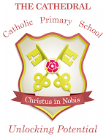

Unlocking potential together

in faith and love.