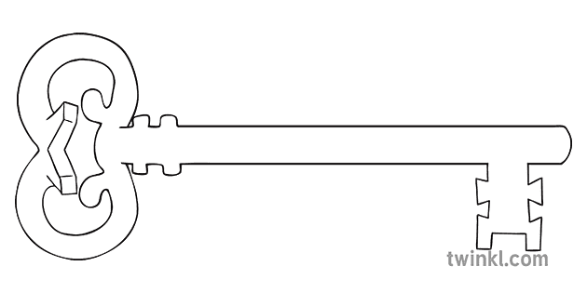

**Art**

Street Art – hieroglyphics to graffiti, as artists we shall be developing our skills in street art – from anti-social vandalism to multi-million-pound installations.

**PE**

As athletes, we shall be taking advantage of the finer weather – enjoying Striking/Fielding – Rounders and athletics.

**Design & Technology**

As designers, we shall be investigating stitches and samplers to help us produce a stunning Ancient Egyptian cross-stitch to accompany next term’s history work.

**Computing**

As computer scientists, we shall be exploring how the internet was invented and then developed as well as using our programming skills on our own personal BBC microcomputer.

**English**

As readers and writers, we will be investigating the curious case of *The London Eye Mystery* by Siobhan Dowd and an online novel *The Curse of Cogston House* as well as writing our own detective fiction.

**Science**

As scientists, we shall be learning all about the circulatory system, healthy hearts and healthy lifestyles!

**Music**

As musicians, we will be working towards an end of year guitar concert as well as preparing to present our very special end of year production!

**PSHE**

As caring community members, we shall be preparing for the transition to high school with a lot of work around friendship groups and making new starts. We shall also start looking at healthy relationships and what that means as we grow up.

**Maths**

As mathematicians, we shall be recapping a whole range of topics, including: Place value,

Fractions, Time and statistics, Geometry

Addition and subtraction & Multiplication and division

**Curriculum Enrichment**

May Bank Holidays

King’s Coronation Activities

Arts Week

Egyptian Dress-Up Day

End of Year Production

**Year 6**

**Summer 1 Term 2023**

History Detectives and Ancient Egytians

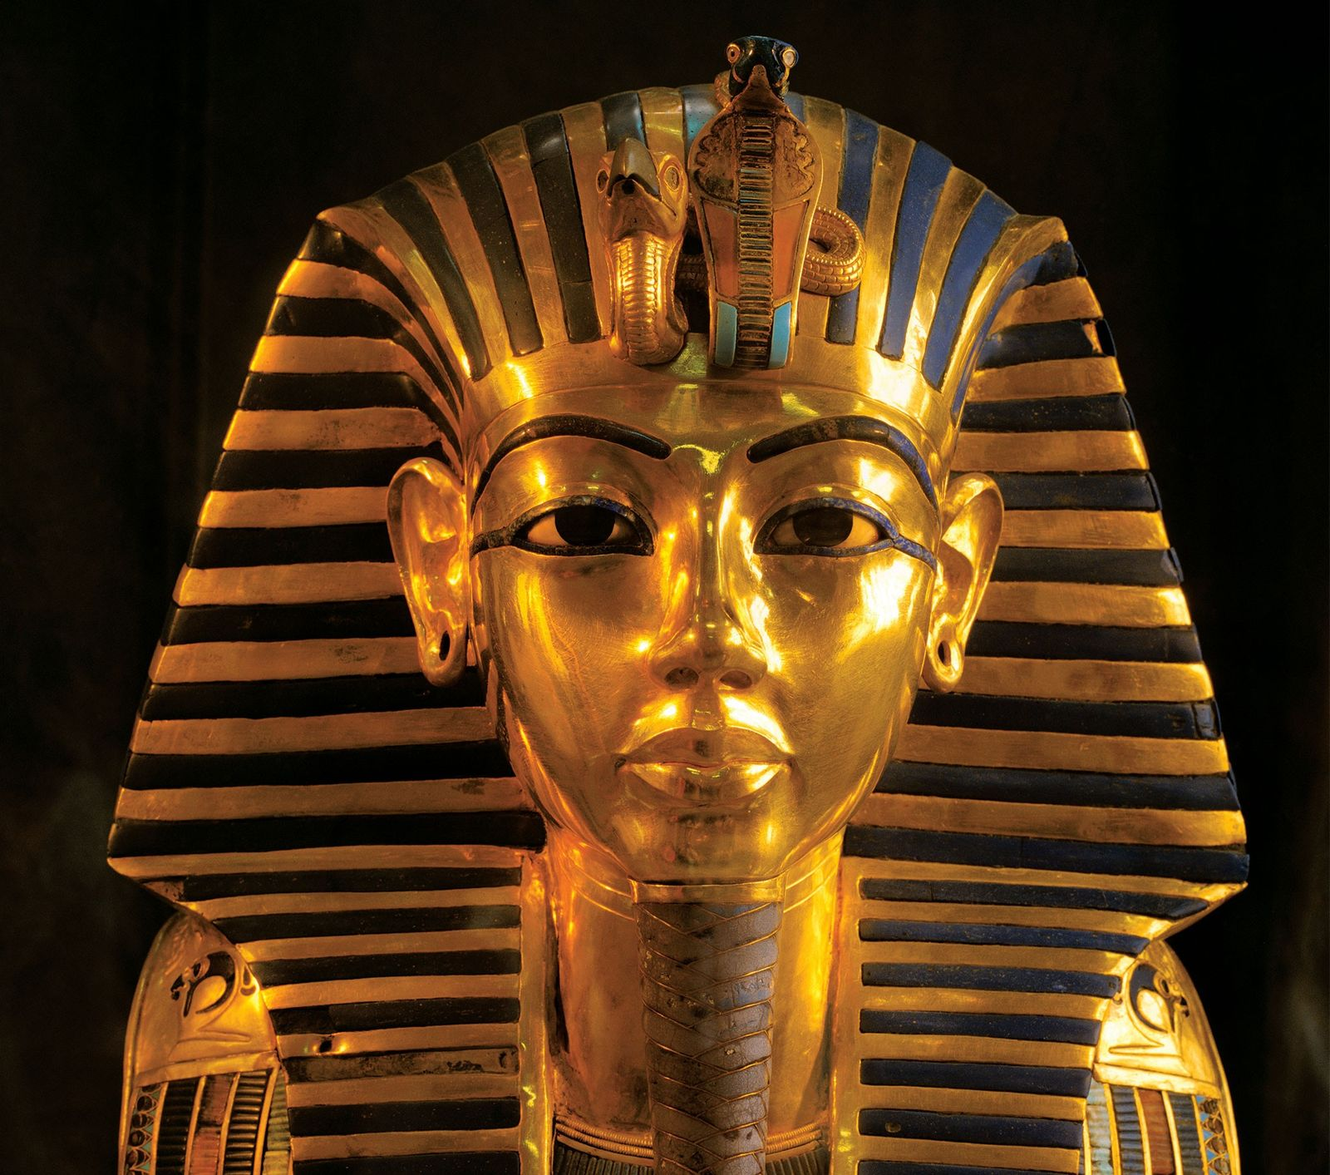

s

**RE**

As theologians, we shall be learning all about Pentecost and the mission Jesus gave to his disciples. We shall also explore the Ascension and recall the events from Jesus’ resurrection to ascending into heaven.

**History/Geography**

As historians and geographers, we shall be exploring one of the world’s earliest civilizations -Ancient Egypt. Taking a look at the culture, lifestyle, wealth and health of these amazing peoples.

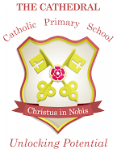

Unlocking potential together

in faith and love.