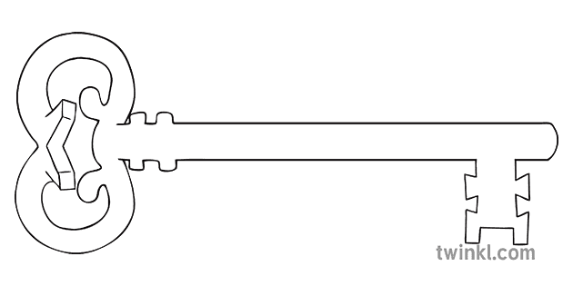

**Maths**

As mathematicians, we shall dive into the area of both triangles and parallelograms! We shall continue to embed our basic arithmetic skills and of course keeping in touch with fractions, measures and time!

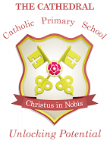

Unlocking potential together

in faith and love.



**RE**

As theologians, we shall learn all about Pentecost trying to understand what it means to be a witness and understand the mission Jesus gave his disciples.

**Year 6**

**Summer 1 Term 2024**

Frances Elizabeth Johnson and the Lancaster Slave Trade

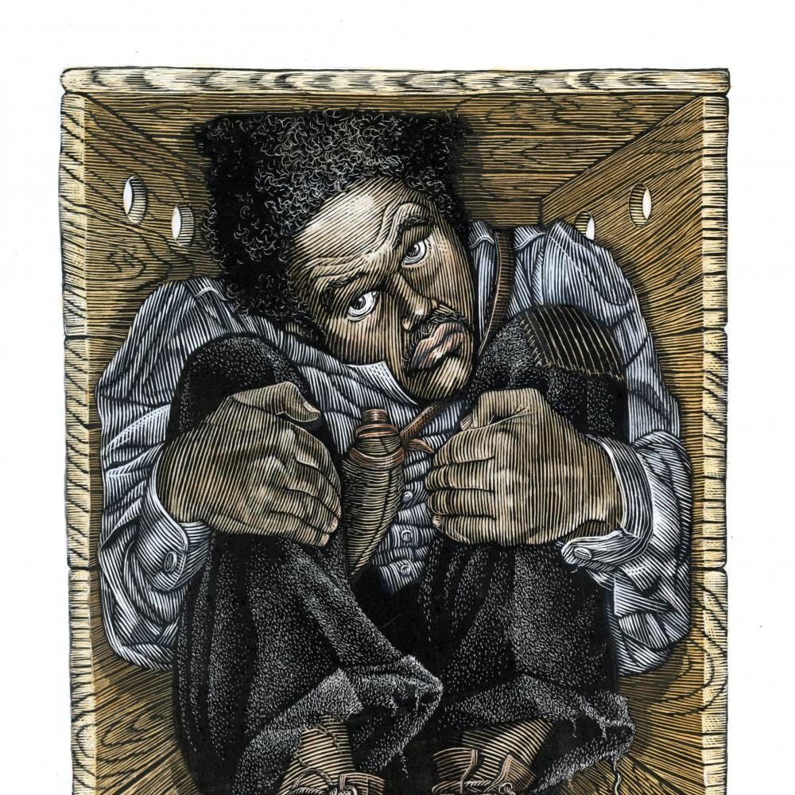

**Curriculum Enrichment**

Lancaster Slave Trade Tour

PSHE Week

Sports Day

Liverpool Residential

**History/Geography**

As historians and geographers, we shall be exploring the Lancaster and in particular tracing it’s dubious claim of being the 4th largest Georgian slave trading port in Britain.

This will include several workshops with Lancaster Black History and link to our residential in Liverpool in July.

**Art**

As artists, we shall be using digital technologies to capture and manipulate images as well as working in mixed media to produce a giant sculpture linked to our history topic.

**PSHE**

As caring community members, we shall be preparing for the transition to high school with a lot of work around friendship groups and making new starts. We shall also start looking at healthy relationships and what that means as we grow up.

**Science**

As scientists, we will learn what happens when different components are tried in a circuit, for example, switches, bulbs, buzzers and motors.

**Computing**

As computer scientists, we shall be exploring how the internet was invented and then developed as well as using our programming skills on our own personal BBC microcomputer.

**Music**

As musicians, we will be examining the history of music as well as preparing to present our very special end of year production!

**PE**

As athletes, we shall be taking advantage of the finer weather – enjoying Striking/Fielding – Rounders and athletics.

**Latin**

As linguists, we shall be recapping our skills from this year, speaking in simple sentences and exchanges that show our understanding as well as writing and adapting simple phrases from memory.

**English**

As readers and writers, we will shall be reading *The Undefeated* by Kwame Alexander & Kadir Nelson and Henry’s Freedom Box by Ellen Levine; allowing them to inspire us to write a number of pieces across the half-term.