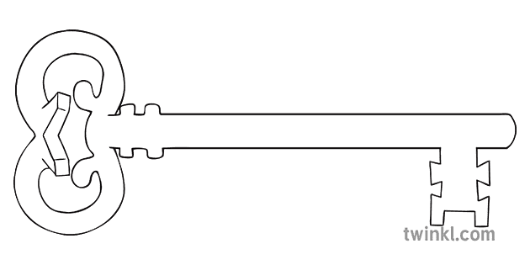

**Maths**

As mathematicians, we shall be consolidating all we have leant from the previous years and learning to apply those skills on a range of both arithmetic and reasoning problems. Starting with place value and the four basic functions, we shall practice using and applying our number skills to a range of written problems.

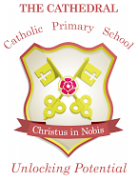

Unlocking potential together

in faith and love.



**PSHE**

As caring community members, we shall be examining the different ways we can keep ourselves safe; from peer pressure to the influence of media – we shall explore strategies and approaches to resist unhelpful pressure and ask for help.

**Curriculum Enrichment**

* Survival skills Day
* Bush-tucker Trial
* Lancaster-city Dino hunt
* Lego Coding Workshop

**History/Geography**

As historians and geographers, we shall be discovering more about the tragic events of the 2004 Boxing Day Tsunami – especially at the impact on the islands that surround the ‘Ring of Fire’

**RE**

As theologians, we shall be exploring our church, how we value people over possessions and ways in which Christian love can be shown at home, at church and globally.

**Latin**

As linguists, we shall be recapping our skills from last year, speaking in simple sentences and exchanges that show our understanding as well as writing and adapting simple phrases from memory.

**PE**

As team-players, we shall explore all aspects of tag rugby as well as working together to improve our dance skills.

**Computing**

As computer scientists, we shall be taking a serious look into internet safety and how to keep ourselves and others safe online.

**Music**

As musicians, we shall continue to build on our guitar playing skills – developing our ability to play together, improving our performance skills and extending our repertoire.

**Art**

As artists, we shall be exploring the art of camouflage – discovering how to dazzle, hide with shadow and blinker with pattern. We shall study the amazing works of Liu Bolin and attempt to create some cracking camouflage art of our own.

**Science**

As scientists, we shall examine evolution and inheritance – trying to find out just how adaptation has affected every living organism on the planet.

**Year 6**

**Autumn 1 Term 2024**

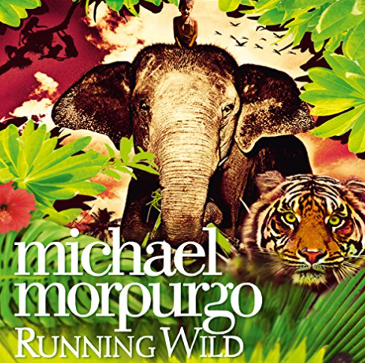

**English**

As readers and writers, we will be enjoying the Michael Morpurgo classic “Running Wild” – using this powerful and engaging book to explore the concepts of novels. We shall also be taking a look at the classic William Blake poem ‘Tyger, Tyger’ and composing our own animal-based poems.