Year 6 Spring 1 2024
Half-termly Creative Independent Homework
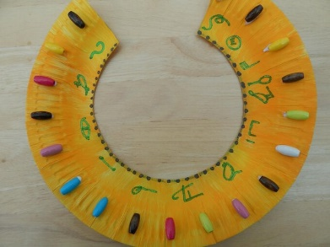
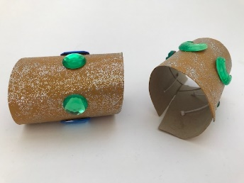

Dress like an Egyptian!

On Friday 9th February, you are invited to a fancy-dress party!
Your homework is to research an Ancient Egyptian, create a dazzling costume and wear your work to school!

Bring with you a one-page personal profile based on your research that will explain what you’re wearing and why!

You could choose:
- A farmer on the Nile delta
- A soldier fighting in the Ancient Egyptian Army
- A Pharaoh ruling the land with great power and wealth
- A healer using the mystic power of the Gods
- A lowly slave building the great pyramids and temples
- Or someone else that catches your imagination

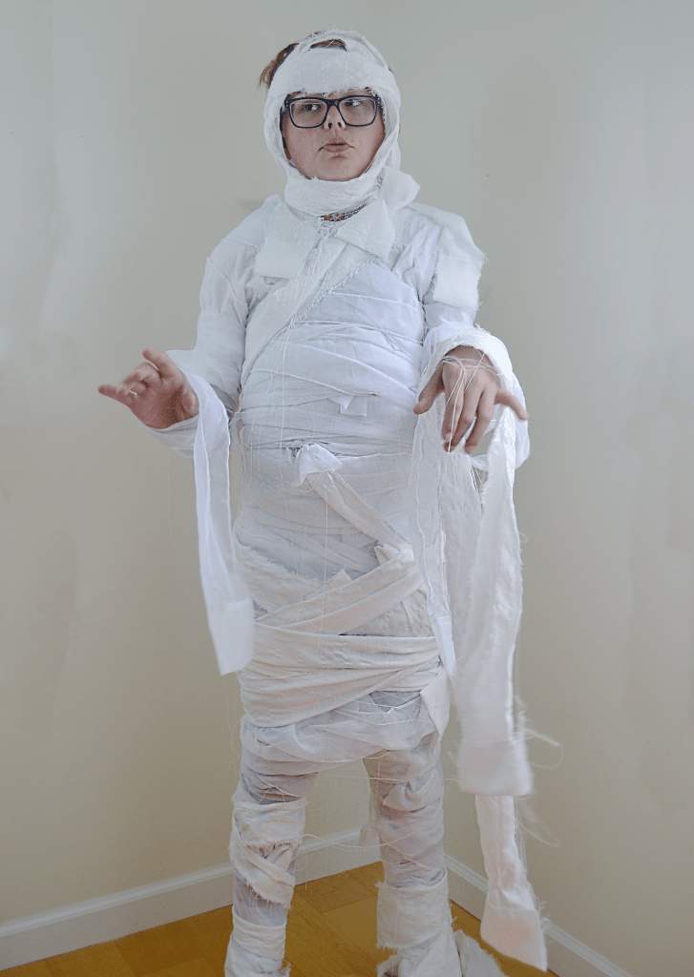
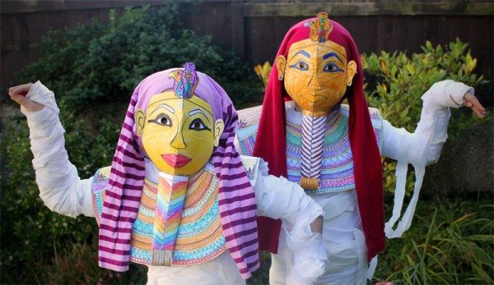

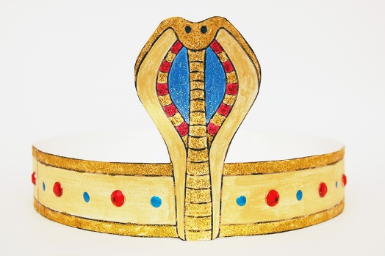
Make and Create instead

