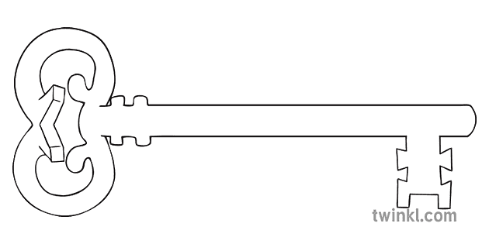

**Maths**

As mathematicians, we will be focussing on the numbers 6-10. We will be learning all about these numbers and how they are made up and how many different ways we can represent this number.

**Curriculum Enrichment**

Police Museum Visit

People who help us visits

Nativity

Pantomime Trip

**Reception**

**Autumn 1 Term 2024**

Superheroes

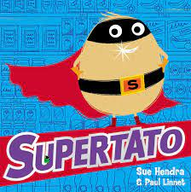

**Our Own Interests**

As independent learners, we may go off topic and complete learning based on our own interests.

**Expressive Art and Design**

As artists, we will be developing our cutting skills and looking at different ways to join materials.

**Understanding the World**

During our understanding the world the lessons, we will be learning about people who help us. We will be describing them and discussing their roles in our society.

**PSED**

As caring community members our PSED is embedded in the EYFS curriculum including sharing, managing emotions and building relationships. In addition, this half term we will be learning about the importance of regular physical exercise.

**Physical Development and PE**

As athletes, in PE this half term we will be developing our fundamental movement skills such as: throwing, catching, rolling, jumping and climbing.

**RE**

As theologians, we will be learning about welcoming and baptism. We will also be learning all about the Christmas story and performing our Nativity.

**Communication and Language**

As linguists, communication and language skills are throughout all areas of the EYFS curriculum. This includes speaking and listening skills, new vocabulary and conversational skills.

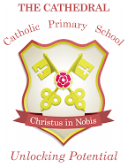

Unlocking potential together

in faith and love.

**Literacy**

As readers and writers, our focus text this half term is “Supertato” by Sue Hendra and Paul Linnet. We will be continuing with our Phase 2 phonics and using our phonics skills to write words and simple phrases. We will also be learning to read and write out names independently.