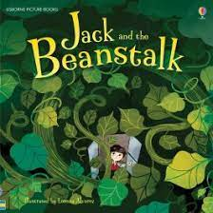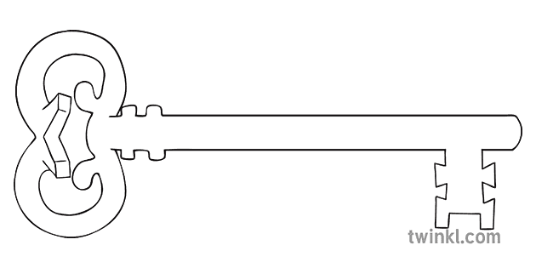

**Maths**

As mathematicians, we will be learning and developing our knowledge of shape space and measure thinking about distance, weight, capacity and money. We will also be thinking about number skills by ordering and comparing numbers.

**Curriculum Enrichment**

Castle Trip

Fairy Tale dress up day

**Reception**

**Summer 1 Term 2024**

Fairy Tales

**Our Own Interests**

As independent learners, we may go off topic and complete learning based on our own interests.

**Expressive Art and Design**

As artists, we will be focusing on the work of Scott Gustafson and exploring texture and how we can use this in our own work.

**Understanding the World**

During our understanding the world the lessons, we will be learning about the Royal Family. We will be thinking about who they are, what they do and seeing how they have changed over time. We will be looking at castles and their different features. We also have our own caterpillars to see how they change over time.

**PSED**

As caring community members our PSED is embedded in the EYFS curriculum including sharing, managing emotions and building relationships. In addition, this half term we will be learning about the importance of sleep.

**Physical Development and PE**

As athletes, in PE this half term we will be developing our fundamental movement skills such as: throwing, catching, rolling, jumping and climbing.

**RE**

As theologians, our topic this half term will be “Ti the Ends of the Earth”. We will be learning about Pentecost and the Holy Spirit. We will also look at what Jesus’ friends did after He left earth.

**Communication and Language**

As linguists, communication and language skills are throughout all areas of the EYFS curriculum. This includes speaking and listening skills, new vocabulary and conversational skills.

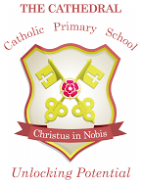

Unlocking potential together

in faith and love.

**Literacy**

As readers and writers, we will be focussing on several different traditional tales. We will be starting with Phase 4 phonics. We will also be starting Talk for Writing, to ensure we can say what we want to write.