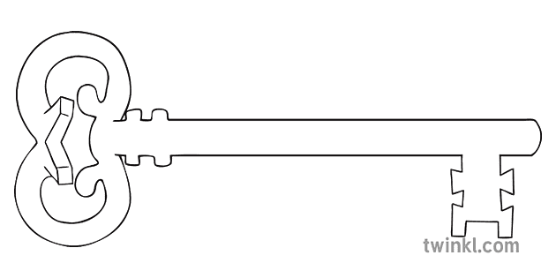

**Maths**

As mathematicians, we will be learning and developing our knowledge of shape, space and measure thinking about time, space and money. We will also be thinking about number skills and continuing with some addition and subtraction.

**Curriculum Enrichment**

Barton Grange Trip

Enterprise Week

**Reception**

**Summer 2 Term 2025**

Growing

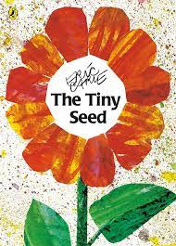

**Our Own Interests**

As independent learners, we may go off topic and complete learning based on our own interests.

**Expressive Art and Design**

As designers, we will be designing and making our own fruit salads. We will start at the beginning of the design process and learning all the steps of design technology.

**Understanding the World**

During our understanding the world the lessons, we will be learning about plants. We will learn about the parts of a plant and what they need to grow. We will also have a go at growing our own plants.

**PSED**

As caring community members our PSED is embedded in the EYFS curriculum including sharing, managing emotions and building relationships.

**Physical Development and PE**

As athletes, in PE this half term we will be developing our fundamental movement skills such as: throwing, catching, rolling, jumping and climbing.

**RE**

As theologians, our topic this half term will be Dialogue and Encounter. We will be learning about how we can live out the Catholic faith today. We will also be learning about other faiths in our class community.

**Communication and Language**

As linguists, communication and language skills are throughout all areas of the EYFS curriculum. This includes speaking and listening skills, new vocabulary and conversational skills.

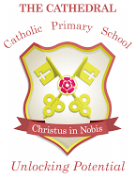

Unlocking potential together

in faith and love.

**Literacy**

As readers and writers, our focus text this half term is “The Tiny Seed” by Eric Carl. We will be continuing with Phase 4 phonics and using our phonics skills to write instructions about how to grow our own plants.