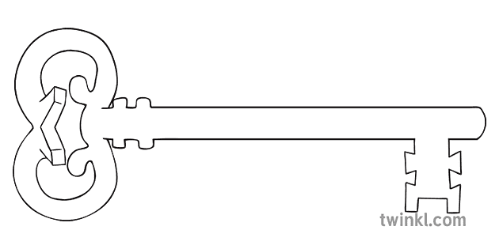

**Maths**

In maths we will be introducing the concept of addition and subtraction. We will also be developing our knowledge of numerical patterns by doubling and halving numbers.

**Curriculum Enrichment**

Trip to Grange-Over-Sands

**Reception**

**Spring 2 Term 2024**

Journeys and Transport

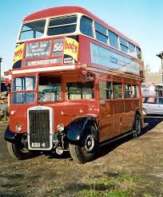

**Our Own Interests**

As well as this, we may go off topic and complete learning based on our own interests.

**Expressive Art and Design**

This half term we will be working on DT and looking at structures. We will be evaluating, designing and making a bridge for the Hundred Decker bus to travel across.

**Understanding the World**

During our understanding the world the lessons, we will be looking at maps. We will have a go at making our own maps, planning routes and looking at their features.

**PSED**

PSED is embedded in the EYFS curriculum including sharing, managing emotions and building relationships. In addition, this half term we will be learning how to be a safe pedestrian.

**Physical Development and PE**

In PE this half term we will be continuing to develop our fundamental movement skills such as: throwing, catching, rolling, jumping and climbing.

**RE**

In our topic this half term, is desert to garden. We will be learning about Lent and why we have this season and how we celebrate it as well as beginning to look at the Easter story.

**Communication and Language**

Throughout all areas of the EYFS curriculum, we will focus on our communication and language skills. This includes speaking and listening skills, new vocabulary and conversational skills.

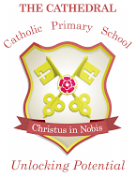

Unlocking potential together

in faith and love.

**Literacy**

This half term we will be continuing with drawing club to develop our vocabulary and story telling skills as well as introducing some talk for writing techniques to tell our own stories.