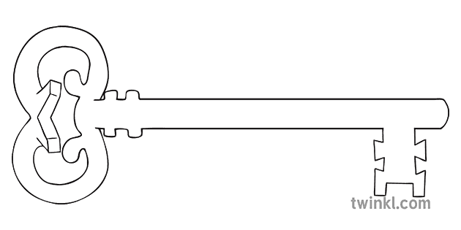
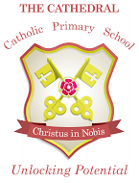
Maths
As mathematicians, we will be learning and developing our knowledge of shape space and measure thinking about distance, weight, capacity and money. We will also be thinking about number skills by ordering and comparing numbers.
Curriculum Enrichment

Castle Visit
Sports Day
Reception
Summer 1 Term 2026
Kings and Queens

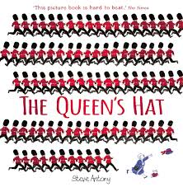
Our Own Interests
As independent learners, we may go off topic and complete learning based on our own interests.

Expressive Art and Design
As artists, we will be focusing on digital art and creating our own pictures using technology.
Understanding the World
During our understanding the world the lessons, we will be learning about leadership. We will be thinking about leaders in our school and what they do. We will be looking at castles and their different features. We also have our own caterpillars to see how they change over time.

PSED
As caring community members our PSED is embedded in the EYFS curriculum including sharing, managing emotions and building relationships. In addition, this half term we will be learning about the importance of sleep.
Physical Development and PE
As athletes, in PE this half term we will be developing our fundamental movement skills such as: throwing, catching, rolling, jumping and climbing.
RE
As theologians, our topic this half term will be “To the Ends of the Earth”. We will be learning about Pentecost and the Holy Spirit. We will also look at what Jesus’ friends did after He left earth.
Communication and Language
As linguists, communication and language skills are throughout all areas of the EYFS curriculum. This includes speaking and listening skills, new vocabulary and conversational skills.
Unlocking potential together
in faith and love.
Literacy
As readers and writers, we will be focussing on The Queens Hat by Stephen Antony. We will be writing our own versions of parts of the story. We will be continuing with Phase 3 phonics.

