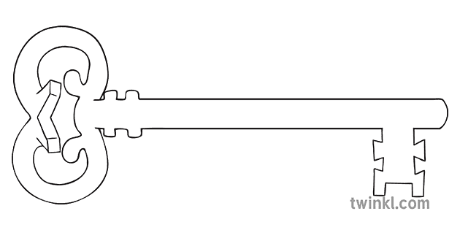

**Maths**

As mathematicians, we will be focussing on the numbers 1-5. We will be learning all about these numbers and how they are made up and how many different ways we can represent this number.

**Curriculum Enrichment**

Williamson’s Park

**Reception**

**Autumn 1 Term 2024**

Marvellous Me

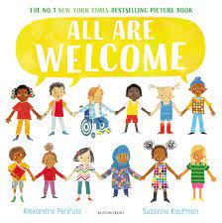

**Our Own Interests**

As independent learners, we may go off topic and complete learning based on our own interests.

**Expressive Art and Design**

As artists, we will be developing our observational drawing skills and creating our own self-portraits.

**Understanding the World**

During our understanding the world the lessons, we will be learning about lives of the people around the world, our similarities and difference.

We will also be celebrating international science week and learning about space.

**PSED**

As caring community members our PSED is embedded in the EYFS curriculum including sharing, managing emotions and building relationships. In addition, this half term we will be learning about healthy eating.

**Physical Development and PE**

As athletes, in PE this half term we will be developing our fundamental movement skills such as: throwing, catching, rolling, jumping and climbing.

**RE**

As theologians, we will be learning about creation and thinking about who loves us. We will also be practicing our school prayer and motto as well us thinking about key people in our church.

**Communication and Language**

As linguists, communication and language skills are throughout all areas of the EYFS curriculum. This includes speaking and listening skills, new vocabulary and conversational skills.

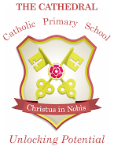

Unlocking potential together

in faith and love.

**Literacy**

As readers and writers, our focus text this half term is “All Are Welcome” by Alexandra Penfold. We will be starting our Phase 2 phonics and using our phonics skills to write words and simple phrases. We will also be learning to read and write out names independently.