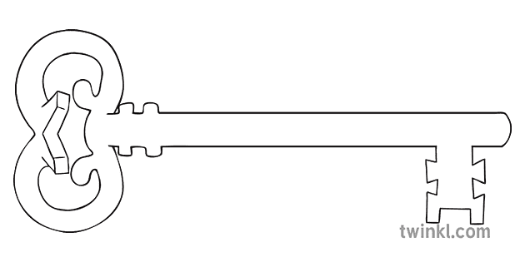

**Maths**

As mathematicians, we will developing our sense of number that we worked on last half term. We will be developing our partitioning skills as well as using numbers to measure weight and length. We will look at teen number and practice counting past 10.

**Curriculum Enrichment**

Williamson Park

Chinese New Year

**Reception**

**Spring 1 2025**

Animals

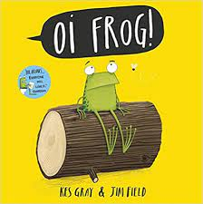

**Our Own Interests**

As independent learners, we may go off topic and complete learning based on our own interests.

**Expressive Art and Design**

As artists, we will be looking at TingaTinga art and having a go at creating our own versions of the art.

**Understanding the World**

During our understanding the world the lessons, we will be learning about animals. We will be thinking about their habitats and grouping different animals. We will also be learning about Chinese New Year and why it is celebrated.

**PSED**

As caring community members our PSED is embedded in the EYFS curriculum including sharing, managing emotions and building relationships. In addition, this half term we will be learning about the importance of cleaning our teeth.

**Physical Development and PE**

As athletes, in PE this half term we will be developing our fundamental movement skills such as: throwing, catching, rolling, jumping and climbing.

**RE**

As theologians, our topic is Galilee to Jerusalem. We will be thinking about the Wise men visiting the baby Jesus and also some of Jesus’ miracles.

**Communication and Language**

As linguists, communication and language skills are throughout all areas of the EYFS curriculum. This includes speaking and listening skills, new vocabulary and conversational skills.

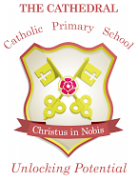

Unlocking potential together

in faith and love.

**Literacy**

As readers and writers, our focus text this half term will be the “Oi, Frog” series by Kes Gray and Jim Field. We will be thinking lots about rhyming. We will be starting Phase 3 phonics and using our phonics skills to write words and simple phrases.