5th October 2018

Dear Stakeholder

Re: Proposed conversion to academy status of Central Lancaster High School

A formal consultation process regarding the proposal to convert Central Lancaster High School to academy status and for the school to join The Bay Learning Trust commences today.

The consultation will run until Friday 16th November 2018. The full timeline of the consultation and a copy of this letter, along with some frequently asked questions are published on our website.

Should you wish to respond to the consultation or have any further queries please do not hesitate to contact me in writing.

Yours faithfully
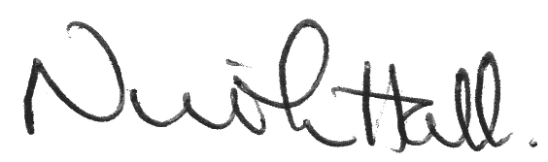
Nicola Hall
Headteacher

