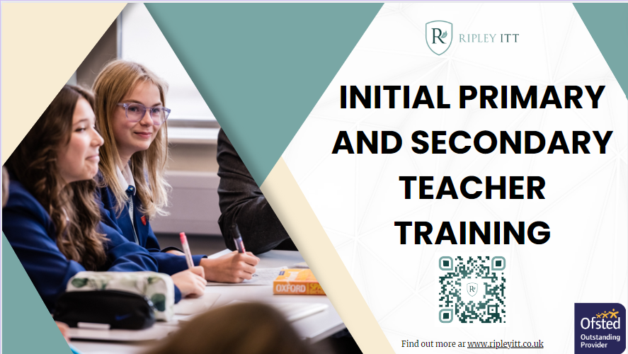

Ripley ITT: Primary and Secondary Teacher Training
Train to become a primary or secondary teacher with Ripley ITT. Our team is dedicated to ensuring that you become the primary or secondary teacher who makes a difference. Our team will provide a solid base of training to guide you through your training year, make excellent progress and ultimately, become a fantastic teacher who will impact future generations of children and learners.

What does our programme include?
- A QTS recommendation in 12 months
- An online PGCE comprised of three modules
- Observations of expert practitioners in school
- A gradual approach to teaching to work at your own pace
- Personal tutor and mentor support
- An experienced Ripley ITT team, there to support you at every stage

Our support
Teacher training years are an intensive route into the profession and we'll be here to support you through every step. You will be supported by a Ripley ITT personal tutor as well as an in-school mentor, who will provide coaching, planning support as well as ensuring your wellbeing is looked after and your workload is manageable.

Find out more
Recruiting the best primary and secondary teachers is our main goal. In 2022-23, 100% of our trainees/apprentices secured employment and we pride ourselves on developing the best teachers to put into schools in the region and across the country. If you know someone who shares that passion for teaching and learning, please share this email and booklet and guide them towards our application process of open events:
Eventbrite: https://www.eventbrite.co.uk/o/ripley-itt-41218351803
Apply: https://www.ripleyitt.co.uk/how-to-apply/
For more information, please visit our website, contact us via email or follow us on our social media channels:
Website: www.ripleyitt.co.uk
Email: ITT@ripley.lancs.sch.uk
Tel: 01524 64496
Twitter and Facebook: @RipleyITT

With best wishes,

Matt Armstrong
Assistant Director – Ripley ITT

If you would like to opt out of our mailing list, please reply ‘Opt Out’ to this email.

