What to expect on
'Healthy Relationships'

Explore the impact of parent disagreements on children

Learn about how your relationships develop and change

Explore what is helpful and harmful conflict

Look at different arguing styles & how your responses can influence how arguments escalate or resolve

Explore how your thoughts, feelings and behaviours impact on how you communicate

Gain strategies to help you connect and communicate better during stressful times

Free Online courses for Parents/ Carers

- Arguing better - Disagreements are a normal part of life. How you approach them can make all the difference to you, your partner, and your children.
- Me, you and baby too (for new parents) - Navigate the changes that happen in a relationship when a baby arrives
- Getting it right for children (for separating parents) - When parents are separating or separated, children can often get caught in the middle

Visit the OnePlusOne parents website, select Lancashire and create an account

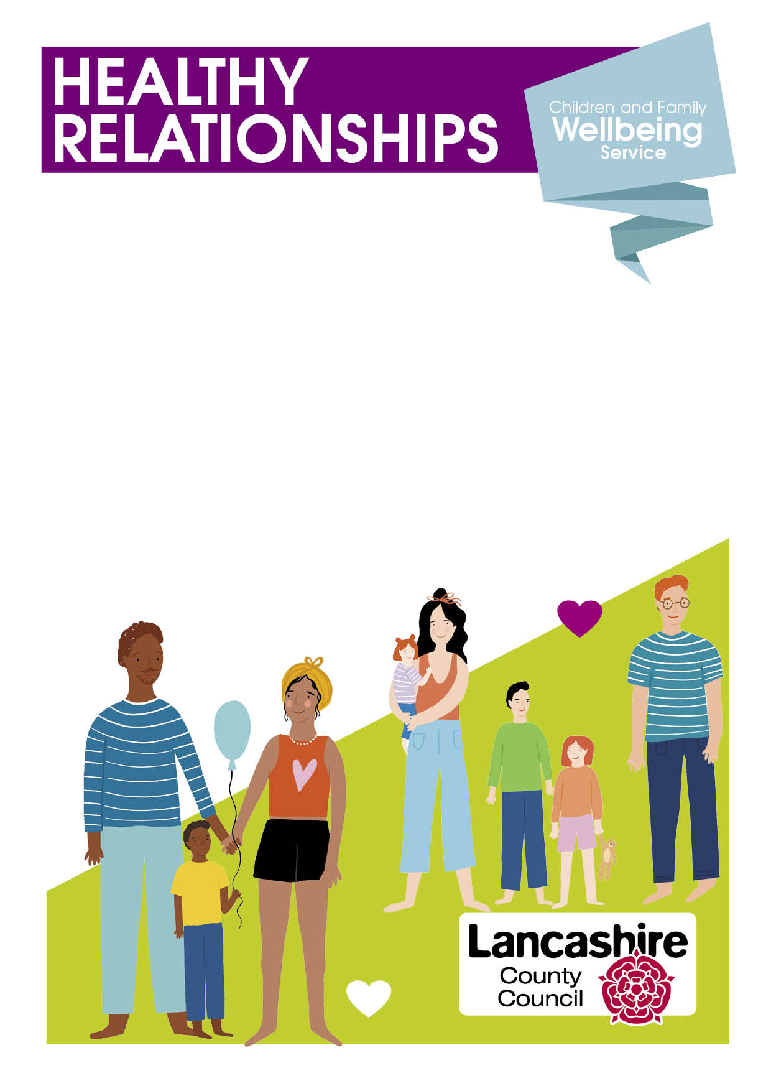
- Arguing about how to parent, money or
household tasks?
- Sulking, silent treatment or walking away?
- Are you using hurtful words, texts or social media against each other?
- Are you anxious or worried this is getting in the way of daily life?
- Worried about splitting up or have split up and struggling to agree?

4 week course for parents experiencing challenging times in their relationship, or just struggling to communicate positively.

Courses starting Tuesday 5th March or 16th April 9:30-11am
Lune Park Family Hub
For more info or to book on call:
01524 581280

