13th January 2020

Dear Parent or Carer

We hope you have all had a wonderful festive season and we wish you the very best for the New Year!

We would like to start off the New Year as positively as possible and ensure that all of our young people are meeting the same standards and expectations across the whole school. With this in mind we would like to take this opportunity to remind you about some of the school rules with regard to expectations and uniform.

School starts promptly at 8.40am. The majority of our pupils manage to arrive at school on time but those few pupils arriving late to registration will receive an after school detention on the same day. We understand that late buses are out of pupil’s control and in instances of this nature; pupils will be asked to sign in at Reception to be marked as present on arrival.

Unfortunately, if pupils arrive late to lessons it causes unfair disruption to the rest of the group, so pupils will continue to be monitored for punctuality to lessons. Pupils arriving 5 minutes or more late to lessons will receive a 20 minute detention on the same day.

The school uniform is as follows and can be purchased from Uniform and Leisure Ltd, on Common Garden Street, Lancaster:
• Black blazer with school logo
• Clip-on school tie (KS3 House tie available from school, KS4 from Uniform & Leisure)
• Black CLHS skirt only or black school trousers (leggings are not allowed)
• White shirt or blouse with top button fastened
• Black knitted V neck jumper (optional)
• Black or white socks or tights
• Plain black shoes (no trainers, no boots)
• Suitable outdoor coat (no denim, leather or hooded tracksuit tops etc.)
• Central Lancaster P.E. kit as supplied by uniform shop (hoodie is optional)
- False eyelashes are not allowed
- Nails must be neutral in colour and of natural length. False nails are not allowed.

There are a very small number of pupils who have provided official medical letters that state they cannot wear school shoes, for all other pupils we expect them to wear school shoes. We will always make attempts to support our pupils with issues about uniform and will provide pumps or shoes if they do not have school shoes. However, if they refuse to wear the provided footwear they will be put into Impact.

Research has shown that an increase in mobile phone use amongst young people is leading to deteriorating mental health and wellbeing. Sadly on some occasions, mobile phones have been used in anti-social behaviour leading to anxiety and emotional upset. For these reasons, mobile phones will not be permitted in the school building. Pupils will be allowed to have a mobile phone in their bag on silent for use to and from school. If a pupil is found to be using their mobile in school, it will be confiscated until the end of the school day. On the 4th instance, their mobile will be confiscated until parents/carers can come and collect it from school.

We appreciate your support in upholding our high expectations in school. Like you, we want the best for our pupils and know that by creating a positive and safe environment in school, our pupils will flourish. If you have any concerns about our expectations please do not hesitate to contact the school, your first point of contact being your child’s House Tutor.

Yours sincerely
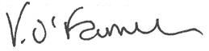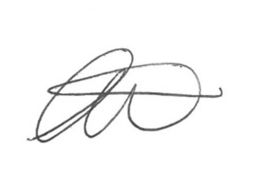
Victoria O’Farrell Lee Mackie
Acting Principal Acting Assistant Principal i/c Behaviour and Inclusion

