Unit R184
Contemporary Issues in Sport
Revision Pack

Sport Studies
Name:
Class:

Contents
Revision Checklist 3
1.1 – 1.3 User groups 4
Gender 5
Ethnic Groups 6
Retired people/Over 60’s 7
Families with children 8
Carers 9
People with family commitments 10
Young Children 11
Teenagers 12
People with disabilities 13
Parents (single or couples) 15
People who work 16
Unemployed/economically disadvantaged people 17
Factors which can impact the popularity of sport 18
1.5 Emerging/new sports in the UK 19
2.1 Values which can be promoted through sport 21
2.2 The Olympic and Paralympic Movement 23
2.3 Sporting values, initiatives and campaigns 25
2.4 The importance of etiquette and sporting behaviour 26
2.5 The use of performing enhancing drugs 27

Revision Checklist

 | Unit R184k  Contemporary issues in Sport |  |  | 
TA1 | Issues which affect participation in sport
1.1 | User groups
1.2 | Possible barriers
1.3 | Possible barrier solutions
1.4 | Factors which can impact the popularity of sport
1.5 | Emerging/new sports in the UK
TA2 | The role of sport in promoting values
2.1 | Values which can be promoted through sport
2.2 | The Olympic and Paralympic movement
2.3 | Sporting values, initiatives, and campaigns
2.4 | The importance of etiquette and sporting behaviour
2.5 | The use of performance enhancing drugs (PEDS) in sport

Topic Area 1 - Issues which affect participation in sport | 1.1 – 1.3 User groups
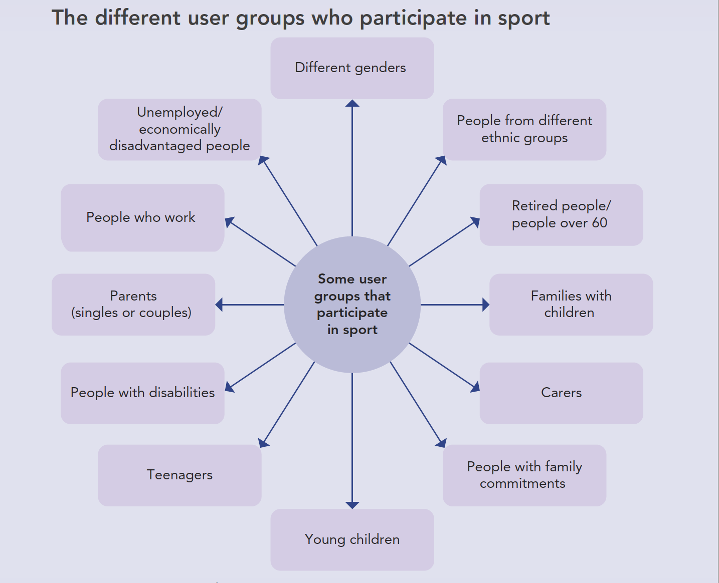

Revision tip: When asked a question on barriers to participation in physical activity and sport barriers remember the following generic barriers:
Transport / Access | Role Models | Disposable Income
Employment | Appropriate activity provision | Awareness
Media coverage | Appeal of alternative activities | Other commitments

Gender
Gender identity is how a person feels and who they know themselves to be. ​
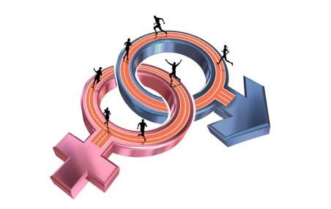
​There are more than two genders, although in relation to society and various cultures it is broadly related to being male or female.​
​Other possible examples of gender include transgender and gender neutral. ​

Barrier to participation
- Stereotypes – some sports can be stereotyped in terms of whom the sport is for and who should play it. This may lead to some genders to feel the sport is not appropriate for them.
- Gender Imbalance – when one gender is treated differently from another. For example media coverage may favour the version of a sport played by a certain gender, but equally the pundits providing analysis may not inspire others to participate in a sport as they can be predominately of one gender
- Lack of role models – linked to a lack of media coverage, positive role models for a gender group may not receive the same amount of coverage so do not inspire members of their gender to take part
- Sexist attitudes – sexist attitudes against a gender can make performers feel uncomfortable about taking part
- Imbalance in funding – certain genders may face an imbalance in funding whereby their gender group receives less funding for coaches, clubs, and competitions than other genders

Sporting Example | Before 2019, majority of England Rugby female players were not paid to play and had to support themselves by working a job while playing for England.

Solutions to barriers that affect participation in sport
- Targeted campaigns e.g. ‘This Girl Can’ created to attract women to sport
- Promotion of positive role models e.g., females playing traditionally male sports, as well as having pundits (commentators) from all genders
- Female or male only sessions
- Provision of specific clubs targeted at certain genders
- Programmes/activities that suit the gender
- Subsidised costs to participate (reduced rates for female-only sessions)
- No tolerance towards sexism. Acceptance that all genders can play sport.

Ethnic Groups
Ethnicity refers to the state of belonging to a group of people who identify with each other based on culture, language, traditions, ancestry, heritages, customs, or religion.
Barriers to participation:
- Lack of awareness or information – ethic groups might not know what sports activities are available for them
- Cultural norms and lack of provision – this may mean there is interests in sports which are not offered in the local area
- Lack of positive role models – there may be few positive role models from the same ethnic group to inspire others to take part
- Lack of coaches from that ethnic group – without coaches to inspire and teach younger children from an ethnic group, members of that group may not decide to attend
- Fear of discrimination / racism – potential discrimination or racism from people at clubs or facilities may prove to be a barrier to participation
- Language barriers – if English is a second language it might prove difficult to read adverts and rules written in English or understand coaches who do not speak the participants first language
- Stereotypes – stereotypically images may portray certain ethnicities in a manner which does not encourage participation
- Lack of media coverage / punditry – certain ethnicities may not receive as much media coverage as others and the pundits covering events may not come from those ethnic groups
- Religious beliefs – different religious beliefs or customs may prohibit competition or activity on certain days – certain dress codes that are not compatible with the typical sportswear used
Sporting Example | During the 2012 Olympics in London, the Iranian women’s football team was disqualified by FIFA, football’s world governing body, because the team showed up for the qualifying match wearing headscarves. ​  ​At the time, this was considered a safety concern and against FIFA’s dress code.​  This ban on headscarves has since been​ removed by FIFA.

Solutions to barriers that affect participation in sport
- Targeted campaigns to attract specific ethnic group
- Promotion of positive role models as well as having pundits (commentators) from all genders
- Subsidised transport links
- Programmes/activities and times which provide sports that appeal to a diverse range of ethnic groups
- Free or subsidised costs for minority ethnic groups
- Encourage integration among different cultures/ethnicities

Retired people/Over 60’s
Retirement is an option to stop performing regular work. Although you can retire at any age, most retired people receive the state pension. The government state pension is between 66-70 years old.
Barriers to participation:
- Lack of confidence – it may be a long time since the person has participated in physical activity
- Lack of fitness – they may lack fitness required to get started or to perform basic physical activities or skills
- Increased likelihood of illness – due to previous illness of injury, older people may be more prone to injury
- Limited access to transport – there may be lack of public transport available to get to a facility – some retired people rely on bus routes to travel
- Cannot afford the cost of participation – some older people only have a basic pension and very little disposable income
- Discrimination from others – they may be perceived by others as being too old to join in or participate and they may feel judged preventing them from attending
- Family commitments – due to caring commitments such as looking after grandchildren or a spouse, they may lack spare time to take part in sport
- Lack of self-esteem – some older people do not have self-belief to take part, and some might believe ‘those days are gone’
- Lack of appropriate activities for older people
Solutions to barriers that affect participation in sport:
- Targeted campaigns e.g., walking football
- Promotion of elderly role models
- Arrange sessions during the day when public transport is more readily available
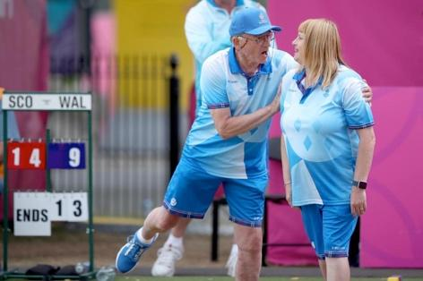
- Programmes/activities and times which provide sports which suit people over 60
- Subsidised costs/rates for over 60’s
- Gym sessions for a certain age only
- Positive representation of this age group in promotions
- Suitable times to suit retired people

Sporting Example | George Miller, Scottish bowls player became the oldest gold medallist in commonwealth games history after winning the para-bowls mixed pairs final in Summer 2022. He was 75 years old.

Families with children
Families with children face certain barriers to participation, largely due to the time pressure involved in raising a young family.
Barriers to participation:
- Family commitments – looking after children can be very time consuming and there is little time left for leisure pursuits
- Childcare costs – money often must be prioritised to childcare ahead of any leisure activity costs
- Limited childcare – If there is no creche at the sports centre it can be difficult for parents to find suitable childcare to allow them to take part in activities and exercise
- Transport issues – partner may need the car (if a one-car family)
- Lack of time – work and family commitments may be prioritised over sport activities and exercise
- Appeal of alternative leisure activities – it may be more appealing, for example, to attend parent-and-child groups or to meet up with other families than it is to exercise
- Partner may wish to exercise – it can be difficult to find time for both parents to exercise – one partner may be able to exercise more than the other due to commitments
Solutions to barriers that affect participation in sport:
- Targeted campaigns to encourage families to take part
- Promotion of role models who balance family commitments with sporting commitments (Bianca Williams – GB Athlete)
- Availability of free/affordable creches in leisure centres
- Provide cheap transport
- Programmes/activities and times that suit families, including the provision of parent-toddler sessions
- Subsidised cost of activities and equipment / free kids / family discount
- Provide a soft play provision
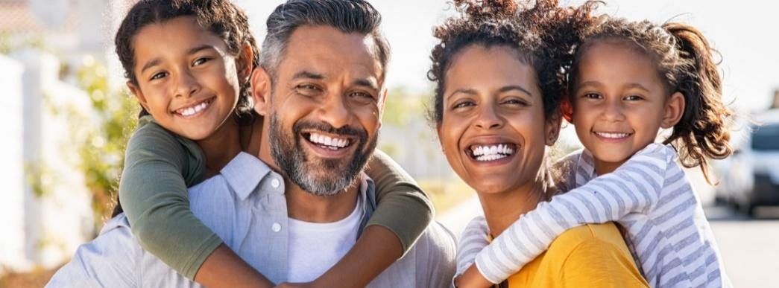

Carers
Carers can be adults or children who care for relatives, elderly people, parents, siblings or dependent others.
Barriers to participation:
- Commitments - the commitment to care for a relative is likely to be a priority so opportunities to take part in sport may be limited
- Lack of time – caring for people can be very time consuming and leave little time for leisure pursuits
- Lack of disposable income – carers may need to give up work to care for their family member so may not have the disposable income to take part in sport
- Lack of appropriate activity options – carers may only have certain times in the day that they can exercise so the options available may be limited
Solutions to barriers that affect participation in sport:
- Targeted campaigns to attract carers
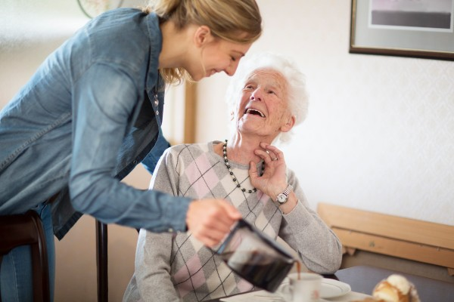
- Promotion of role models who balancing caring and sporting performance
- Possibility to exercise at home (online gym classes)
- Programmes/activities and times to suit carers
- Access to subsidised clubs
- Online participation or support network to free up time

People with family commitments
Commitments to family members can vary from person to person. However, people with such commitments can face barriers to participation.
Barriers to participation:
- Childcare costs of dependants – this often means that money has to be prioritised to childcare ahead of any leisure activity costs
- No creche or childcare at the sports centre – nowhere for the children to go while their parents are exercising
- Transport issues – the use of any transport the family has may need to be prioritised for other commitments, such as child’s sports clubs
- Lack of time – time is prioritised to other family commitments
- Lack of disposable income – any disposable income may need to be spend on other family members rather than on the person

Solutions to barriers that affect participation in sport:
- Better promotion of available activities
- Promote role models who balance raising a child with sport commitments
- Availability of creche in leisure centre
- Provide (cheap) transport
- Programmes/activities and times that suit families, including the provision of parent-toddler sessions
- Subsidised cost / free kids / family discount
- Free public facilities for parents and children (gym equipment in local park)
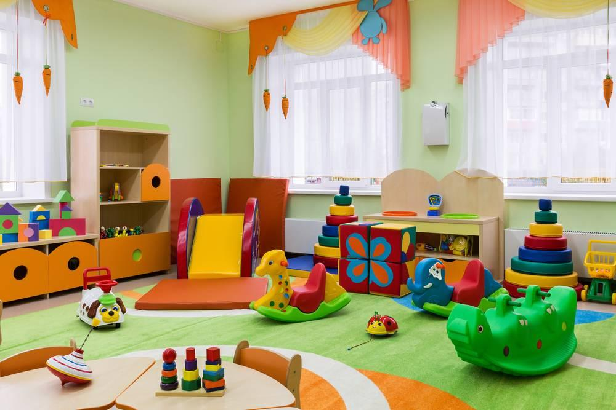
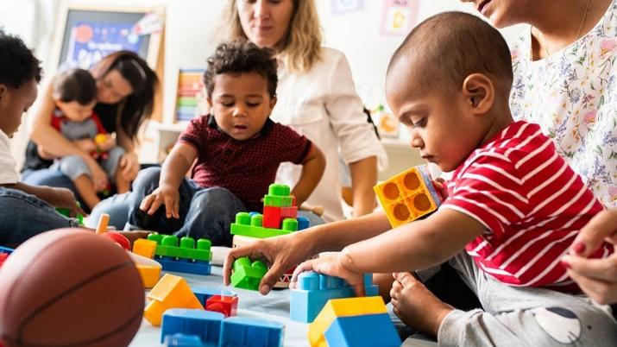

Young Children
Young children are between 0 years old and 11 years old.
Barriers to participation:
- Lack of role models – important sporting role models for children are often family members, and if there aren’t any role models in the family, then the child might not be encouraged to take part/ join a local club
- Lack of awareness – children may not know what clubs or activities are available
- Lack of money/disposable income – a child will not have a job or obvious source of income and so is likely to be reliant on parental contribution
- Lack of access to facilities/transport – children may not be allowed to travel on their own so are reliant on being transported
- Lack of appropriate activities options – there may be lack of interesting, suitable, child-friendly activities for young children to take part in
- Negative attitude towards participation – some children would rather do something else that is deemed ‘cooler’, more adventurous or they simply ‘can’t be bothered’ to do physical exercise
- Distractions – children may get distracted watching television, using laptops or mobile phones
- School / homework commitments – the child may prioritise schoolwork ahead of leisure pursuits
Solutions to barriers that affect participation in sport:
- Targeted promotion of available activities for children
- Promotion of positive role models for children
- Reduce restrictions on when children can attend
- Children-only clubs
- Free/cost effective sessions for children
- After school / holiday sports activity clubs

Teenagers
Teenagers are aged between 12 years old and 18 years old – some of the barriers are similar to young children.
Barriers to participation:
- Lack of role models to inspire the user group – very few sporting teenagers are seen as positive role models
- Lack of awareness that suitable activities for teenagers exist – few teenagers involved in sport receive media coverage
- Lack of money/disposable income – teenagers may not be able to afford entry/equipment/membership to take part in more appealing sports – disposable income may be spent on other interests
- Lack of access to facilities/transport – cannot drive yet
- Lack of appropriate activities options
- Negative attitude towards participation – some children would rather do something else that is deemed ‘cooler’, more adventurous or they simply ‘can’t be bothered’ to do physical exercise
- Poor body image – at this age many children do not want to wear or be seen in sports clothing
- Peer pressure to undertake alternative, more sedentary activities (socialising or gaming)
- School / homework commitments – a teenager may prioritise homework towards exams or assessments rather than commit time to take part in sport activities
Solutions to barriers that affect participation in sport:
- Better promotion of available activities for teenagers
- Offer free taster sessions
- Produce targeted marketing via social media
- Promotion of positive role models for teenagers
- Subsidised or free transport to leisure facilities
- Programmes/activities and times to suit teenagers
- Competitive and non-competitive provision
- Free/student prices for teenagers
- Incentives or rewards for sustained involvement (through apps)
- Opportunities to participate outside of school hours

People with disabilities
People with disabilities have a physical or mental condition that can affect their ability to carry out movement, use different senses or undertake everyday activities. There is a range of classifications of disability, each of which face barriers to participation.
This range includes:
- Visual impairment
- Deafness or being hard of hearing
- Mental health conditions
- Intellectual disability
- Disability due to an acquired brain injury
- Autism spectrum disorder
- Physical disability

Barriers to participation:
- Lack of access to specialist facilities – may not be available locally
- Lack of access to specialist equipment – may not be available at their local leisure centre
- Lack of transport – specialist transport may be needed e.g., wheelchair users to get to sports centre
- Few role models – there is a lack of media coverage showing elite para-athletes
- Cost of equipment/participation charges – specialist equipment may come with high charges
- No suitable programmes session – no provision for disabled activities, lack of suitable adapted activities, no suitable clubs, no information available
- Lack of mobility/not physically able to do the sport – the level of disability makes participation more difficult
- Discrimination/view of others
- Lack of specialist staff – specialists with knowledge of disability are needed to supervise or coach specialist club or activities
- Lack of confidence/lack of self-esteem

Solutions to barriers that affect participation in sport:
- Promotion of disabled-only events
- Media coverage of disabled sport
- Promote role models and pundits with disabilities
- Wheelchair access / disabled parking bays
- Provision of transport for disabled users
- Separate sessions e.g., wheelchair basketball
- Ensure provision of specialist equipment e.g., ball with bell inside
- More specialist coaches
- Subsidised sessions / specialist equipment
- Signs written in braille
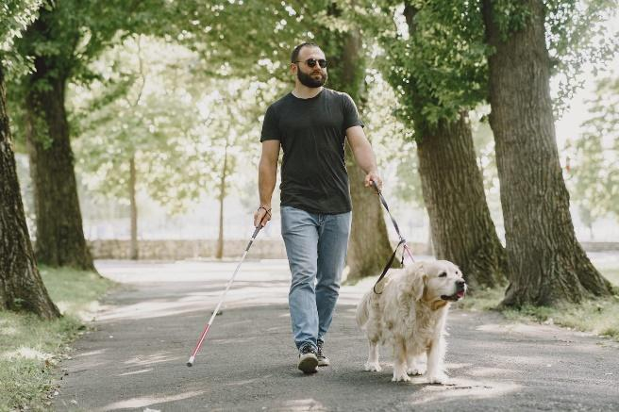

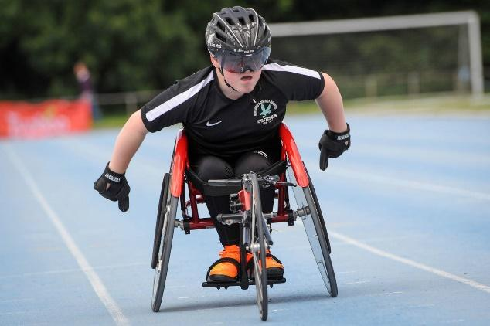

Parents (single or couples)
Parents of children must allocate appropriate amounts of their time to ensuring their children are cared for. A single parent is classes as any adult who is bringing up a child/children on their own.
Parents (single or couples) face similar barriers to the user group ‘people with children’ but single parents do not have a partner to help them out.
Barriers to participation:
- Parenting commitments – a single parent may lack time to participate in sport activities as looking after children can be very time consuming
- Childcare costs – money often must be prioritised to childcare ahead of any leisure activity costs
- Limited childcare – If there is no creche at the sports centre it can be difficult for parents to find suitable childcare to allow them to take part in activities and exercise
- Transport issues – the single parent may not have access to a car or the income to use public transport
- Lack of time – work and family commitments may be prioritised over sport activities and exercise
- Appeal of alternative leisure activities – it may be more appealing, for example, to attend parent-and-child groups or to meet up with other families than it is to exercise
- Lack of role models – there are few single-parent role models who make elite level in sport
Solutions to barriers that affect participation in sport:
- Better promotion of available activities outside of working hours
- Promotion of positive role models
- Workplace gyms / work based running clubs
- Provision of singles club / twilight (out of work time) sessions
- Subsidised membership through work or medical schemes
- Medical cover with health and fitness incentives

People who work
Most adults have a job and work for a living. They face the pressures and demands of the world of work and often struggle to find time to take part in physical activity.
Barriers to participation:
- Commitment to work
- Lack of time – mainly due to work
- Fatigue/tiredness – due to excessive work hours
- Unsuitable timing of activities – some sporting activities cannot be attended as they are only available during working hours
- Lack of provision – provision local to work or home may be limited or at unsuitable times
- Transport issues – may work in the city and be unable to travel easily to facilities
- Appeal of alternative activities – work events

Solutions to barriers that affect participation in sport:
- Better promotion of available activities outside of working hours
- Promotion of positive role models
- Workplace gyms / work based running clubs
- Provision of singles club / twilight (out of work time) sessions
- Subsidised membership through work or medical schemes
- Medical cover with health and fitness incentives


Unemployed/economically disadvantaged people

Barriers to participation:
- Lack of disposable income – low income due to unemployed or economically disadvantaged status may mean an individual is not able to afford membership to take part in a sport
- Lack of transport – an unemployed or economically disadvantaged person may not have a car or money to pay for transport to facilities
- Other priorities – spending the time finding a job
- Cost of equipment – many sports require specialist equipment which comes at a cost
- Lack of awareness - unemployed or economically disadvantaged people may be unaware of activities or opportunities that are subsidised, cheap or free

Solutions to barriers that affect participation in sport:
- Targeted promotion of available activities that are subsidised or cheap
- Promotion of positive role models
- Subsidised or free transport to leisure facilities
- Offer schemes/activities specifically aimed at the unemployed
- Offer free/reduced cost activities
- Offer free/discounted equipment

Revision tip: When asked a question on solutions to these barriers remember these SIX solutions
Targeted Promotion | Role Models | Access
Provision | Cost | Other Solutions (specific to user group)

Topic Area 1 - Issues which affect participation in sport | 1.4 Factors which can impact the popularity of sport

Positive and negative impacts on popularity
Factor | Example of positive or negative impact
Number of people participating | - More people that take part in a sport = more popular it becomes  - Media coverage can impact this  - British success in Olympic Games  - Tour De France – shown on TV - Low cost / ease of getting involved in cycling
Provision of facilities / appropriate climate | - People are more likely to participate in and watch sports if they can access facilities close to where they live  - Example – people in Scotland can take part in winter sports in real conditions within the UK because they are closer to the mountains / colder climate
Live spectator opportunities | - Living near a rugby stadium where a professional team play could lead to a person participating because they can see it and be inspired by the professional players
Amount and range of media coverage | - The more sport is in the media or in the news the more likely it is that people will want to play it  - Example – men’s football gets more coverage than other sports, whereas some sports such as Boccia or Lacrosse get little or no TV coverage
Level of success | - The success of individual sports people can lead to an increase in popularity  - Example – when Andy Murray won the 2013 Wimbledon Tennis Championships more people in the UK started playing tennis
Number and range of role models | - When Team GB won a gold medal in women’s hockey at the Rio 2016 Olympic Games, the players became role models overnight and the number of people playing hockey increased in the UK
Social Acceptability | - Boxing has not always been socially acceptable because some people think it is violent  - Horse racing is another example of a sport that is often classed as socially unacceptable in the UK due to animal cruelty

Topic Area 1 - Issues which affect participation in sport | 1.5 Emerging/new sports in the UK

The world of sport is dynamic in that new sports can start up and sports which have been popular in the past start to emerge and increase in popularity

Handball is becoming more popular in the UK, although GB handball teams have not yet been successful in international competitions. ​ | 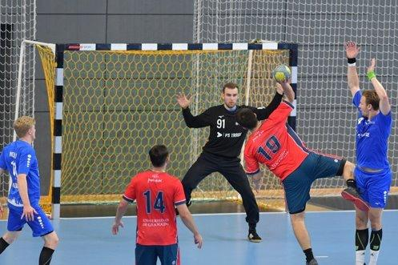
The reasons for handballs growing popularity include:
- Players feel more involved because smaller team / pitch sizes means they are more likely to have contact with the ball compared to sports like football.

- It can be played by all ages and abilities​ | - It allows players to use skills found in other sports, such as passing ​
- It is an Olympic sport, so it receives media attention​ | - It can be played without specialist equipment (could use smaller footballs/volleyballs)​

Footgolf is a growing and popular sport in the UK. About 30,000 people play footgolf in the UK every week, with more than 200 affiliated footgolf courses, some which are adapted from traditional golf courses. ​ | 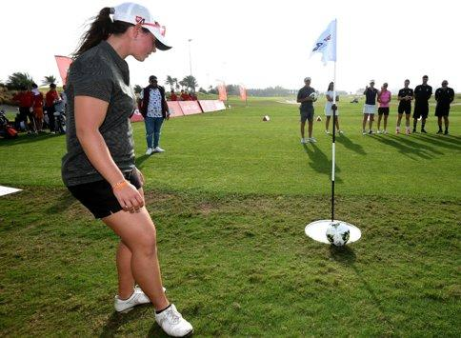
The reasons for footgolf’s growing popularity include:
- It is cheaper to play than golf and doesn’t require golf clubs
- It has an National Governing Body (NGB) – UK Footgolf Association and a World Cup. ​ | - It can be played by all ages and abilities​ ​

Padel is a racket sport like tennis and is mainly played in doubles on a court that is one-third the size of a tennis court. ​ | 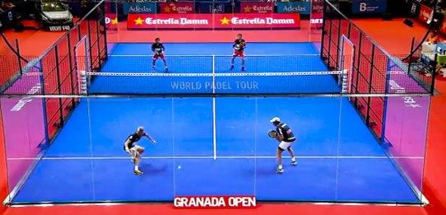
The reasons for padel’s growing popularity include:
- It was incorporated into the Lawn Tennis Association (LTA) in 2019.​
- Anyone can play Padel regardless of age or ability – it is easy for beginners to pick up | However, Padel is still growing and therefore not reached maximum popularity.  This could be because: ​  - Equipment can be expensive ​
- There are more than 89,000 active Padel players across the UK and this number is increasing. ​ | - There are only around 65 Padel clubs (250 courts) in the UK, so not everyone can access it easily – they are looking to expand this to 400 courts by the end of this year​

Ultimate Frisbee is a non-contact sport played by two teams of seven on a large rectangular pitch, outside or in a hall with no referee | 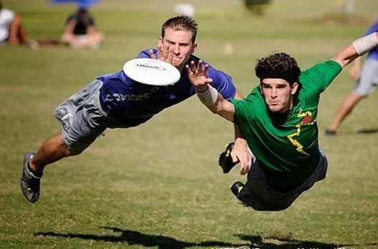
The reasons for ultimate frisbee’s growing popularity include:
- The number of clubs is growing, but it is easy to set up a game with enough people and space ​
- It has an National Governing Body (NGB) – UK Ultimate, who arrange leagues and tournaments | - It doesn’t involve expensive equipment and is easy to learn for all ages and abilities ​ ​

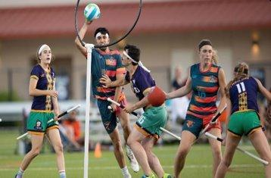
REMEMBER – Sports which are growing and emerging will change from year to year so you will need to ensure you are kept up to date with current trends

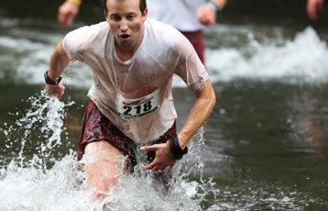
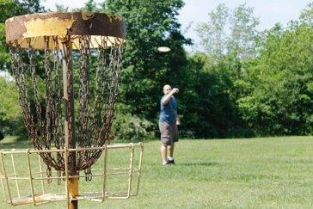
Topic Area 2 - The role of sport in promoting values | 2.1 Values which can be promoted through sport


Team Spirit
Supporting fellow team or squad members and working together to reach a common goal
Fair Play
When the performer follows the rules and sporting etiquette and does not cheat
Tolerance and Respect
Seen as one value. Relates to showing a greater understanding of other performers from different cultures and ethnicities
Inclusion
The idea that there should be equal opportunities for all social groups in society to take part in sport
Excellence
Performers striving to be the best that they can be in their chosen activity



Citizenship
How people act as a good citizen of their community by creating community links and community spirits
National Pride
Creating a feeling of togetherness and unity within the whole population in their support of their country





Sporting Values - Sport Specific Examples
Team Spirit - The British and Irish Lions rugby team come together every four years. Players are selected from different clubs and countries, however, when they play as the Lions against other countries’ teams, the players work together and support each other to try to defeat the opposition. ​
Fair Play - If a tennis player is ready to serve and their opponent is using time to collect their towel when they should be ready to receive the ball, the opponent might not be demonstrating fair play. ​
Tolerance and Respect - During the 2020 Men’s Euro’s, three black England football players were racially abused online after missing penalties in the final. ​Other England players spoke out. ​Some fans showed their tolerance and respect for the players by covering a defaced mural of Rashford with flowers, poems, and positive messages. ​
Inclusion - ‘This Girl Can’ is a campaign that aims to encourage women and girls whatever their abilities and background to get active.
Citizenship - Anthony Joshua invested money into his childhood boxing club in north London. He often visits the club to help and to inspire young people in boxing.
National Pride - When the cyclist Geraint Thomas took part in the Tour de France in 2018, there was lots of support for him in his home country of Wales. Even people who knew nothing about cycling made flags and banners and supported, which brought people together.
Excellence - Rowers must commit to demanding training schedule to maintain their highest standard of performance.​

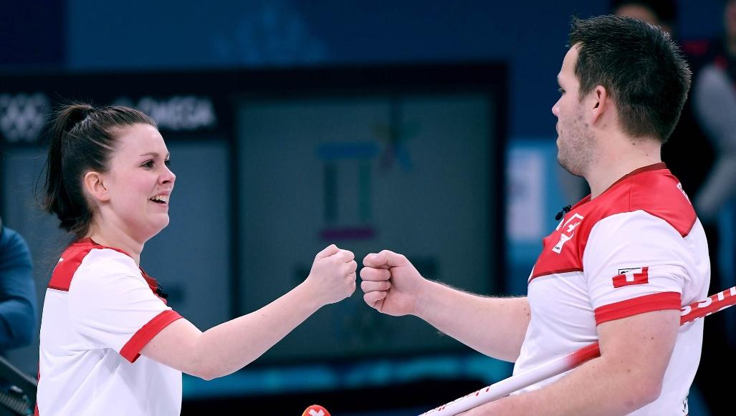

Topic Area 2 - The role of sport in promoting values | 2.2 The Olympic and Paralympic Movement
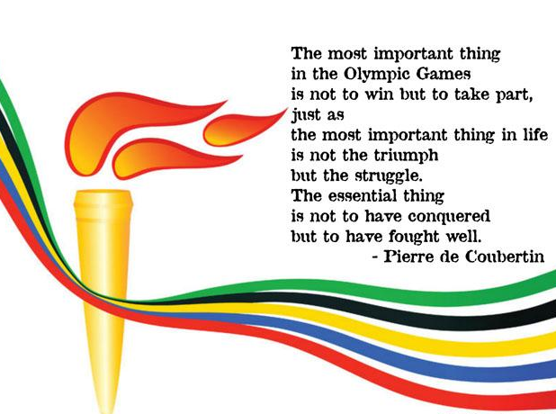
The Olympic Creed
This is designed to provide a moral message about taking part, emphasising that life is like sport in that there will be struggles, but what is important is that you try your best to deal with these struggles.
Pierre de Coubertin – Founder of IOC and modern Olympic Games in 1908

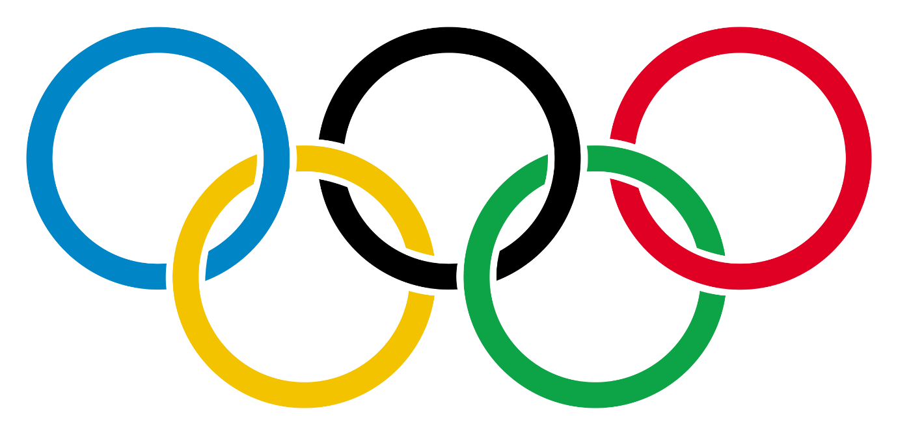
The Olympic Symbol
- Pierre De Coubertin created the Olympic symbol in 1913
- Each ring represents the five continents that produce Olympic athletes – Africa, the Americas, Asia, Europe and Oceania
- The rings interlock to demonstrate the closeness of continents
- The different colours on a white background represent the fact that the Olympic values are universal, because the colours are used in many of the world’s national flags

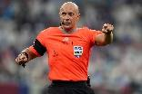
Olympic Values
Respect | Respecting the rules, the officials, the opposition, each nation, and oneself
Excellence | Somebody doing the best that they can in sport and in life
Friendship | Using sport to develop understanding between nations and cultures for athletes, spectators, and citizens
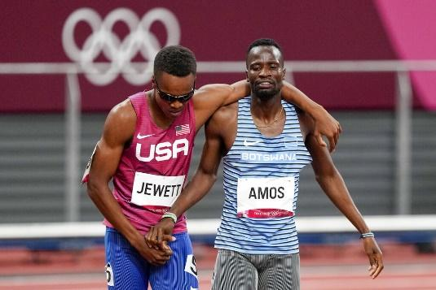
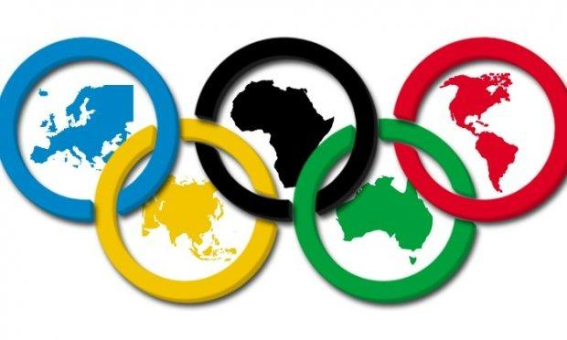
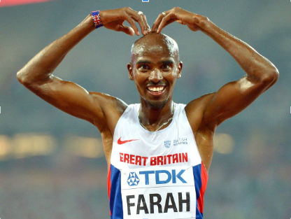

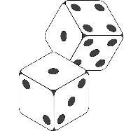
Paralympic Values
Determination | Having the strength to overcome barriers to train and compete at the highest level. Paralympic athletes push themselves to their limits to achieve their aim.
Inspiration | Being a positive role model to others, by taking part or by achieving success.
Courage | Overcoming difficulties to compete in their event. Paralympic athletes rise above their circumstances to show what they are capable of
Equality | Celebrating diversity and showing that difference is a strength.
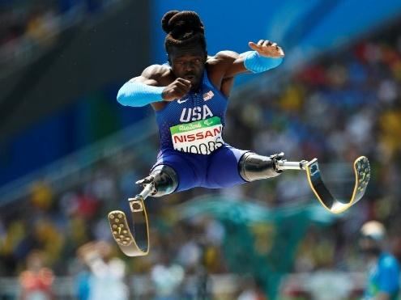
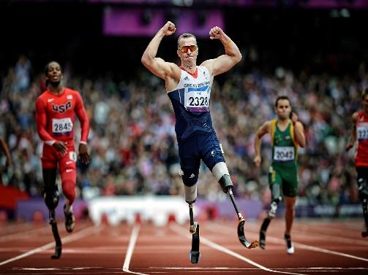
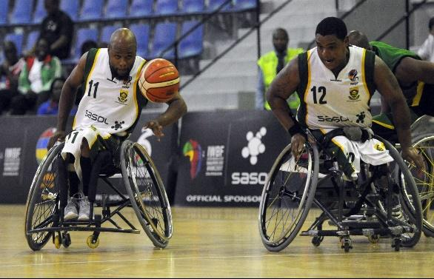

Topic Area 2 - The role of sport in promoting values | 2.3 Sporting values, initiatives and campaigns

Initiatives, campaigns and events to promote sporting values can occur at local, regional and national levels

Local level - Sports clubs and those who run the club may decide to actively promote values. ​
​
Regional level - The Yorkshire Sport Foundation launched a campaign called ‘Mum’s Team’ to encourage citizenship among the mums of Yorkshire.​

National level - Many local and regional campaigns happen as a result of larger national campaigns​

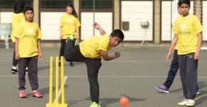



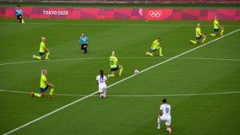


Remember - It is important to keep up to date with current initiatives

Topic Area 2 - The role of sport in promoting values | 2.4 The importance of etiquette and sporting behaviour

Sporting behaviour is behaving in a way that shows sportsmanship.
Etiquette and appropriate sporting behaviour holds great importance in ensuring sport is far and is played in an appropriate manner. ​

- Having appropriate manners while playing sport​
- Respecting your opponent/s while playing sport​
- Trying your hardest within the rules of the sport ​
- Ensuring the safety of themselves and other performers
- Performing in a fair way
- Acting as a positive role model
- Maintaining silence at appropriate times whilst their opponent takes their turn
- Being respectful to those in their own and the opposition team
- Promoting positive sporting values
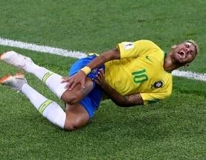
​
Sportsmanship means playing fairly by the rules
- Clapping an opposition’s goal
- Shaking hands before and after a game
- Not using gamesmanship in order to gain an unfair advantage
- Ensuring that any comments made to an opponent are appropriate
- Respecting opposition, referee and coaches

Gamesmanship means bending the rules to gain an advantage
- Taking a long time to collect the ball to waste time in football
- Re-tying shoelaces when an opponent is above to serve in tennis with the intention of putting them off
- Grunting when a playing a tennis shot (may put your opponent off)
- Taking a long time to set a scrum position in rugby

Spectator Etiquette
Spectators have to play a part to ensure that other spectators and players enjoy the sport in an appropriate and safe way.

Positive spectator etiquette:
- Being quiet when a tennis player is about to serve
- Respecting other countries national anthem
- Spectators not entering the playing area

Negative spectator etiquette:
- Booing / shouting abuse at the referee’s decision
- Shouting abuse at players/athletes
- Pitch-invading
- Talking while a rugby player takes a conversion

Topic Area 2 - The role of sport in promoting values | 2.5 The use of performing enhancing drugs

Performance enhancing drugs (PEDs) are any substance that are used to improve any form of activity performance in humans. Sometimes these substances are prohibited (banned) and take against the rules and regulations.

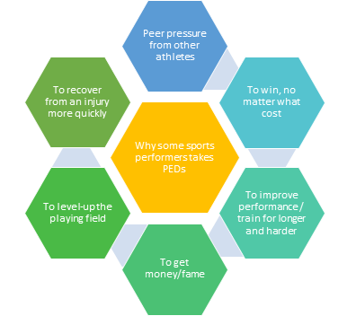
Why might performers take performance enhancing drugs (PEDs)?

Athletes caught taking PEDs:
- Lance Armstrong (Cyclist)
- CJ Ujah (GB Relay Team)
- Dwain Chambers (sprinter)
- David Millar (cyclist)

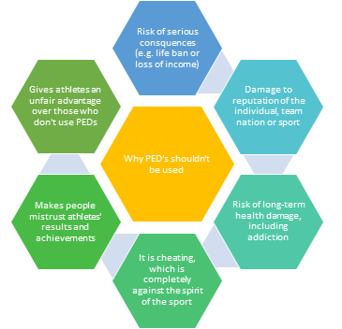
What is wrong with taking performance enhancing drugs (PEDs)?

Remember
- There are many reasons as to why sports performers shouldn’t use PEDs
- Sanctions for the use of PEDs include lifetime bans and loss of trophies or medals
- Performers may also lose earnings and sponsors
- Even though the risks are huge, some performers will still decide to use PEDs to achieve their goal


World Anti-Doping Agency (WADA)
The World Anti-Doping Agency was founded in 1999 and it aims to ensure a drug-free sporting environment all over the world. It is funded by sports organisations and governments, with its main activities being scientific research, education, development, and monitoring of anti-doping methods.

The Whereabouts Rule
- This is WADA’s main strategy to make elite sport a PED-free environment
- Selected athletes must be available for random drug-testing at any time

Athletes must:
- Always provide information about their location (when they are not competing)
- Provide information about their overnight accommodation
- Provide details of their training and competition schedules
- Be available for testing at pre-agreed place for one hour every day
- Understand that missing three tests in one year will result in a sanction



Drug tests are carried out by officials under close supervision in a laboratory.

The test samples can be blood, urine, hair or nails.




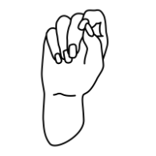

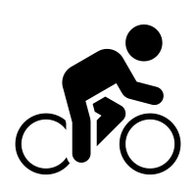
Sporting Example
In 2016, Team GB Cyclist Lizzie Deignan missed three random drug tests in one year and was at risk of being banned from competition for FOUR years. She argued that she only missed the first test because the tester didn’t try hard enough to contact her. Arbitrators agreed that it wasn’t her fault, and she did not receive a sanction.

