
 | The Central Line on Classroom Practice
 | Retrieval Practice – What is Learning?
Willingham’s Model of Memory
WHY? |  | HOW? | WHAT?
It is important to understand this model well in order to:  - Secure students’ learning in the long-term memory.  - Structure our lessons in a way that facilitates attention.  - Plan and scaffold our practice over time. |  | In the classroom, this is what attention to Willingham’s model of memory may look like:  - Instructions are succinct and scaffolded.  - Students are facing the front and not getting distracted.  - The environment is clutter free.  - There is no redundant visuals cluttering our presentations.  - Students practise what they learn.  - Many questions are asked to clarify and check understanding.  - The teacher offers directed and focused verbal feedback to students.  - Students practise remembering and self-test. | Willingham’s model of memory shows us the different stages in the process of learning: from securing the correct environment for learning, to facilitating the transfer from working-memory to long-term memory, to securing knowledge through retrieval.  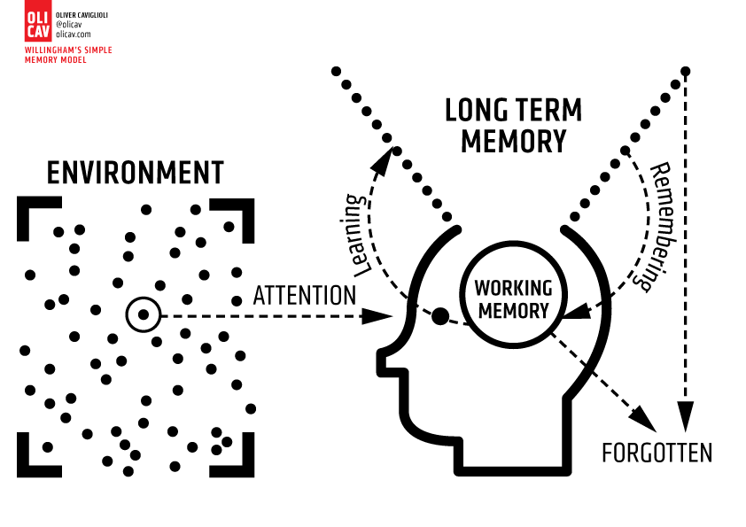
Cognitive Load Theory
WHY? |  | HOW? | WHAT?
It is important to understand this theory in order to:  - Consider very carefully what the optimum amount to introduce in a lesson should be.  - Ensure students can access the work and grow in confidence.  - Ensure we limit as much as we can distractions in the classroom.  - Plan for practice at regular intervals so shift learning from short- term to long-term memory. |  | In the classroom, it may look like this:  - Aide memoires such as glossaries or knowledge organisers are offered.  - Only a small amount of new information is introduced at a time.  - Any introduction of content is quickly followed by practice.  - Instructions are kept succinct and ideally also displayed and sequenced clearly.  - The use of diagrams alongside text can reduce the load.  - The slides we use are clutter free. | Cognitive Load theory  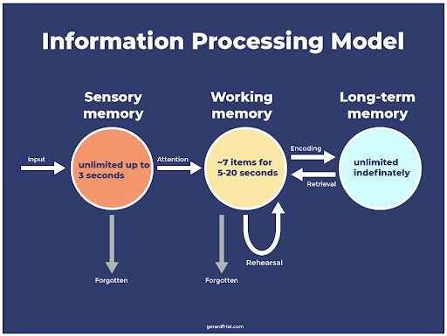  It is based on the work of John Sweller. This theory says that because short-term memory is limited, learning experiences should be designed to reduce working memory ‘load’ in order to promote schema acquisition.
Dual Coding
WHY? |  | HOW? | WHAT?
When talking to your class, your students will try to remember what you are saying. Much of what you say is forgotten quickly as our working memory can only hold so much at a time. Dual coding helps the amount of information that is recalled.  Combining both verbal (auditory channel) and visual representations gives you two ways to remember information later on.  For instance talking whilst a text is displayed on a slide can create an overload and a distraction whilst talking over a diagram or picture will be beneficial to help students make connections and develop a mental representation. |  | - Combine visuals with text- diagrams, pictures and definition for instance.  - Try using different ways to represent the information visually: infographic, timeline, cartoon strip, diagrams, icons, symbols…  - Looking at visuals and using your own words to describe/ analyse it.  - Remove redundant information on materials you are using with students.  - Use visual cues such as pictures or videos for retrieval.  - Teacher explain ideas slowly to make sure students can see how visuals fit with explanation.  - Treat written words and spoken words as the same thing. Your brain treats them both as verbal communication. Only use one at a time with your students.  - Don’t try to use written text as a visual representation. | Dual coding is about combining verbal material with visuals in your teaching practice. However, keep it simple: combining more than two types of multimedia can be detrimental for your students.  Dual coding means giving your students verbal and visual representations at the same time. This lets them process the knowledge in two different ways. Using it in your classroom can boost students' learning and help them retain information over time  