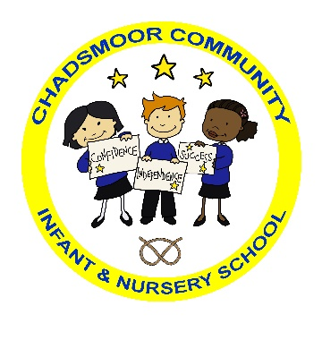

The Federation of

Chadsmoor Community Infant and Nursery School

and

Chadsmoor C.E (VC) Junior School

Executive Headteacher: Mrs J Westley (BA (Hons) QTS, NPQH)

Email: [infantoffice@chadsmoorfed.staffs.sch.uk](mailto:infantoffice@chadsmoorfed.staffs.sch.uk)

Website: www.chadsmoorfed.staffs.sch.uk

Kingsway, Chadsmoor, Cannock, Staffs. WS11 6EU

Telephone 01543 570718

Email: [junioroffice@chadsmoorfed.staffs.sch.uk](mailto:junioroffice@chadsmoorfed.staffs.sch.uk)

Website: www.chadsmoorfed.staffs.sch.uk

Burns Street, Chadsmoor, Cannock, Staffs, WS11 6DR

Telephone: 01543 758607

Governing is a way to volunteer your time for a school and a community. A governing board can be made up of all adult ages. Some are retired, some work full and part-time, some are parents, grandparents or those who just want to support the local school and community.

Governing is a voluntary role so it’s not paid. You don’t need to know how a school works. Support and training will be given. This isn’t a role where you will be working with children but you will be expected to visit the school and check that pupils are receiving a good education. Sometimes difficult decisions have to be made but experience of this can be useful in other areas and careers.

Job Description – School Governor Responsibilities

* Attend meetings
* Visit the school
* Serve on a committee
* Be attached to an area of the school’s work
* Take part in making decisions on the Governing Body
* Undertake training and development
* Work within an agreed code of conduct
* Represent the school within the local community
* Represent the local community on the Governing Body
* Maintain confidentially as required

**A Person Specification**

* Caring
* Committed to the values of the school
* Attend meetings regularly
* Read paperwork before meetings
* Asks questions
* Commitment of offering time
* Willingness to undergo training and development
* Prepared to work as a member of a team
* Willing to contribute to school development and improvement
* Reliable
* Honest.

There are different types of governors:

**Co-opted** – will be voted on by the board due to the skills and experience they will bring.

**Foundation** – governors who are there as part of the school being a faith school.

**Parent governor** – elected by parents. They must have a child at the school at the time of election. The role of a parent governor is not as a spokesperson for the views of parents. They are the same as any other governor on the board, providing a ‘*parental viewpoint*’

If you would be interested in becoming a governor please contact [infantoffice2@chadsmoorfed.staffs.sch.uk](mailto:infantoffice2@chadsmoorfed.staffs.sch.uk) . More information will be given and you will be invited to visit the school and meet with the Chair of Governors.