All About Me
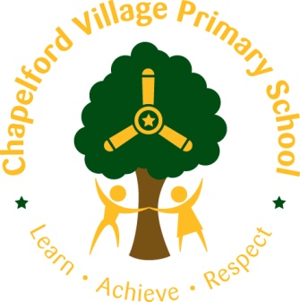

Name –
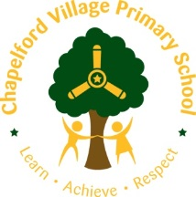
This is a picture of me.

My name is …………………………………
I was born in ……………………………….
I live with ……………………………………
Before I started school I went to ………
…………………………………………………..
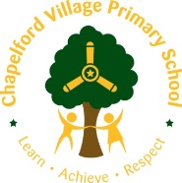

I have ………….. brothers aged ………….
They are called ……………………………..

I have ………….. sisters aged …………….
They are called ……………………………..
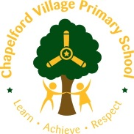
My favourite things!
(Please talk to your child about the things on this page)
On my own I like to…..

With my friends I like to …..

My favourite toys and games are …..

My favourite songs and rhymes are …..

My favourite stories are ….

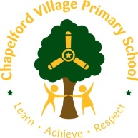
Things I am good at!

I am really good at ……

Recognise some letters
Use Scissors
I can share my toys
Put on my coat by myself
Get dressed by myself
Recognise some numbers
Go to the toilet myself
Use a knife and fork
Read some words
Count ___ things

I am learning to ….

Write my name
Join in with rhymes and poems

Share and take turns
Ride my bike or scooter

I may get worried or upset by ….

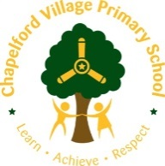
Personal Details

First language of child

First language of Parents

Language/s spoken at home

Who will bring your child to school?

Who will collect your child?

Is your child able to go to the toilet alone?

Has your child been involved in any Nursery pre-school groups?

Has your child any health problems or food allergies?

Have there been any problems or concerns in your child’s development?

Has your child been identified as having any special educational need?

Have any other agencies been involved with your child? (i.e. speech and language)

Signature required …………………………………….

