General

**PLEASE put your child’s name on ALL items of clothing, bags, lunchboxes and shoes, including P.E. kit.**

Children are not permitted to bring in toys from home. This can become a distraction when learning is taking place and it can also cause upset if lost or damaged. We do ‘show and tell’ each day before home time to allow children to share news or show special items from home. This could include something they have made or drawn, achievements out of school eg certificates, medals etc or simply some news about somewhere they have been or are going to.

We are now using our online learning journey Tapestry. If you haven’t received an email to set up your account, please see your child’s class teacher and we will get you set up.

Children need to have a named water bottle in school every day, which they will bring home to be washed each night. Please ensure this is water only and not sugary drinks, as this is school policy. Could you all ensure that children carry their water bottles separately and they are not placed in book bags.

**Dates for the diary:**

EYFS pirate day Friday 8th October

If you have any concerns, questions or queries please do not hesitate to contact your child’s class teacher.

Thank you for your continued support,

EYFS Team

**EYFS Autumn term **

**Welcome Reception parents!**

The children have made a fantastic start in settling into their new classes and it is lovely to see them starting to make new friends already.

We wanted to share with you some of the things we will be getting up to this half term.

## Numeracy

Our work in numeracy this half term will include:

* Sorting into groups
* Matching
* Comparing amounts
* Compare size, mass and capacity
* Exploring pattern

Learning Challenge

During our Learning Challenge this half term we will also be looking at the topic 'All about me'. We will look at what makes us different, why we are special, parts of the body, who is in our family, where we live and our local community.

Physical Education:

Children should now have an PE kit in school. PE kits will be sent home at the end of each half term for a wash. Please find below the details of which day of the week your child will have PE lessons.

Class 1 - Tuesday,

Class 2 - Wednesday

Class 3 - Thursday.

If your child wears earrings and cannot remove themselves, *please* remove them on P.E. days as staff are not permitted to do this. Alternatively, send in some surgical tape to cover up earrings. We are trying to encourage the children to be independent learners so it would be great if they could practice getting dressed themselves. All items in PE kits should be clearly labelled with your child’s name.

.

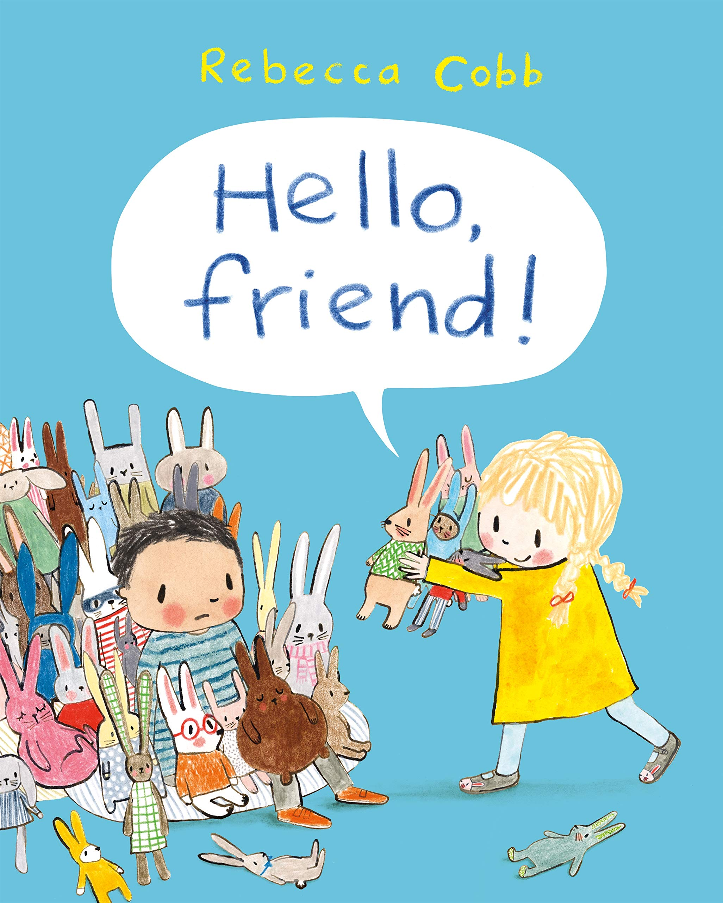 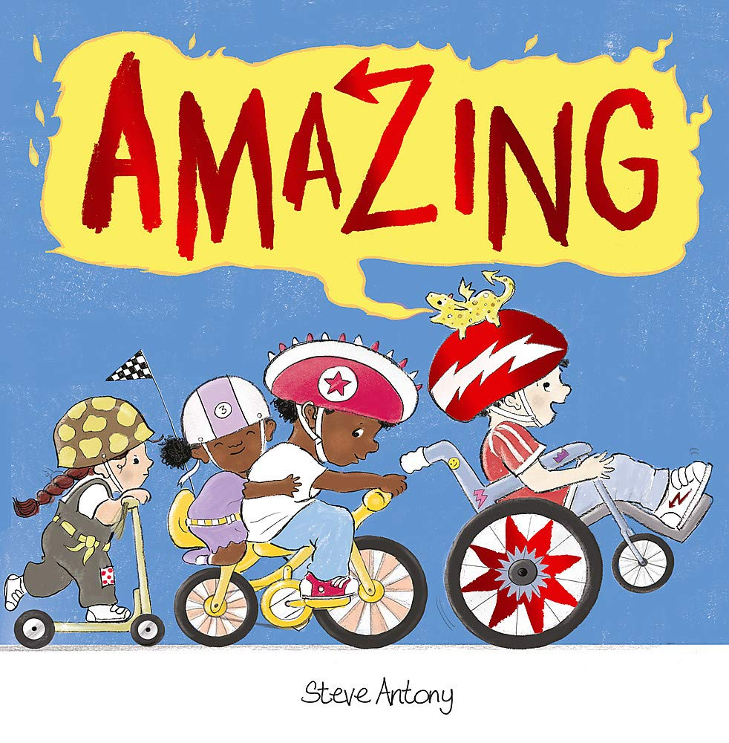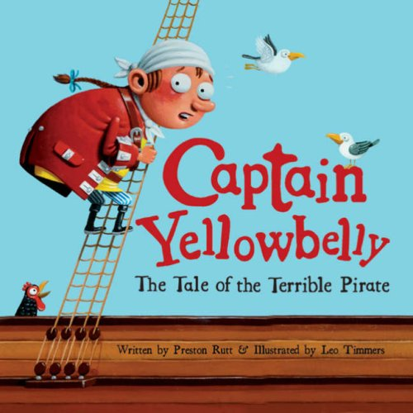

# Literacy

Our Literacy work this half term will focus on the story ‘Captain Yellow Belly’. We will be ordering and retelling the events in the story and looking at the different characters.

Phonics

We will soon be starting our Read Write Inc daily phonics sessions. We will start by learning set 1 sounds focusing on pronouncing them phonetically, recognising the sounds by sight and hearing initial, medial and final sounds in simple words. We will be providing detailed information about how we teach phonics and how you can support your child on **Thursday 16th September**. Details of how you can access this information will be provided soon.

Reading at home

Children will start to bring home a story book of their choice from our classroom reading area. Books will be collected in and changed each Friday. This book will be for you to read to your child and encourage a love of reading. This is an opportunity for your child to see you as a reader, as well as hearing and enjoying a range of stories. You could discuss the front cover, the pictures, the characters and the settings within the book. This will benefit your child in becoming confident at unpicking and recognising the structure of texts. Once your child is starting to segment and blend simple words they will also start to bring home a reading book and each week and a reading record for you to record their reading at home in.