Dear Parents/Carers,

Re: Opening of school for all pupils at Chapelford Village Primary School

I hope this letter finds you and your families all well, happy and healthy. We are very much welcoming all of our children back to school on Monday 8th March 2021. This letter will explain some of the operational requirements. As a school we will be undertaking planning for a wide range of pastoral activities to support them socially and emotionally to settle effectively back into their routines and classrooms.

Since the announcement that all children were returning to school on Monday 8th March 2021, we have been working to further develop our plans which enable us to do this as safely as possible for the children and school staff.

In these ever-changing times we are mindful that any guidance and indeed circumstances can change very quickly and these are often outside of the control of the school. As such the information provided in this letter is at this point provisional and could be subject to change over the next week. If, for any reason, information is changed then you will be notified by text and directed to the school website where any changes would be clearly communicated.

With the health, safety and well-being of our children, staff and families being my top priority I have personalised the OMEGA MAT Trust plan to put in place a plan that I believe works for our school, children and staff. We have reflected on the reopening plan from September 2021 and tried to make the dropping off and collection of children to and from school more supportive for families with siblings. We understand that our previous system was difficult and we have tried to make this more supportive for parents. However, the success and sustainability of these revised plans will be completely reliant upon the compliance of all parents adhering to the school’s social distancing rules and risk assessment requirements. We will be monitoring and reviewing these on a daily basis as part of our operational plan.

Our plan is aimed at welcoming all children back to school and giving staff, parents and children the time we all need to build in confidence and feel safe and secure in our new way of operating. I do not underestimate how anxious we all feel as we step forward to the full opening of school but please be assured that we will be taking the greatest care to support the entire school community emotionally and socially whilst also recalibrating the educational provision across the school as a priority.

All pupils are expected to return to full-time on-site provision commencing Monday 8 March 2021. Attendance is mandatory in line with the usual rules unless your child is classified as clinically extremely vulnerable (CEV). As a school we may request a copy of the shielding letter received by CEV pupils to confirm their attendance status.

We will, as a school, be continuing to support and develop our remote learning offer to support all families with home learning. During this second period of lock down and school closures many of you have continued as co-educators of your child and we aim to continue to support this for those families that wish to continue this moving forward.

Here is an outline of the agreed plan for the full reopening of the school:

- Each year group will be split into Bubbles with your child’s named class teacher. The school will have in place provision to support children with their emotional wellbeing within each class on return to school.

- Within each Bubble the school has put into place proportionate control and protective measures to minimise the number of contacts within each class within the Bubble. This will include dedicated teaching and support staff to work within the Bubble throughout the week and staggered break and lunchtimes across the school.

- Children will enter and exit school via the allocated external classroom doors following the school’s external one-way system. Your child’s class within the Bubble will be clearly marked with your child’s named teacher. Please see the attached map for the location of your child’s classroom.

- Children in each Year Group Bubble will arrive and finish school during a twenty-minute period of time. All classroom doors will remain open for the twenty-minute period. Registration will not start until the end of the 20-minute period.

- Please arrive for drop off and collection anytime during the twenty-minute period. We hope that this 20-minute period will avoid large numbers of parents and children on the school grounds at any one time. If we find that this is not successful we will have to revert back to staggered times for each year group to avoid large groups of people on the school grounds at any one time. Your support in this is very much appreciated.

Drop Off Time for all Year Groups | School Pick Up Time
8.40am – 9.00am | 3.00 – 3.20pm

- Children will need to arrive and be picked up within the stated times above. We understand that on some occasions this could be problematic for families for a variety of reasons. We will of course endeavour to support families on these rare occasions. If you should arrive at school and find the external gates closed you will be required to telephone the school office for assistance. The school gates will be closed from 9.00am until 3.00pm.

- Children, unless unwell, will not be able to arrive or leave school at any times other than their drop off and collection times unless the school office is notified beforehand. Once the children are in school the school gates will be locked to ensure the school site is secure whilst enhanced ventilation is enabled.

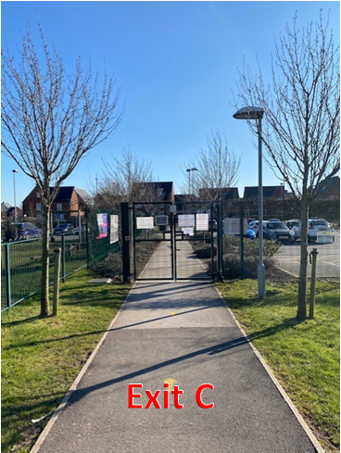
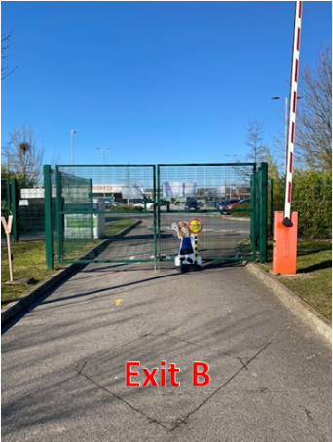
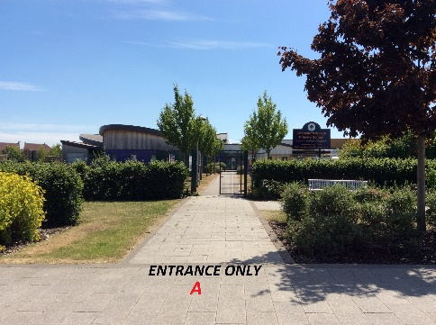
- For the safety of the school community we will be continuing to operate a one-way system around school. All staff and parents are to enter the school grounds via the main entrance gate pictured below and to leave the school grounds, following the one way system via the exit gates as pictured below.

- Each child will be allocated a place at a named desk or carpet space for younger children. All working stations will be forward facing in line with Government Guidance. All children will keep their own personal items (eg stationery) for their use only and this will be provided by the school. Children will only be permitted to bring their named clear water bottle, coat and packed lunch to school. Children will need to bring their PE kits into school on the first day back in a named PE Draw String bag. Children will not be permitted other bags or equipment into school.

- Each pupil will have an individual tray for their provided resources and books. Classrooms have been reorganised to enable all items to be easily cleaned and accessed within each Bubble.

- Children in Early Years and Year One will have the option of a hot school meal from the kitchen or their own packed lunch in the school dining room.

- Children in Year Two to Year Six will have the option of a hot packed lunch provided by the school kitchen/ or their own packed lunch and this will be eaten in their classroom.

- Your child may bring their own packed lunch into school if you have opted out of school meals. Please keep in mind that the school does not have the facility to refrigerate lunches and that these will be kept with children in the classroom, so where possible these should be in an insulated lunch bag.

- Break times will be staggered so that each Bubble takes their break time separately. Each class within the Bubble will be given their own recreational space.

- At this time parents will not be permitted to accompany children into the school building under any circumstances. The school office and reception area will remain closed until further notice and any correspondence with the school must be via email or telephone.

Where possible we kindly request that children are brought to school by one adult only as this will reduce the number of people on the school site at any time. All parents/carers dropping off / collecting children should wear a mask unless they have a medical exemption.
- To keep a sense of normality we require pupils to continue to wear school uniform each day.

Please understand that the operational routines and expectations for children and staff returning to schools across the country at this time are not what we, as a school, wish for our pupils or staff here at Chapelford Village Primary School. We ask you to please understand they are absolutely necessary to reduce the risk of transmission and create a safe environment for our school community. All procedures put in place are sensible, proportionate and practical and will be monitored and reviewed daily for their effectiveness.

At this very challenging time we are doing all we can to keep our pupils, staff and wider community safe – please be mindful that we are doing our very best under very difficult, ever changing and often unknown circumstances. Your support, patience and cooperation at this time is really appreciated. I would like to personally thank you for your patience and understanding that you have shown to the school and staff over this second period of school closure – it has been very much appreciated and welcomed.

We know that some of our school community have lost loved ones over the course of the pandemic and our thoughts, prayers and support is with you all at this difficult time. Please continue to take care of yourselves and your families over the weeks ahead. We now have light at the end of the tunnel and by all working together we will all reach a much desired “normality” in the near future.

We really are looking forward to reopening our lovely school and welcoming everybody back to Chapelford Village Primary School next week – Monday 8th March 2021.

Assuring you of my best attention during these times. Please do not hesitate to contact your child’s current Class Teacher or the school office via email chapelford_admin@omegamat.co.uk if you require any further support, information or assistance.

Kindest regards,

Mrs Joanne Hewson

