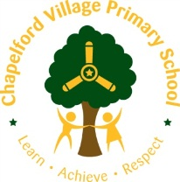

EYFS Curriculum Overview 2021/2022
Year group:  EYFS | Autumn 1 | Autumn 2 | Spring 1 | Spring 2 | Summer 1 | Summer 2
Maths | - Sorting into groups  - Matching  - Comparing amounts  - Compare size, mass and capacity  - Exploring pattern | - Representing, comparing and composition of numbers 1 2 3  - One more and one less  - Positional language  - 2D shapes  - Representing numbers 1-5  - Time - my day | - Introduce zero  - Comparing numbers to 5  - Composition of 4 and 5  - Compare mass  - Compare capacity  - Making pairs | - Combining two groups  - Numbers 6-10  - Length, height and time  - Comparing numbers to 10  - Number bonds to 10  - Pattern | - Building numbers beyond 10  - Counting patterns  - Adding more  - Taking away  - Spatial reasoning | - Doubling  - Sharing and grouping  - Even and odd  - Patterns and relationships  - Spatial reasoning
English texts | 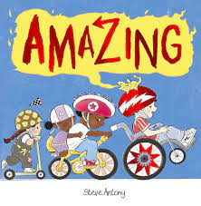  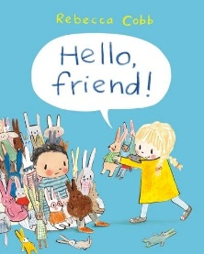  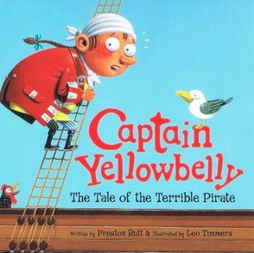 | 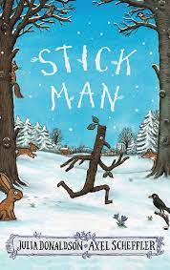  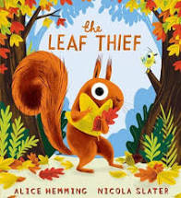  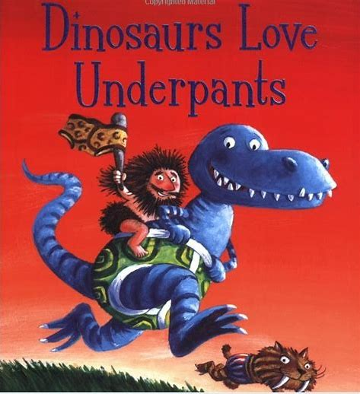 | 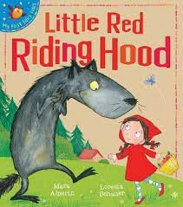  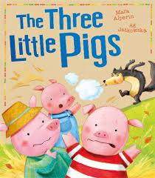  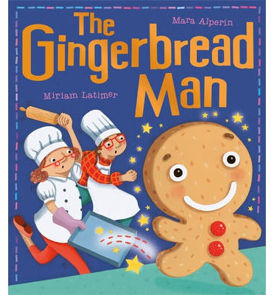 | 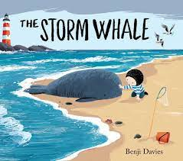  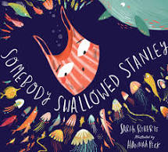  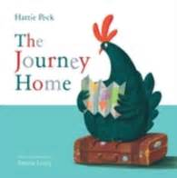 | 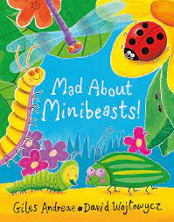  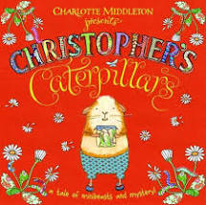  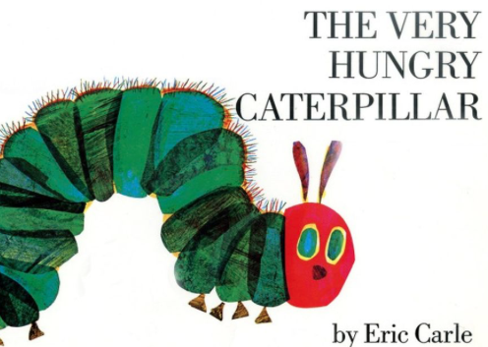 | 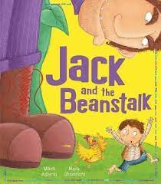  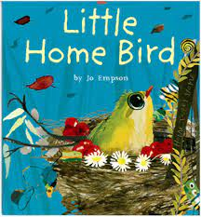  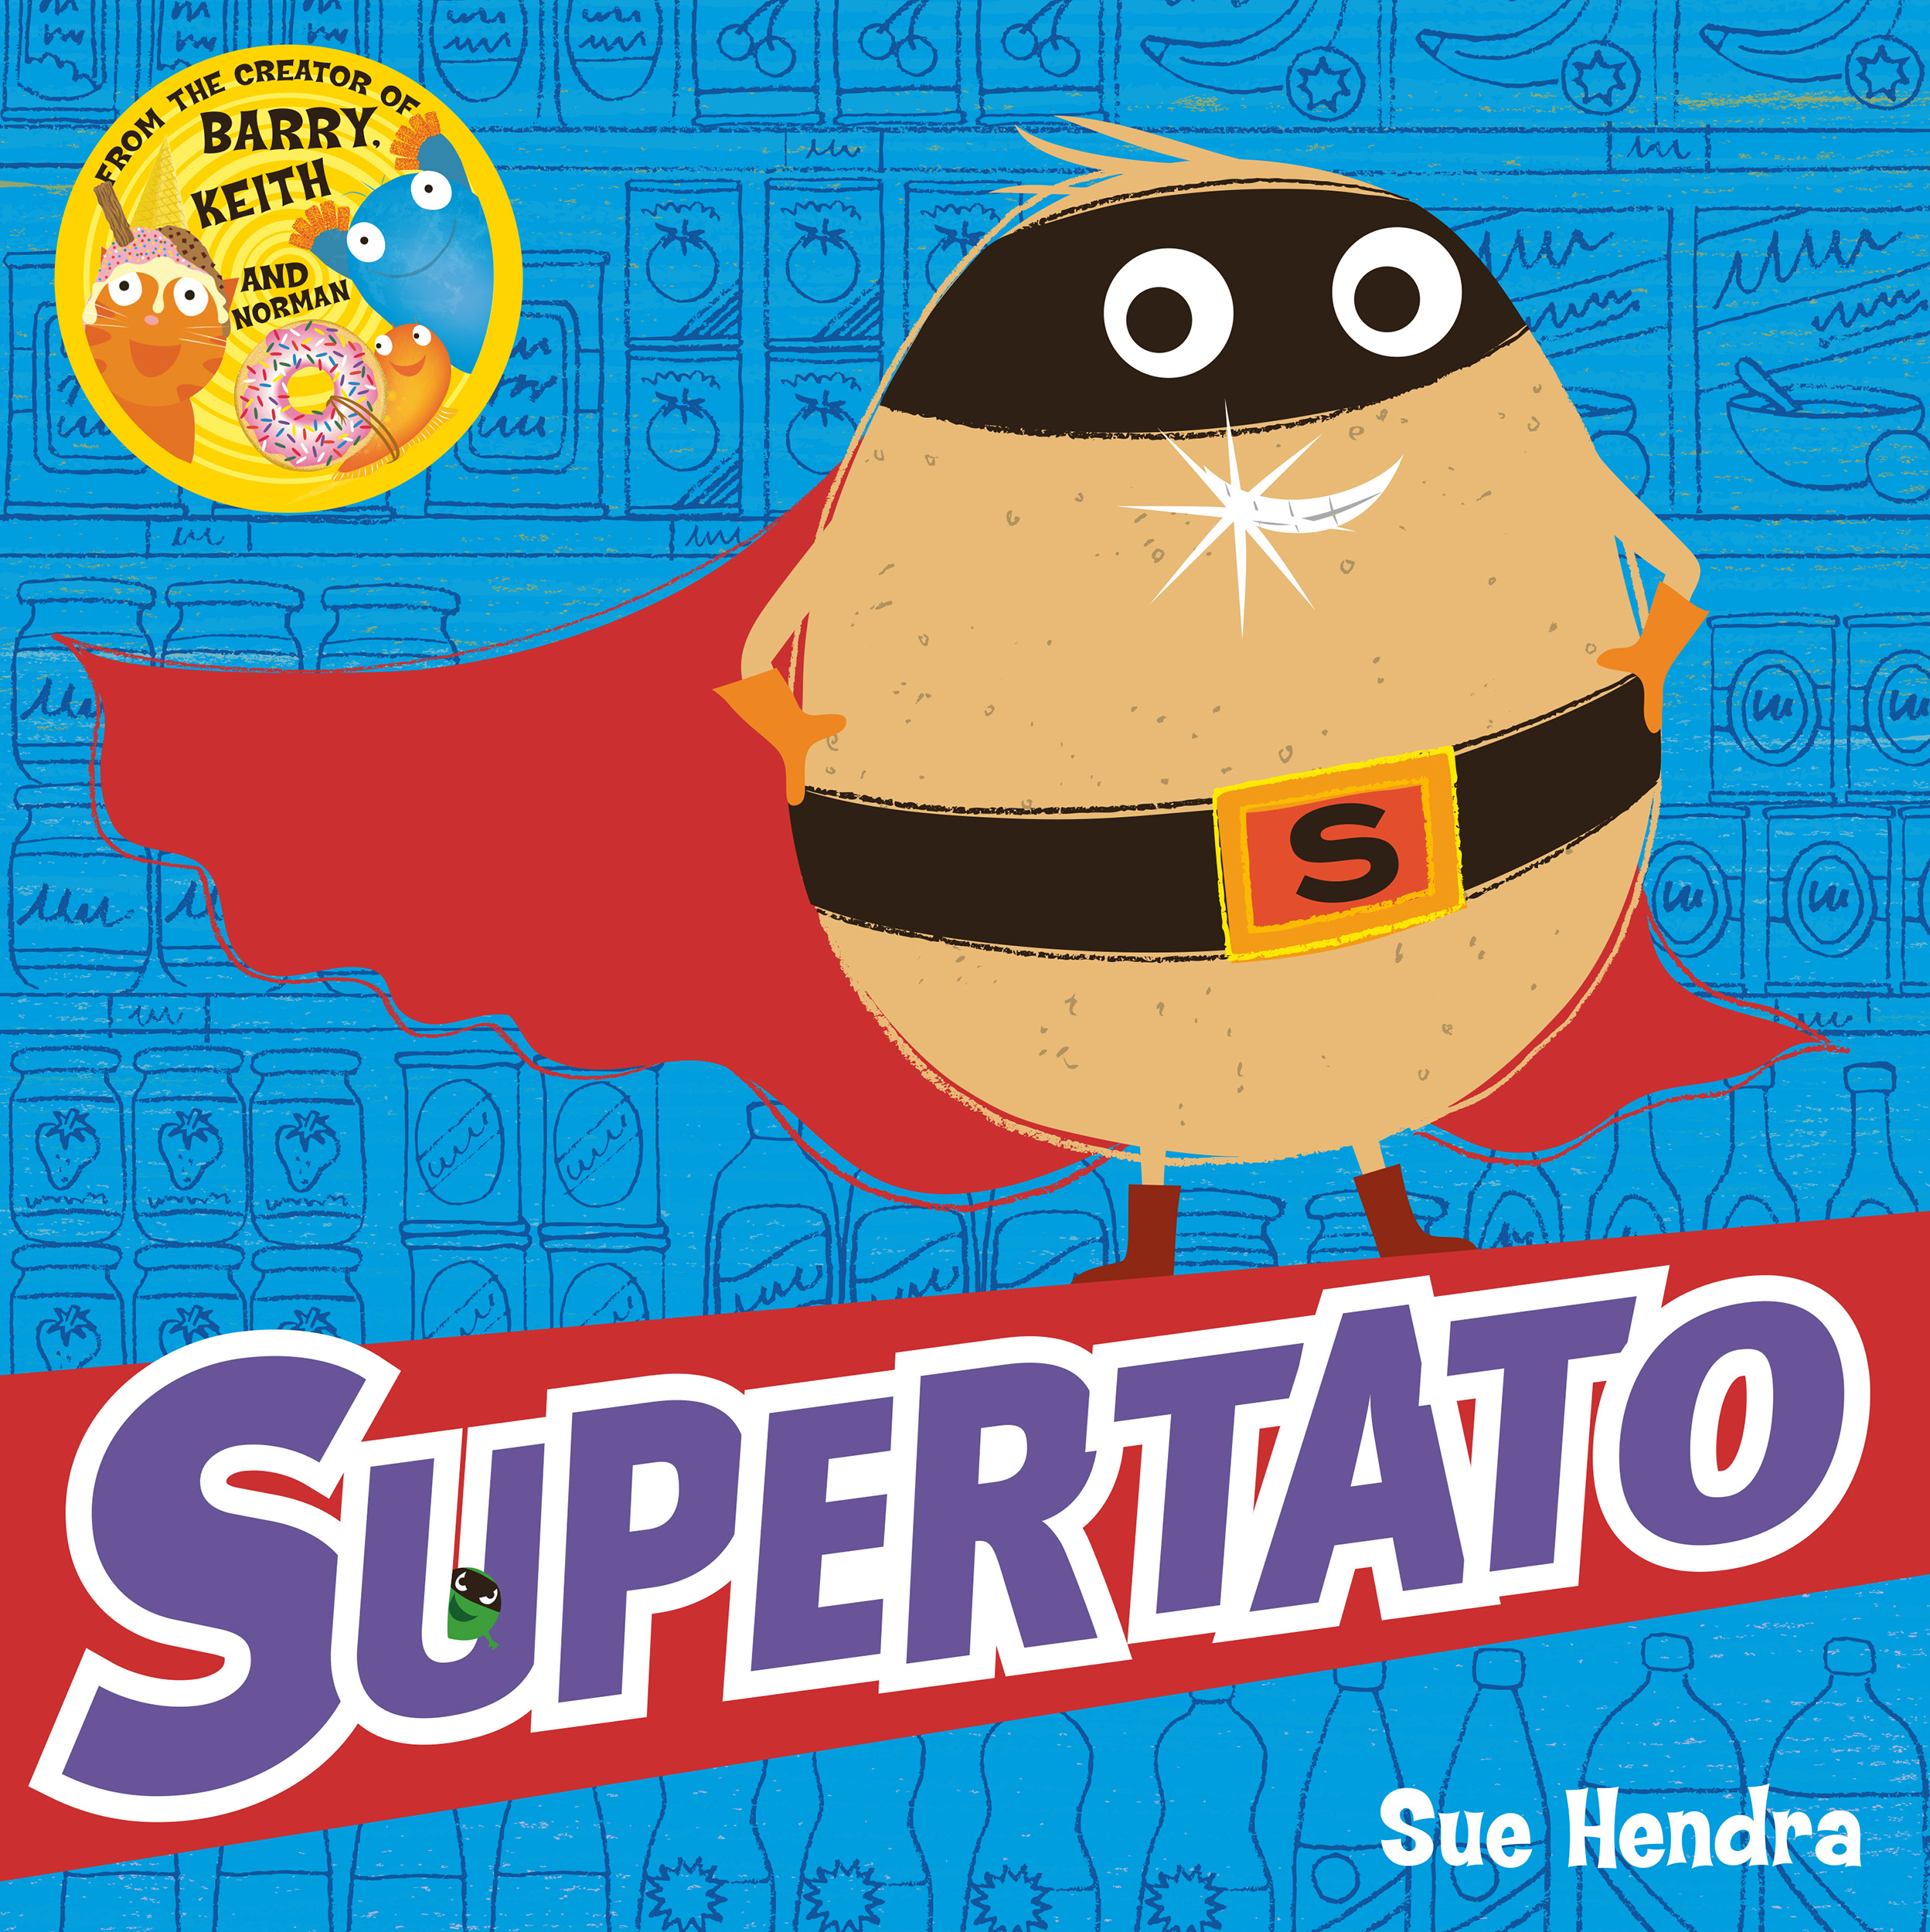
Class Author Study | Jill Murphy |  | Mick Inkpen | Marcus Pfister | Eric Carle | David McKee
Poetry Focus | Nursery rhymes and songs |  | Short rhyming poems |  | Pathways poetry unit
Role Play | Cafe  Home area  Shop | Post office  Vets  Potions | Doctors  Police  Fire station | Shop  Vets | Ice cream parlour  Shop | Ice cream parlour  Shop
Small world | Pirates | Dinosaurs | People who help us | Under the Sea animals | Minibeasts | Minibeasts
Theme | Pirates  All about me | Dinosaurs  Seasons | People who help us | Journeys | Minibeasts | Growing
Celebrations | Transition and change  Autumn  European languages day | Winter  Bonfire night  Harvest festival  Diwali  Christmas  Nativity | Spring  Chinese New Year | Life cycles – chicks  Easter  Mother’s Day  World Book Day | Life cycles - butterfly  Summer  Minibeast ball | Transition and change  Father’s Day  Sports Day  Graduation  Superhero day
Educational Visits  And Residential | Pirate day  Autumn walk around school grounds | Christmas Theatre  Nativity  Diwali celebration day - Bollywood dance workshop, food tasting etc | Visit from the police, firemen etc  Chinese New Year celebration day - own clothes, food tasting etc | Chicks - hatching eggs  Trip out to museum  Spring walk | Butterflies - life cycles  Creepy Crawly Show visit | Transition week  Graduation
Science | The human body  Naming parts of the body.  Look at the 5 senses.  How do we grow? | Seasonal changes  Investigating the seasons and the changes in the weather. Why are there so many leaves on the ground?  Classification  Dinosaur investigation – herbivore, carnivore, omnivore. | Everyday materials  Investigating materials – Naming and sorting everyday materials. Why didn't the brick house blow down in the Three Little Pigs? Why couldn’t the gingerbread man swim? | Life cycles and change  Life cycle of a hen. Investigating and observing the eggs and the stages of growth.  Similarities and differences of living things.  The Ocean  Floating and sinking.  Impact of plastic in our oceans. | Life cycles and change  Life cycle of a butterfly  Investigating and observing the eggs and the stages of growth.  Similarities and differences of minibeasts, habitats etc. | Plants  Growing - What do plants need to grow? Life cycle of a bean. What happens if plants don’t have sunlight?
Ongoing Science all Year | How do the seasons impact on what we do?  Observe changes across the four seasons  Observe and describe weather associated with the seasons and changes to length of the days.  Ask simple questions and recognise that they can be answered in different ways; Observe carefully, using simple equipment; Identifying and classifying.  Using their observations and ideas to suggest answers to their questions; Gathering and recording data to help in answering questions.
History | Babies and childhood  How have I changed since I was a baby?  Children to bring in a time line of their life – photograph of each year of their life  Families  Talk about members of their immediate family and community | Toys from different cultures and times. | Families  Name and describe people who are familiar to them. Talk about people the children may come across with in their community – fire brigade, doctors etc.  Looking at old emergency service vehicles. How have they changed? Can you guess the emergency service? | Comment on the images of familiar situations in the past-present children with pictures, stories, artefacts from the past, explaining similarities and differences. Children to recognise things happened before they were born. | Compare and contrast characters from stories including figures from the past. Share texts to show an understanding of past and present.  Fictional and non-fictional characters from a range of cultures. Draw out common themes from stories – bravery, difficult choices and kindness.
Geography | Where do we live? | Houses and homes  Compare with other countries | Our local area, community and buildings | Maps | Different cultures and communities | Comparing different environments
Art | Drawing  Observational drawings | Collage  Create a seasons collage. | Painting  Explore colour and colour mixing.  Look at different textures - painting on different materials. | Sculpture  Children to use clay and a range of materials to create under the sea animals. | Printing  Use different objects to create prints using minibeast colours and patterns. | Textile  Weaving with different natural materials.
MFL  (Primary Language Network) | Listening and joining in. | Counting and signing | Celebrations | Rainbows and Easter | Families and rhymes | Join in with stories and performance
Music  (charanga) | Me! | My stories | Everyone! | Our world | Big Bear funk | Reflect, Rewind and Replay
PE  (Real PE/Games) | Unit 1 - personal skills  Games | Unit 2 - social skills  Games | Unit 3 - cognitive skills  Games | Unit 4 - creative skills  Games | Unit 5 - applying physical skills  Games | Unit 6 - Health and fitness  Games
Computing | By the end of the Foundation Stage most children will:  - Show an interest in ICT  - Know how to operate simple equipment  - Complete a simple program on the computer and / or perform simple functions on ICT equipment  - Find out about and identify the uses of everyday technology and use information and communication toys to support their learning.
Religious Education  (Scheme) | Christianity | Islam | Hinduism | Christianity | Islam | Hinduism
PHSCE | All About Me  Starting school  Classroom rules  Getting to know each other  History link – share information about their families, ask questions and make comments. | Friendship & Relationships  Anti-Bullying Week  What makes a good friend? | Families  Who is in my family  Different family groups | Every Body is Different  How are we different?  Listening to and respecting other people’s views  What hobbies do we have?  History link – fictional and non-fictional characters from a range of cultures. Draw out common themes from stories – bravery, difficult choices and kindness. | Healthy Eating and Staying Safe  Personal hygiene  Stranger danger  Road safety | What have I Achieved?  Personal goals  Emotions and feelings  Value achievements and talents
Commando Joe | If you’re happy and you know it – Self awareness | Twinkle twinkle little star – Excellence | Jack and Jill - Empathy | Three Blind Mice – Communication  Row row row our boat - Teamwork | Incy wincy spider – Resilience | Humpty dumpty – Positivity

