Monday  Outdoors Day!  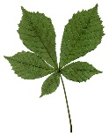 | Valentine’s Day outdoor crafting  Look outside for inspiration for your own homemade love tokens. Children will enjoy making collages from leaves, twigs, bark or pressed spring flowers to stick onto homemade cards, giving them a focus for some fresh-air time.  If the weather is warm enough then take their painting or colouring crayons outside to practice some nature art. | Mini Garden Olympics or Football Tournament  As there has been no Olympics this year why not create your own? Pick a country to represent, dress up in their colours, create your own competition numbers and start your competition!  - Garden Sprint  - Garden distance run  - Sack race  - Triple Jump  - Long Jump  - Discus – try using a frisbee!  You could buy cheap medals online to present to the winners! | Eat Outdoors  Children  love the adventure of taking their meals outside at any time of year. If you’re feeling adventurous then why not have a camp fire and toast marshmallows or cook some supper outdoors. If you’re looking for a simpler option then how about baking some potatoes at home and wrapping in foil or making up a flask of soup and then head out to the garden or nearest woods with a blanket and enjoy eating outdoors. You could even throw in a little den building! | Feed the Birds  Make a feast for the birds in your garden using only an apple, some seeds, string and sticks!  Click the link below to find out how:  https://www.bbc.co.uk/cbeebies/makes/bird-feeder | Family Night Time Adventure  With no home school to be getting up for the children can have a bit of a later night, wrap up warm, take some hot drinks and take a night walk to go stargazing, we love the free app ‘Star Tracker’ so you can tell which stars and planets you are looking at!  https://play.google.com/store/apps/details?id=com.PYOPYO.StarTracker&hl=en_GB&gl=US
Tuesday  Pancake Day!  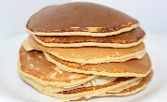 | Create a Pancake Kitchen Role Play Area  Put out some of the utensils you might use for making pancakes and print photos / set out the different ingredients used in making pancakes! | Pancake Treasure Hunt  Cut out some paper pancakes and hide them around the house and garden (like an Easter egg hunt). | Read Pancake Themed Stories  ‘The Runaway Pancake’, ‘Mr Wolf’s Pancakes’, ‘The Pancake King.’  Find more stories here:  https://www.theguardian.com/childrens-books-site/2016/feb/08/best-childrens-books-on-pancakes-pancake-day | What would you like on your Pancake?  Draw or print some pancakes and children can have fun decorating them with all the toppings of their imaginations!  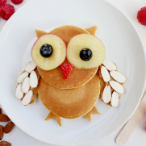 | Make Traditional Pancakes  Ingredients:  - 100g plain flour  - 2 large eggs  - 300ml milk  - 1 tbsp sunflower or vegetable oil, plus a little extra for frying  - Topping of your choice!  Click below to find the recipe:  https://www.bbcgoodfood.com/recipes/easy-pancakes
Wednesday  Animal Day!  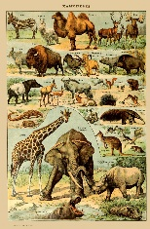 | Tune in to live animal webcams at  Edinburgh Zoo  They have five webcams watching some of your favourite animals. We watched a panda munching on its lunch and a tiger taking a snooze!  https://www.edinburghzoo.org.uk/webcams/panda-cam/ | Sounds of Nature Bingo  Whether you’re a town mouse or a country mouse, you’re bound to have lots of noisy neighbours. We’re talking about cooing pigeons, crying seagulls, buzzing bees and hooting owls. If you listen carefully you may also hear the wind in the trees or the patter of rain. Listen carefully in the garden or on a walk and tick off the sounds when you hear them.  Click below to print the bingo board:  https://nt.global.ssl.fastly.net/documents/sounds-of-nature-bingo.pdf | Visit the Great Barrier Reef!  If you love sea life take a virtual trip to Queensland’s Barrier Reef children’s website with games including one that involves clicking on as many plastic bags as possible in 30 seconds, while not disturbing the jellyfish.  https://www.barrierreef.org/kids | Stone Painting  Find a large stone or pebble and paint it as your favourite animal. I love this bumble bee. You could then leave it somewhere for other children to find on your local walk. | Lion Mask  Why not make this amazing lion mask and then use it in pretend play. You can pretend to be a lion. How do they walk and move? Can you copy? Can you roar like a lion? You could try other animal masks too.  https://www.fantasticfunandlearning.com/lion-mask.html
Thursday  Self Care & Relax Day! | Enjoy a little ‘Hygge’ Time!  ‘Hygge’ pronounced “hoo-ga” comes from Denmark and means feeling cosy, through enjoying the simple things in life; it’s a perfect idea for any rainy gloomy day at home.  Choose a room to get cosy and do everything you can to make it look and feel different. Grab blankets, duvets, fluffy pillows and every single teddy that the children own downstairs. Lighting is key – choose cosy lamps and fairy lights over the ‘big light’  Then make a den, wear your cosiest clothes, have some snacks, play games and enjoy the feeling of being cosy! | Home Spa Day  Have a day to unwind and bring the spa to you.  Ideas could include:  - Relaxing spa music  - Drinks in plastic flutes  - Healthy snacks  - Homemade face masks  - Foot spa with bubbles  - Nail painting  - Hand massage  - Cucumber eyes  Find some homemade face masks recipes below:  https://www.fancynancyworld.com/2017/08/16/3-diy-edible-face-masks/ | Bring the West End to your home  So we love that West End production The Wind In The Willows has announced it will stream its production online for free! The classic children’s fairytale has been a beloved tale for generations, and now we’ll all be able to get it directly to your devices or TV’s. Get cosy on the couch and tune in!  Click below:  https://www.willowsmusical.com/ | Yoga  Try some yoga!  You can trial the Cosmic Kids app for two weeks for free at https://cosmickids.com/  Here you will find amazing videos for your children to follow at home.  Namaste! | Read a Story!  Go to Oxford Owl for lots of free downloadable books  https://www.oxfordowl.co.uk/  Set up a cosy space at home and read to family, your pet or quietly read alone.  Why not try to re-tell the story without using the book to help, do you think you could remember? Draw pictures to help!
Friday  Craft Day!  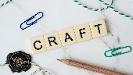 | Make your own Playdough  Its super easy and you only need five ingredients: flour, salt, water, vegetable oil and food colouring. You can even store in the fridge for days after and have fun with it all week.  Watch the video below and find out how!  https://www.bbcgoodfood.com/howto/guide/playdough-recipe | Play with the playdough!  The sensory nature of play dough allows babies and toddlers to be naturally curious and explore the world around them using their senses. It is also beneficial for fine motor development and strengthening little fingers, hands and wrists.  - Make shapes using cutters  - Use different utensils to roll, cut and mould  - Add natural scents to the dough and guess the different smells like cinnamon, mint and vanilla  - Shape into your favourite animals  - Add sequins, pipe cleaners, beads and buttons to change the texture  - Roll into balls – how many can you make? Can you fill a jar? | Paint Pasta  Children can use markers or paint to change bow-tie pasta into beautiful butterflies.  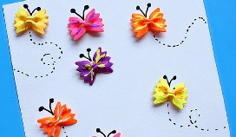 | Family Frames  Draw your family or print out a picture at home. Then can you design a frame using lollipop sticks? You could paint, colour, glue and stick, use your imagination. You could then display it pride of place in your room!  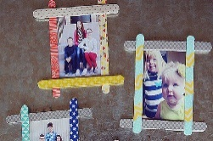 | Animal Crafting  Perfect for stomping, tromping, and roaming through imaginary lands, these cereal-box feet are a fun addition to the dress-up area. What monster or animal could you pretend to be?  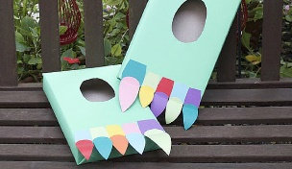  Sponge Prints  Cut a sponge into animal foot print shapes, dip into paint then print onto paper for a wild pattern.  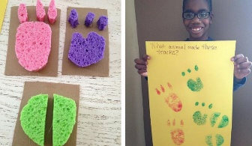  Can an adult guess which animal make the tracks?

