Chapelford Village Primary School
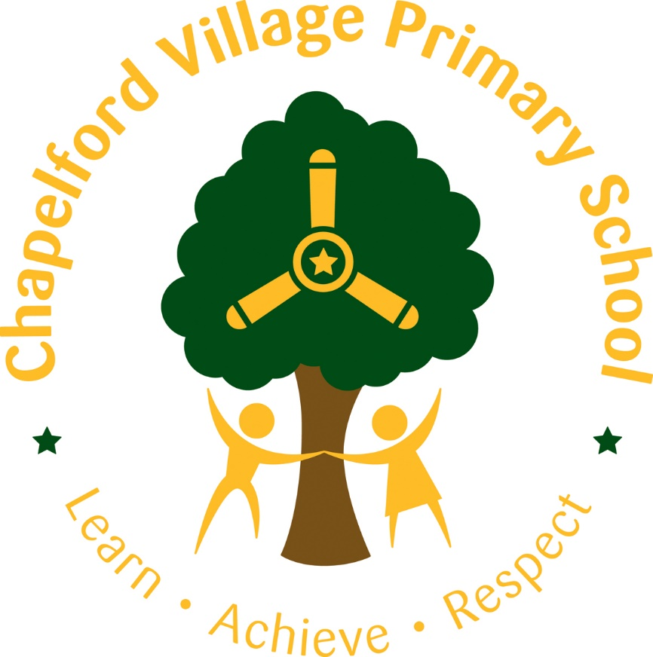

Geography Curriculum Statement

Intent
The geography curriculum is ambitious, broad and balanced. It is coherently planned and sequenced and has been designed and developed to include all children, including SEND and disadvantaged children. Children are encouraged to develop a greater understanding and knowledge of the world, places, and their environments, as well as their place in it. The geography curriculum at CVPS enables children to develop knowledge and skills that are progressive, as well as transferable to other curriculum areas, which can and are used to promote their spiritual, moral, social and cultural development.
Implementation
To ensure high standards of teaching and learning in geography, we implement a curriculum that is progressive throughout the whole school. The geography curriculum at CVPS is based upon the 2014 Primary National Curriculum, which provides a broad framework and outlines the knowledge and skills to be taught in each Key Stage. Teachers plan lessons for their year groups using the CUSP curriculum. This curriculum ensures that the skills, knowledge and vocabulary taught is progressive from year 1 to year 6. It also allows teachers to plan lessons that build upon previous knowledge and regular retrieval activities are planned in to assess how well they are retaining previously taught knowledge.
Impact
All teaching of geography is at least consistently good across the school All children, relevant to their stage of development, can recall current and previous learning. Through Pupil voice, children will be able to: articulate their knowledge and understanding as a geographer, explain how geography ‘happens’ in their local area, talk about the world around them and how it has been shaped, describe what geography is and how they have applied this learning in a given context and say if the know more, remember more and understand more.

