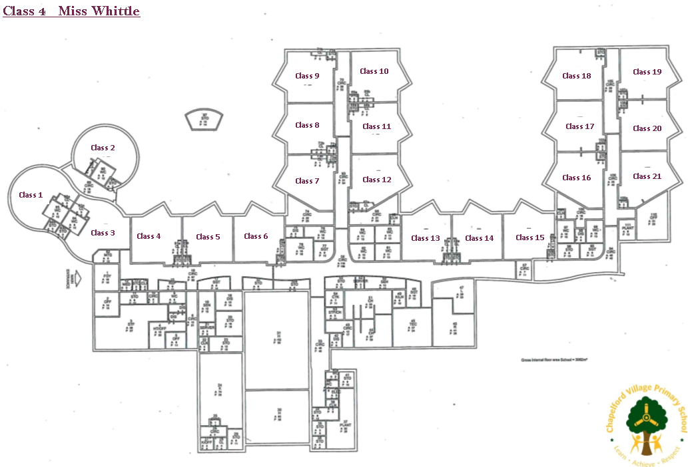Chaperl

Chapelford Village Primary School Site Map 2021