Residential Fieldtrip Learning Opportunities/Ideas  Robinwood and London  Year 6  Learn, Practice, Repeat …  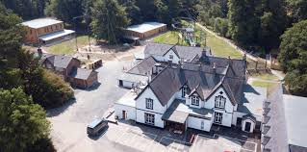  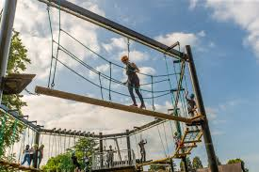  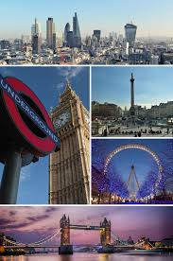 | Art – Intent  *To develop previous learning from AUT term where the children used a range of drawing implements to sketch, the children will use oil pastels to create piece of art inspired by Van Gogh to broaden their knowledge of great artists.  Expected Outcome: Art Skills  *Use oil pastels to make different marks, lines, patterns and shapes within a drawing. (sgraffito)  *Explore colour mixing and blending techniques with pastels.  *Use different techniques for different purposes i.e. shading, hatching within their own work.  *Start to develop their own style using tonal contrast and mixed media.  Expected Outcome: Art Knowledge  *Vincent Willem van Gogh was a Dutch painter who is among the most famous and influential figures in the history of Western art.  *In just over a decade he created about 2,100 artworks, including around 860 oil paintings, most of them in the last two years of his life.  *He was 27 when he painted his first piece.  *He suffered with a variety of mental illnesses.  *He only became famous after he died.  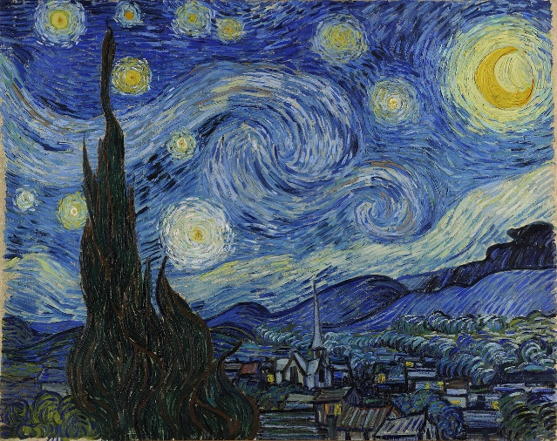  Oil Pastel  Observe the night sky to observe details- clouds, moon light, stars, how the sky gradually lightens near the surface.  Use step by step tutorial to use strokes in the style of Van Gogh to create their own night scene.  Music  •Song writing about their experiences- write poetry that could be used as lyrics  •Use this as a basis and use Garage Band on ipads to create backing for lyrics and perform and create a song.  •Perform during assembly | London/Robinwood  Y4/5 SoW  Spring 2/Summer 1  Feeling well/ unwell  Jungle animals and fantastical animals  Weather  Clothes  Starting the morning with how you feel  Group names/dorms using jungle animals  Game like corners with French vocab  Clothing kit list in French  Starting the morning with the weather forecast, talking about clothes based on this  Conversations in partners about how you feel  Introducing ourselves with age and names  What are you wearing today, what you need to go and put on… | London –Year 6  River Thames  Length: 346 km (215 miles)  Source: Thames Head, Gloucestershire (England)  Mouth: Thames Estuary (North Sea)  - The River Thames is the second longest river in the UK.  - It is the most well-known of Britain’s rivers because it flows through central London. It also flows through (or really close by) some other important towns and cities in England, such as: Richmond, Kingston upon Thames, Windsor, Henley-on-Thames, Oxford and Reading.  - The Thames is tidal when it flows through London.  - More than 80 islands are contained in the River Thames. These include: the Isle of Sheppey, Canvey Island and Rose Isle. About two thirds of London’s drinking water comes from the Thames.  - The River Thames has several tributaries, including: the River Churn, Windrush, Cherwell, Thame, Loddon and Mole. Several rivers also join the Thames after it has become tidal. These include: the River Brent, Effra, Westbourne and Fleet.  - The Thames becomes tidal below Teddington Lock. This is just over 50 miles from the Thames Estuary (and the river’s mouth).  Geography Activities/Skills/Learning  Locate the journey of the river, from Cirencester. Locate on old/new maps. Timeline of the river. Has the uses of the river changed? Why? How might the uses change in the future? What role has the river had in the development of transport and trade?  Compare to the River Dee/River Mersey.  Imagine you are an entrepreneur. What business would you start using the Thames? Leisure? Environmental? Sales? Entertainment? Where would your business be? Create advertising for your new business. Justifying choices. | History  Tower of London  Mighty fortress. Royal palace. Infamous prison.  When William the Conqueror built a mighty stone tower at the centre of his London fortress in the 1070s, defeated Londoners must have looked on in awe. Now nearly 1000 years later, the Tower still has the capacity to fascinate and horrify.  As protector of the Crown Jewels, home of the Yeomen Warders and its legendary guardians, the pampered ravens, the Tower now attracts over three million visitors a year. Here, the Ceremony of the Keys and other traditions live on, as do the ghost stories and terrible tales of torture and execution.  But the Tower also has a richer and more complex history, having been home to a wide array of institutions including the Royal Mint, the Royal Armouries and even a zoo.  Fortress. Palace. Prison.  As the most secure castle in the land, the Tower guarded royal possessions and even the royal family in times of war and rebellion.  But for 500 years monarchs also used the Tower as a surprisingly luxurious palace.  Throughout history, the Tower has also been a visible symbol of awe and fear. Kings and queens imprisoned their rivals and enemies within its walls. The stories of prisoners, rich and poor, still haunt the Tower.  The Conqueror’s fortress  In the 1070s, William the Conqueror, fresh from his victory but nervous of rebellion, began to build a massive stone fortress in London to defend and proclaim his royal power. Nothing like it had ever been seen in England before.  William intended his mighty castle keep not only to dominate the skyline, but also the hearts and minds of the defeated Londoners.  The Tower took around 20 years to build. Masons arrived from Normandy, bringing with them stone from Caen in France. Most of the actual labour was provided by Englishmen.  The fortress expands  Throughout history, the Tower has been adapted and developed to defend and control the nation.  Henry III (1216-72) and Edward I (1272-1307) expanded William’s fortress, adding huge ‘curtain’ (defensive) walls with a series of smaller towers, and enlarging the moat.  The Medieval Tower  They also transformed the Tower into England’s largest and strongest ‘concentric’ castle (with one ring of defences inside another).  Inside, the medieval kings built magnificent royal lodgings.  Did you know?  In 1240, Henry III had the Tower’s great keep painted white, making it the White Tower.  Tower of strength  Kings and queens used the Tower in times of trouble to protect their possessions and themselves. Arms and armour were made, tested and stored here until the 1800s.  The Tower also controlled the supply of the nation’s money. All coins of the realm were made at the Tower Mint from the reign of Edward I until 1810. Kings and queens also locked away their valuables and jewels at the Tower and even today, the Crown Jewels are protected by a garrison of soldiers.  The Bloodier Tower  The Tower of London has also been the infamous setting for stories of royal tragedy and death.  During the Wars of the Roses, Henry VI was murdered here in 1471 and, later, the children of his great rival Edward IV – the Princes in the Tower - vanished within its walls in 1483.  In 1674, two skeletons were unearthed at the Tower.  The bones were re-examined in 1933 and proved to be those of two boys aged about 12 and 10, exactly the same ages as the princes when they disappeared.  The palace guards…  The famous Yeoman Warders, recognised as symbols of the Tower all over the world, have been here for centuries. They were originally part of the Yeomen of the Guard, the monarch’s personal bodyguard who travelled with him.  Henry VIII (1507-47) decreed that some of them would stay and guard the Tower permanently.  Did you know?  Henry VII's personal guards were the first 'Beefeaters', so named as they were permitted to eat as much beef as they wanted from the King's table  Ceremony of the Keys  Today the Yeomen Warders or the 'Beefeaters' guard the visitors, but still carry out ceremonial duties, such as unlocking and locking the Tower every day in the Ceremony of the Keys.  They wear their red state ‘dress uniforms’ for important occasions at the Tower, and also for special events such as the firing of the huge cannon on the Wharf, known as the Gun Salutes.  Royal life and death  Medieval kings and queens lived in luxurious apartments at the Tower. They worshipped in the Chapel Royal, kept a menagerie of exotic animals (which lasted until the 19th century) and welcomed foreign rulers at magnificent ceremonial occasions.  Although long since vanished, there was once a splendid royal palace to the south of the White Tower. Henry VIII modernised the rooms inside in preparation for the coronation of his new bride, Anne Boleyn in 1533. She and the King feasted here in splendour the night before Anne processed in triumph through the City of London to Westminster Abbey.  Three years later Anne was back at the Tower, this time accused of adultery and treason. She was held in the same luxurious lodgings before being executed by sword on Tower Green.  Sent to the Tower  For over 800 years, men and women have arrived at the Tower, uncertain of their fate. Some stayed for only a few days, other many years.  During the Tudor age, the Tower became the most important state prison in the country. Anyone thought to be a threat to national security came here.  The future Elizabeth I, Lady Jane Grey, Sir Walter Raleigh and Guy Fawkes were all ‘sent to the Tower’. Even in the 20th century, German spies were brought here and shot  Legends and ghosts  The Tower has been a visitor attraction since the 18th century, but numbers of tourists increased dramatically in the 1800s. Visitors were fascinated by the stories of England’s turbulent and sometimes gruesome history.  Stories of ghosts haunt the Tower. Anne Boleyn is said to stalk the site of her execution on Tower Green.  Arbella Stuart, the cousin of Elizabeth I who starved while under arrest for marrying without royal permission, is said to frequent the Queen’s House still.  Two smaller ghosts are thought to be the ‘princes in the Tower’, and the Yeomen Warders even tell a chilling tale of a huge bear who occasionally appears to frighten visitors to death.  The Tower Ravens  One of the most famous legends of the Tower surrounds the ravens. The story goes that should the ravens leave the Tower, both it and the kingdom will fall.  Seven ravens live at the Tower today and are cared for by a dedicated Yeoman Warder known as the Ravenmaster.  Did you know?  These highly intelligent birds have one flight feather trimmed to stop them flying away  The Tower today  The Tower of London is still one the world’s leading tourist attractions and a world heritage site, attracting visitors from all over the world.  And when the gates are locked and all the visitors have gone, the Tower embraces a thriving community within its walls. The Tower of London is still home to the Yeomen Warders and their families, the Resident Governor, and a garrison of soldiers. There is a doctor and a chaplain. And there is even a pub!  https://www.hrp.org.uk/tower-of-london/history-and-stories/the-story-of-the-tower-of-london/#gs.pzujqc  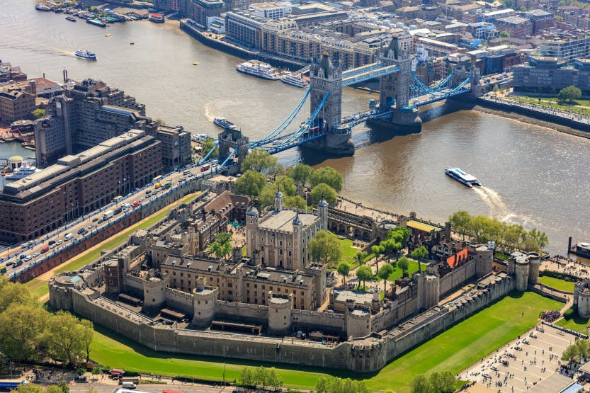

Year 6 – Is an activity based residential so use it as an opportunity to highlight your progression skills grids to support your assessments.
This will be to work on skills such as perseverance, resilience, risk taking, team work, encouragement and motivation.
OAA -
- I can work confidently in route finding, in a nearby environment, e.g. local park, secondary school site.
- I can adapt quickly to a new environment when making route decisions.
- I can show effective leadership in organising a team event.
- I can discuss and analyse the techniques used to complete a course, e.g. aiming off, hand railing.
- I can practise and refine new skills to improve my performance.
- I can warm up and cool down using mobility, whole body and static exercises. I can explain that the body will respond in different ways to different types of exercise, such as those that improve strength, stamina, speed and suppleness.
- I can explain that exercise helps me to take a more active role, keeps me fit and makes me feel good.
 | Area of Computing | Learning Opportunity | Objectives Covered
Year 6 | Creativity | Create an iMovie / presentation of their time at Robinwood to share with parents. | Video (iMovie)  Plan for the use of special effects and transitions.  Export their video.  Presentation (Powerpoint)  Use transitions and animations to improve the quality of the presentation.  Include sounds and moving graphics in the slides.

