Year 1 English Overview 2019 / 2020
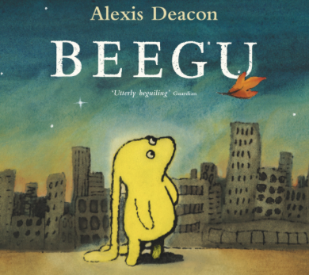
Year group:  One | Autumn 1 | Autumn 2 | Spring 1 | Spring 2 | Summer 1 | Summer 2
English | Lost and Found  Oliver Jeffers  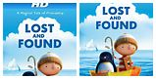  Salina Yoon’s Penguin stories  Be brave little penguin by Giles Andrea  The Emperor’s egg by Martin Jenkins  The penguin who wanted to find out by Jill Tomlinson | Nibbles  Emma Yarlette  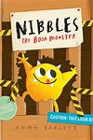  Goldilocks and the three bears by Emma  Chichester Clark  Little Red Riding Hood and Jack and the  Beanstalk texts  The Gruffalo by Julia Donaldson  Where the Wild Things Are  by Maurice Sendak | Lion Inside  Rachel Bright  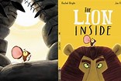  How to be a lion by Ed Vere  The tiger who came to tea by Judith Kerr  Mog the forgetful cat by Judith Kerr | Beegu  Alexis Deacon  Refugee focus | Toys in Space  Mini Grey  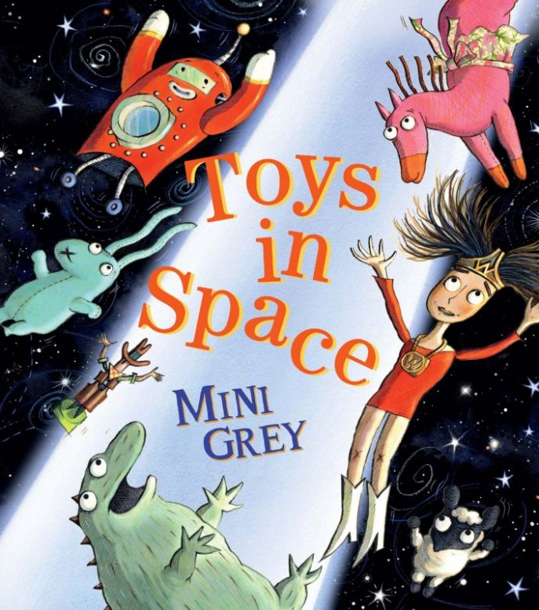  Space Dog by Mini Grey  It was a dark and stormy night by Janet and Allan Ahlberg  One true bear by Ted Dewan | Goldilocks and Just the One Bear  Leigh Hodgkinson  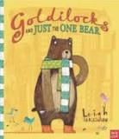  Old bear stories by Jane Hissey  Dogger by Shirley Hughes  Scaredy bear by Steve Smallman
Outcomes | Outcome  Fiction: story based on the structure of Lost and Found  Greater Depth  Change the setting of the story | Outcome  Recount: diary  Greater Depth  Add in further details about other characters’ feelings | Outcome  Fiction: story based on the structure of The Lion Inside.  Greater Depth  Change both animals in the story. | Outcome  Greater Depth | Outcome  Fiction: story based on the structure of Toys in Space.  Extension: Instructions  Greater Depth  Choose their own toy to write about and change the space creature. | Outcome  Fiction: story based on the structure of Goldilocks and just the one bear.  Extension: Non-chronological report  Greater Depth  Change the animal and the setting
Sentence | Combine words to make sentences  Write sentences | Join words using and | Join words and clauses using and  Sequence sentences to form short narratives | Join words and clauses using and  Sequence sentences to form short narratives | Join words and clauses using and | Join words and clauses using and
Text | Compose a sentence orally before writing it | Use plural noun suffixes -s and - es  Sequence sentences to form short narratives (link ideas or events by pronoun) | Add suffixes to verbs where no change is needed to the root | Add suffixes to verbs where no change is needed to the root | Add suffixes to verbs where no change is needed to the root  Change the meaning of verbs and adjectives by adding prefix un- | Use simple description  Sequence narrative accurately
Punctuation | Leave spaces between words  Punctuate sentences using a capital letter and a full stop  Use a capital letter for names of people and the personal pronoun ‘I’ | Punctuate sentences using a capital letter and a full top | Punctuate sentences using a capital letter and a full stop, question mark or exclamation mark | Punctuate sentences using a capital letter and a full stop, question mark or exclamation mark | Punctuate sentences using a capital letter and a full stop, question mark or exclamation mark | Use a capital letter for places and days of the week  Punctuate sentences using a capital letter, full stop, question
Word | Word Throughout each unit of Pathways to Write there will be opportunities to teach and apply word skills:  Spell words containing each of the 40+ phonemes already taught  Spell common exception words
 | 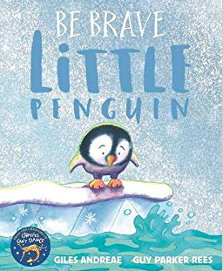  Agreed Additional Unit:  Be Brave little penguin – Jiles Andree | 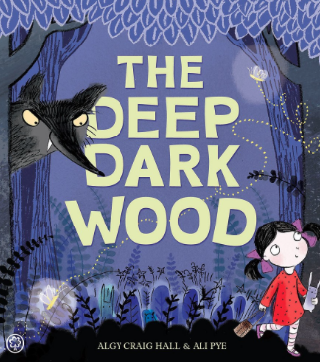  Agreed Additional Unit:  In the Deep Dark Wood  Algy Craig Hall | 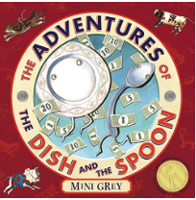  Agreed Additional Unit:  The adventures of the dish and the spoon  Mini Grey | 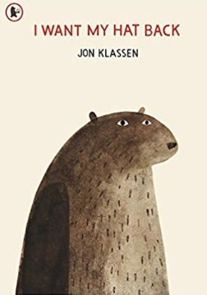  Agreed Additional Unit:  I want my hat back  Jon Klassen | 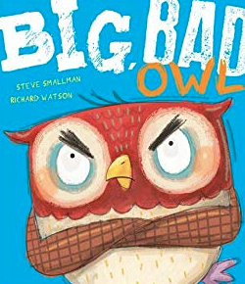  Agreed Additional Text:  The Big Bad owl  Steve Smallman | 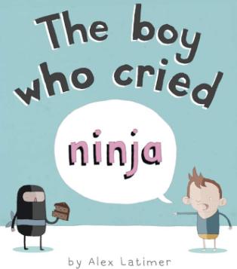  Agreed Additional Text:  The Boy Who Cried Ninja  Alex Latimer
Non Fiction Focus | Information Texts about penguins (Fact file) Use introduction to Ruby Rat |  | Recount – Reggie (form of diary) |  | Instructions – How to make a happy hat – Iggy
Non Fiction Apply (Previous taught to apply across English or LC) |  | Information Texts (Fact file) |  | Recount (newspaper form) |  | Instructions – non-fiction topic based as Summer 1 is fiction
Class Author Study | Julia Donaldson | Oliver Jeffers | Nicola Davis – World Book Day Focus and Art Week | Benji Davis | Martin Waddell | Allan Ahlberg

