Year 2 English Overview 2019 / 2020

Year group:  Two | Autumn 1 | Autumn 2 | Spring 1 | Spring 2 | Summer 1 | Summer 2
English | Troll Swap  Leigh Hodgkinson  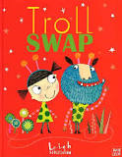  Novel:  Trolls Go Home  Alan McDonald | Norbert  Joanna Boyle (2018 – 2019)  *Using the plan from The Owl Who Was Afraid of the Dark.  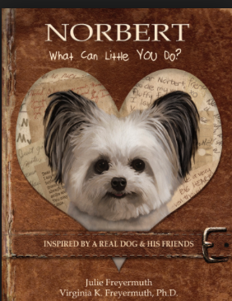  Novel: The legend of Spud Murphy  Eoin Colfer | My name is not refugee  Kate Milner  Novel: Paddington | The Last Wolf  Mini Grey  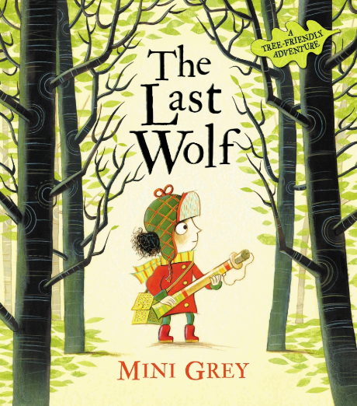  Novel  Fantastic Mr Fox  Roald Dahl | Revision unit:  Grandad’s Secret Giant  David Litchfield  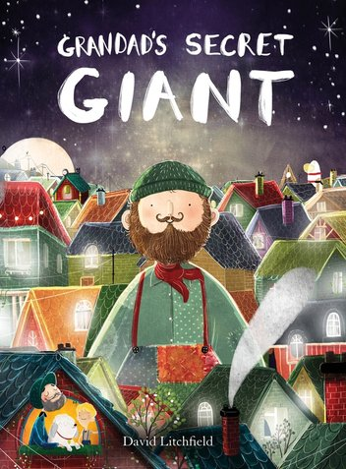  Novel  The BFG  Roald Dahl | The Sea Monster  Chris Wormell  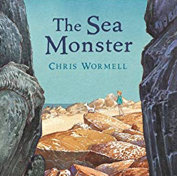  The Secret of Black Rock
Outcome | Outcome  Fiction: story with focus on characters  Greater Depth  Story about two independently invented contrasting characters who swap places | Outcome  Non-chronological report: report about owls  Greater Depth  Alter the layout to include own subheadings and extra features | Outcome  Fiction: story with adventure focus  Extension: Instructions  Greater Depth  Story written in 1st person | Outcome  Letter: letter in role as the character persuading to save the trees  Greater Depth  Real life letter to specific audience e.g. local MP | Outcome  Fiction: story with moral focus  Greater Depth  Story from the point of view of the giant | Outcome  Greater Depth
Sentence | Use subordination (because) and co-ordination (and)  Write expanded noun phrases to describe and specify | Use co-ordination (but, or)  Add -ly to turn adjectives into adverbs | Write sentences with different forms: statement, question, exclamation, command  Use subordination (apply because, introduce when)  Use present and past tenses correctly and consistently (some progressive) | Use present and past tenses correctly and consistently  Use the progressive form of verbs in the present and past tense  Use subordination (apply because, when; introduce that) | Use subordination (if, that)  Add -er and -est to adjectives  Use homophones and near homophones | Use present and past tenses correctly and consistently including the progressive form  Use subordination (using when, if, that, or because) and co-ordination (using or, and, or but)  Write expanded noun phrases to describe and specify  Add suffixes to spell longer  words e.g. -ment,- ful
Text | Plan or say out loud what is going to be written about | Write for different purposes | Read aloud with intonation | Write down ideas, key words, new vocabulary | Write down ideas, key words, new vocabulary | Make simple additions, revisions and corrections
Puncuation | Punctuation  Use punctuation correctly - full stops, capital letters | Punctuation  Use commas to separate items in a list | Punctuation  Use punctuation correctly - exclamation marks, question marks | Punctuation  Use punctuation correctly - apostrophes for the possessive (singular) | Punctuation  Use punctuation correctly – apostrophes for contracted forms | Punctuation  Proof-read to check for errors in spelling, grammar and punctuation
Word | Throughout each unit of Pathways to Write there will be opportunities to apply word skills:  - Spell many words correctly by segmenting spoken words into phonemes and representing these by graphemes  - Spell common exception words.
 | 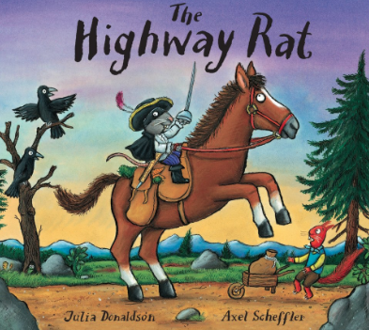  Agreed Additional Text:  The Highway Rat  Julia Donaldson | 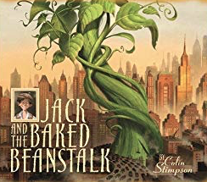  Agreed Additional Text:  Jack and the bakedbean stalk. | 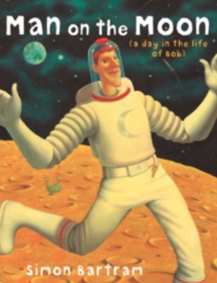  Agreed Additional Text:  The Man on the Moon  Simon Bartrom | 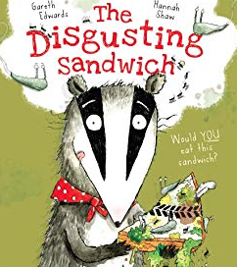  Agreed Additional Text:  The Disgusting Sandwich  Gareth Edwards | 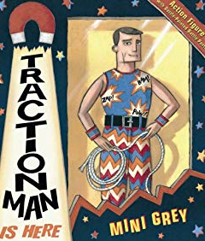  Agreed Additional Text:  Traction Man  Mini Gray | 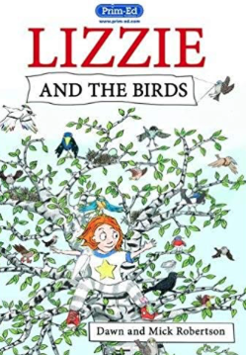  Agreed Additional Text:  Lizzie and the birds (text and the handbook)
Non Fiction Focus | Instructions (How to be a good troll) | Non-chronological reports (Penquin – missing page from an information book) |  | Recount in the form of a diary for Traction Man
Non Fiction Apply (Previous taught to apply across LC or English) |  | Instructions (based on a real event/task) | Non-chronological reports (Leaflet links to Crosby) |  |  | Recount of trip to the beach (real life)
Class Author Study | Julia Donaldson | Raymond Briggs | Emily Gravett | Jeanne Wilis | Mini Grey | Roald Dahl

