Year 3 English Overview 2019 / 2020

Year group:  Three | Autumn 1 | Autumn 2 | Spring 1 | Spring 2 | Summer 1 | Summer 2
English | Seal Surfer by Michael Foreman  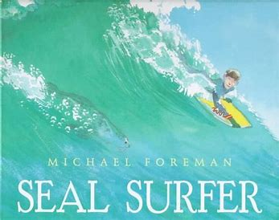  Climb novel:  Dancing Bear  Michael Morporgo | Stone Age Boy  Satoshi Kitamura  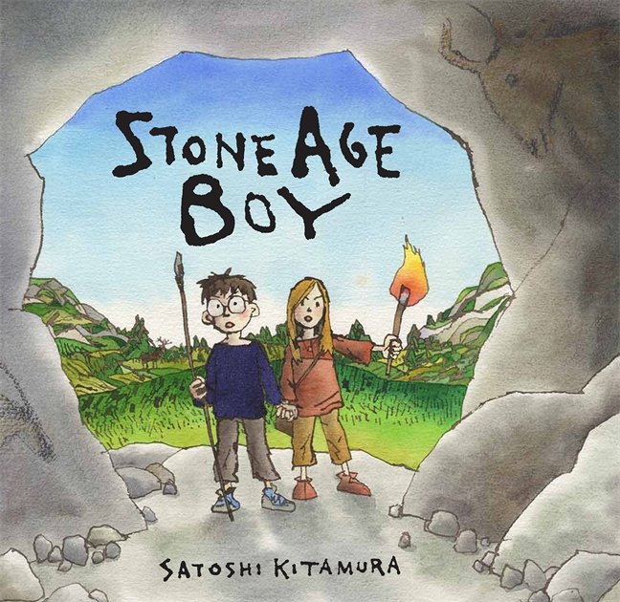  Climb novel: Christophe’s story  Nikki Conwell | Winter’s Child  Graham Baker Smith  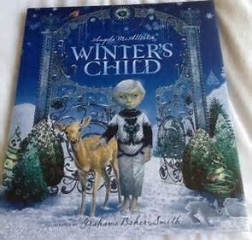  Climb novel:  Ice Palace  Robert Swindells | Escape from Pompeii by Christina Balit  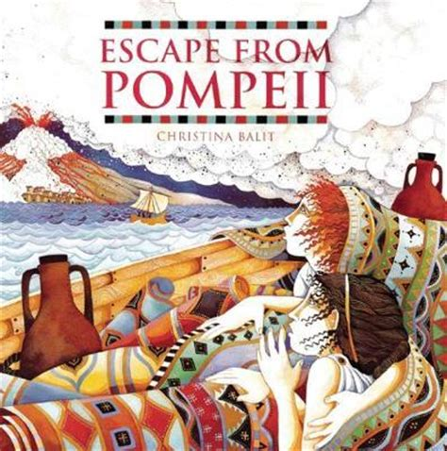  Climb novel:  A Roman Girls Diary  Sue Reid | Big blue Whale by Nicola Davies  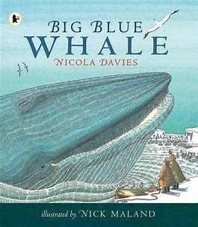  Climb novel:  The Morning I Met A whale  Michael Morporgo | Journey by Aaron Becker  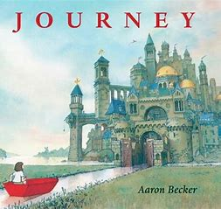  Quest by Aaron Becker  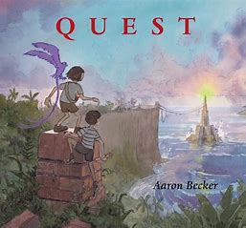  Tilly Mint Tales  Berlie Doherty  Climb novel: Billionaire Boy  David Walliams
Outcome | Outcome  Recount: letter in role  Greater Depth  Write a letter from Grandad in response to one of his grandson’s letters |  | Outcome  Fiction: fantasy story based on a fable  Greater Depth  Narrative from a different POV | Outcome  Fiction: historical narrative from character’s point of view  Greater Depth  Write from the POV of the captain | Outcome  Persuasion: leaflet persuading for the protection of the blue whale  Greater Depth  Include a fact file about endangered sea creatures | Outcome  Fiction: adventure story based on Journey using the language of Berlie Doherty  Greater Depth  Include a new setting route to lead from one place into another
Sentence | Use prepositions to express time, place and cause. | Form nouns with a range of prefixes | Use conjunctions to express, time, place and cause  Use adverbs to express time | Use the present perfect form of verbs in contrast to the past tense | Build an increasing range of sentence structures  Use adverbs to express time, place and cause | Use the present perfect form of verbs in contrast to the past tense  Use prepositions and adverbs to express time, place and cause (demonstrating some awareness of purpose through selection of relevant content)
Text | Group related ideas into paragraphs | Use paragraphs to organise information  Use headings and subheadings | Create characters, settings and plot in narrative  Propose changes to grammar and vocabulary to improve consistency | Asses the effectiveness of own and others’ writing (fiction)  Group related ideas into paragraphs (write an opening paragraph and further paragraphs for each stage) | Assess the effectiveness of own and others’ writing (non-fiction) | Group related ideas into paragraphs (write an opening paragraph and further paragraphs for each stage)
Punctuation | Use inverted commas to punctuate direct speech (introduction) |  | Proof-read for spelling and punctuation errors prior to publishing for a key audience | Use inverted commas to punctuate direct speech (and to show relationship between two characters) | Full range of punctuation taught at Y2 | Use inverted commas to punctuate direct speech
 | 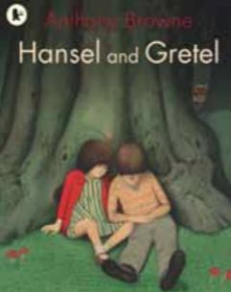  Agreed Additional Text  Hansel and Gretel  Anthony Browne | 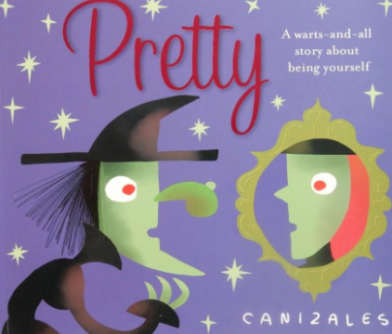  Agreed Additional Text:  Pretty  Canizales | 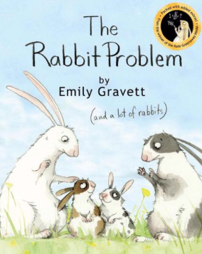  Agreed Additional Text:  The Rabbit problem  Emily Gravitt | 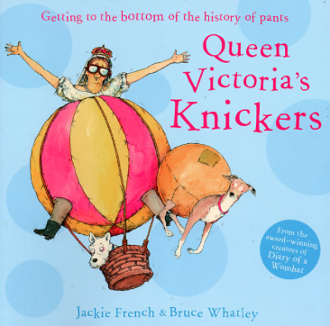  Agreed Additional Text:  Queen Victoria’s Knickers  Jaquie French | 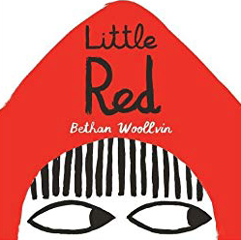  Agreed Additional Text:  Little Red  Bethan Woollvin | 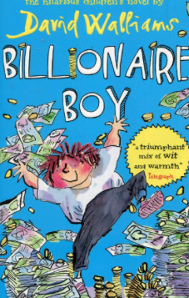  Agreed Additional  Text: Billionaire Boy  David Walliams
Non Fiction Focus | Recount – Fox Howl (real life) |  | Persuasion – Leaflet | Persuasive Advert  Explanation – Fiction Queens Knickers (Start of term) | Non Chronological Report – Snow Dragon (form of a page from an information book)
Non Fiction Apply (Previous taught to apply across English and LC) |  | Recount (newspaper or diary) |  | Explanation non-fiction focus (end of term) |  | Non Chronological Report (leaflet or brochure)
Class Author Study | Helen Ward | Nigel Hinton | Nicola Davis – World Book Day Focus and Art Week | Dick King Smith | Jeff Brown | Roald Dahl

