Year 5 English Overview 2019 / 2020
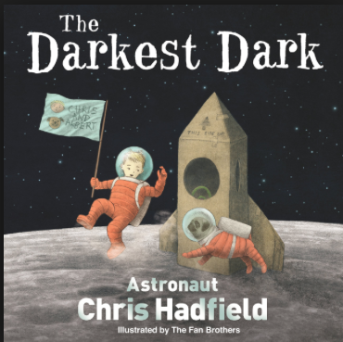
Year group:  Five | Autumn 1 | Autumn 2 | Spring 1 | Spring 2 | Summer 1 | Summer 2
English | Queen of the Falls by Chris Van Allsburg  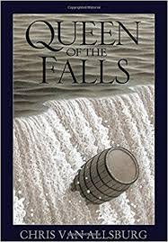  Climb Novel: Goodnight stories for rebel girls  Elena Favilli | The Darkest Dark  Chris Hadfield  Climb Novel: Millions  Frank Cottrell-Boyce | The Lost Happy Endings by Carol Ann Duffy  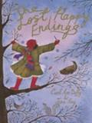  Climb Novel: Friend or Foe – Michael Morpurgo (links to WWII) | Room 13 by Robert Swindells  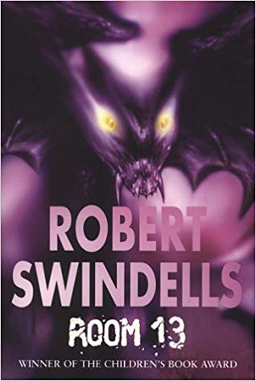  Climb Novel: Room 13 | The Paperbag Prince by Colin Thompson  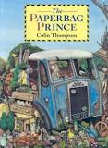  Climb novel: The Last Wild  Piers Torday | Arthur and the Golden Rope by Joe Todd Stanton  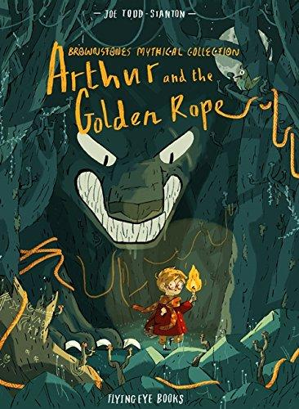  Climb Novel:  Who let the gods out?  Max Evans
Outcome | Outcome  Recount: series of diaries  Greater Depth  Series of diaries with viewpoint of other characters | Outcome  Recount : non chronological report  Greater Depth  Write a leaflet/ letter to a film director explaining why ‘The Darkest Dark’ should be made into a film | Outcome  Fiction: traditional tale  Greater Depth  Traditional tale from another character’s POV | Outcome  Fiction: Mystery narrative  Greater Depth  Apply figurative language to objects within the mystery. | Outcome  Persuasion/information:  Hybrid leaflet  Greater Depth  Write an oral presentation for a TV or online broadcast as expert | Outcome  Fiction: myth  Create heroes, villains and monsters  Greater Depth  Vary the viewpoint from which the myth is told
Sentence | Use fronted adverbials | Relative clauses to add detail and description  Use adverbs to indicate degrees of possibility | Use expanded noun phrases to convey complicated information concisely | Relative clauses to add detail and description  Use adverbs to indicate degrees of possibility  Adapt sentence length and vocabulary to change and enhance meaning | Use modal verbs to indicate degrees of possibility  Select appropriate grammar and vocabulary (Formal) | Use expanded noun phrases to convey complicated information concisely  Relative clauses to add detail and description
Text | Plan writing by identifying audience and purpose  Organise paragraphs around a theme | Link ideas across paragraphs using adverbials | Describe settings, characters and atmosphere  Integrate dialogue to convey character and advance the action | Link ideas across paragraphs using adverbials  Apply dialogue to convey character and advance the action | Use devices to build cohesion within a paragraph  Choose the appropriate register | Use a wide range of devices to build cohesion
Punctuation | Commas after fronted adverbials (Y4)  Commas to clarify meaning and avoid ambiguity |  | Use of inverted commas and other punctuation to punctuate direct speech (Y4) | Use brackets, dashes or commas to indicate parenthesis | Use brackets, dashes or commas to indicate parenthesis | Commas to clarify meaning and avoid ambiguity
Additional Texts: | 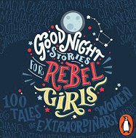  Goodnight stories for rebel girls  Elena Favilli | 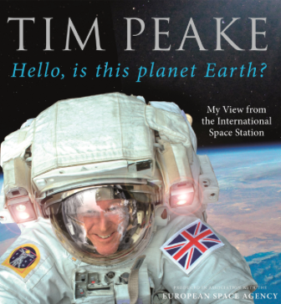  Tim Peake  Hello, Is this planet Earth? | 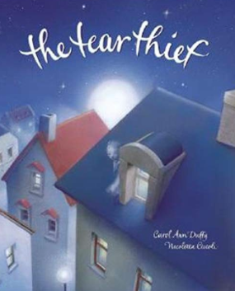  The Tear Thief  Carole Ann Duffy | 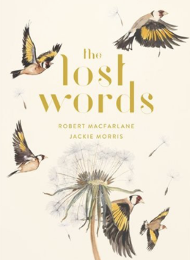  The Lost Words Robert Macfarlane, Jackie Morris | 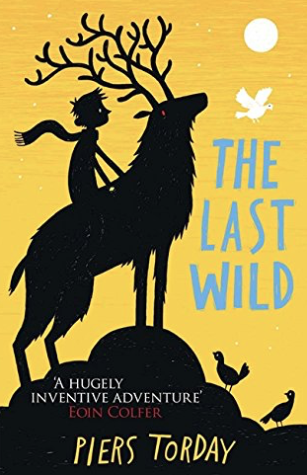  The Last Wild  Piers Torday | 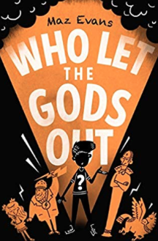  Who let the gods out?  Maz Evans
Non Fiction |  |  | Persuasion – Brochure (Poaching – elephants, sea turtles, pandas) | Non Chron report – linked to Whitby (Room 13) Tourist leaflet | Explanation (Leaflet)
Non Fiction Apply | Recount – newspaper report |  |  | Instructions – How to kill a vampire  Biography – Anne Frank through learning challenge | Non Chron report – missing page from information book/ museum display | Explanation – speech or comic strip
Class author Study | David Weisner | Lois Sachar | Carole Anne Duffy | Michael Morporgo | Colin Thompson | Colin Thompson

