English Overview – 2019 / 2020
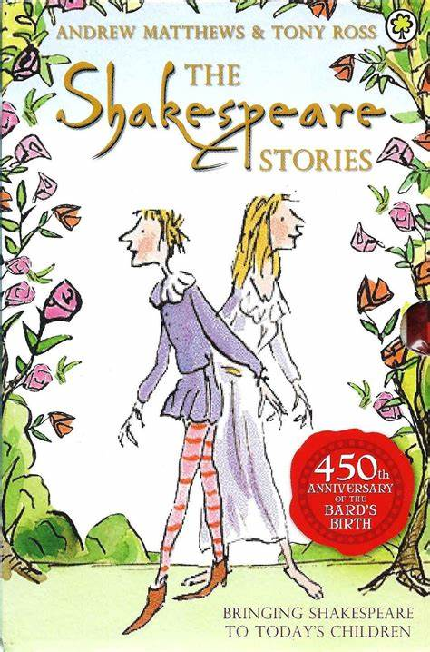
Year group:  Six | Autumn 1 | Autumn 2 | Spring 1 | Spring 2 | Summer 1 | Summer 2
English | Can we save the tiger?  by Martin Jenkins  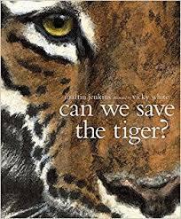  Climb novel: The Explorer:  Katherine Rundell | Star of fear Star of Hope  Joe Hoestlandt  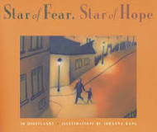  Climb novel: The boy in the striped pyjamas  John Boyne | Manfish  by Jennifer Berne  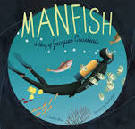  Climb novel:  Wonder  RJ Palacio | Selfish Giant  by Oscar Wilde  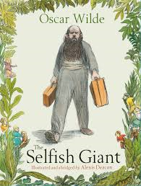  Climb Novel: Goldfish Boy  Lisa Thompson | Jemmy Button  by Alix Barzelay  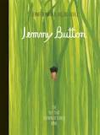  Climb Novel: Skychasers by Emma Carroll | Transition Unit  Shakespeare  Climb Texts: Shakespeare
Outcome | Outcome  Hybrid text - information and explanation  Greater Depth  Write a Newsround TV style story | Outcome  Flashback story  Information text  Greater Depth  To write a narrative with a flashback | Outcome  Biography /hybrid text  Greater Depth  Add in a script commentary about role in conservation debate | Outcome  Classic fiction  Explanation  Greater Depth  Write the narrative from a different viewpoint | Outcome  Journalistic  Discussion  Greater Depth  Write a magazine article/hybrid text | Outcome:  Modern retelling narrative  Greater Depth  Comparison of same event from two viewpoints.
Sentence | Use modal verbs or adverbs to indicate degrees of possibility  Use expanded noun phrases to convey complicated information concisely | Use expanded noun phrases to convey complicated information concisely  (Y5)  Use passive verbs | Use relative clauses beginning with who, which, where, when, whose, that or an omitted relative pronoun (Y5) | Recognise vocabulary and structures for formal speech and writing, including subjunctive forms  Use passive verbs | Use passive verbs  Use consistent and correct tense  Use the perfect form of verbs | Recognise vocabulary and structures for formal speech and writing, including subjunctive forms
Text | Select appropriate grammar and vocabulary | Link ideas across paragraphs using a wider range of cohesive devices (recap from Y5)  Integrate dialogue to convey character and advance the action | Use a wide range of devices to build cohesion | Distinguish between the language of speech and writing  Integrate dialogue to convey character and advance the action | Use a wide range of devices to build cohesion  Use layout devices | Identify the audience and purpose for writing  Choose the appropriate register
Punctuation | Use brackets, dashes or commas to indicate parenthesis | Use a colon to introduce a list  Punctuate bullet points consistently | Use a colon to introduce a list and use of semi-colons within lists  Use hyphens to avoid ambiguity | Use semi-colons to mark boundaries between independent clauses | Use colons or dashes to mark boundaries between independent clauses | Use semi-colons, colons or dashes to mark boundaries between independent clauses
Additional Units | Explorer  Katherine Blundell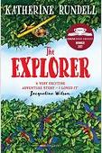 | Additional text – The Boy in Striped Pyjamas John Boyne  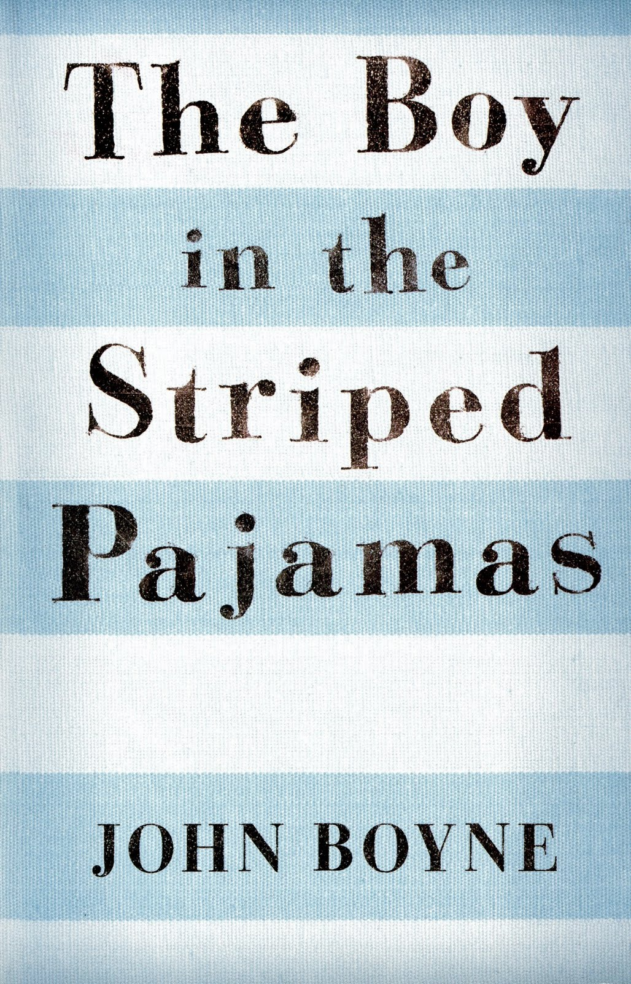 | Additional Text:  Wonder RJ Palacio  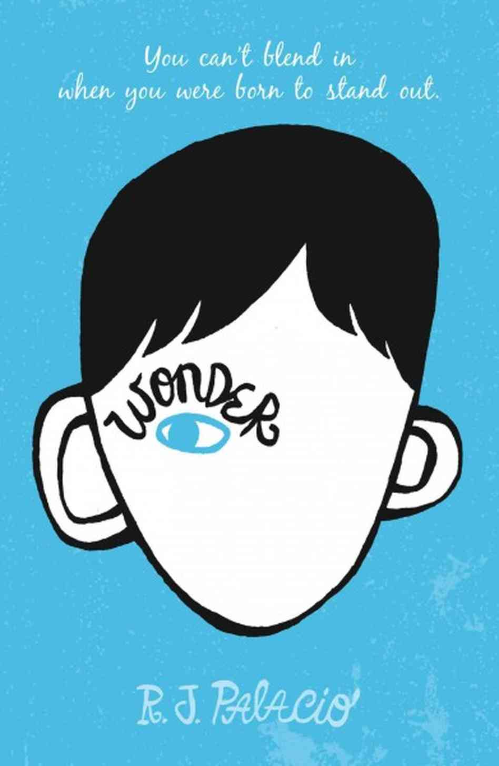 | Additional Text:  Giant’s Necklace by Michael Morpurgo  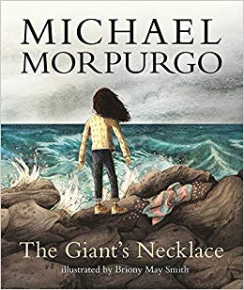 | 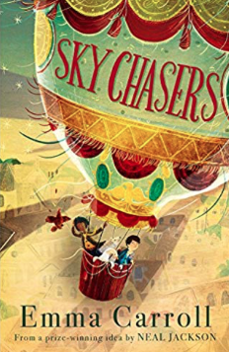  Additional Text:  Skychasers by Emma Carroll | Shakespeare Performance
Non fiction | Discussion: balanced or persuasive argument (Tigers – choose audience speech?) | Non-chronological report (War – Page in an Information text) |  | Explanation (The Selfish Giant – choose audience)  Recount: Newspaper report (Giant’s Necklace)
Non fiction Apply | Non-chronological report (Tigers – leaflet/brochure) |  | Recount: Biography (Manfish) | Discussion (Jemmy Button- choose audience, TV show?) | Recount: Newspaper report (Jemmy Button) | Explanation (link to topic/English – different formality to Spring 1)
Class Author Study | RJ Palacio | Shaun Tan | John Boyle | Nicola Davis – World Book Day Focus and Art Week | Frank Cotteral Boyce | Anthony Horowitz

