|  |
| --- |
| **Maths Home Learning**  **Counting** |
| **EYFS – Learning Booklet** |

Can you fill in the missing numbers to 10?

1. 1 __ 3 4 5 __ 7 8 __ 9 10

__ 1 __ 3 __ 5 6 __ 8 9 __

1. 1 2 __ __ 5 __ 7 __ 9 __

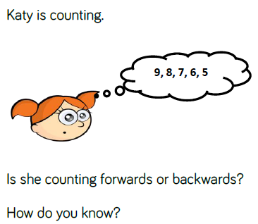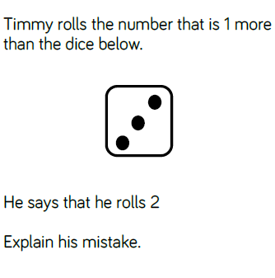

**Count all the hearts**

Can you circle the mistake in the number lines?

10 11 12 31 14 15

15 16 18 17 19 20

17 18 19 02 21 22

Count how many…

* Flowers you can see outside
* People you can see
* Teddies you can see in your house

Which ladybird has the most spots? Can you put them in order? 

What is one more and one less of the numbers below…?

|  |  |  |
| --- | --- | --- |
| 1 - | number | 1 + |
|  | 7 |  |
|  | 11 |  |
|  | 15 |  |
|  | 19 |  |
|  | 13 |  |
|  | 14 |  |

