|  |
| --- |
| **Maths Home Learning**  **Calculating** |
| **Year 1 Learning Booklet** |

**I can recall number bonds for addition and subtraction to 20**

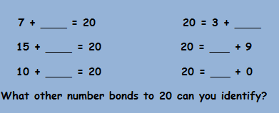

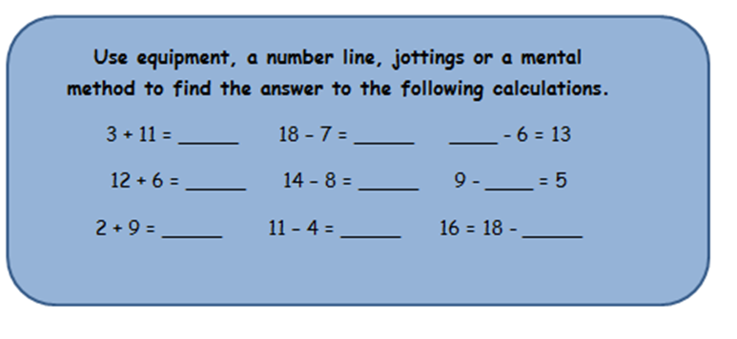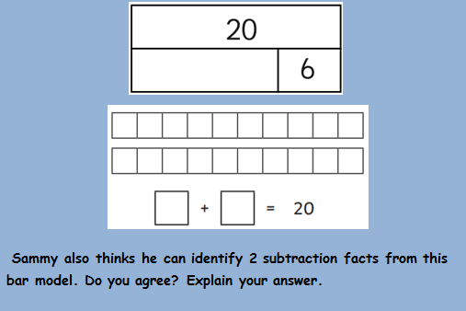

**I can add or subtract 1 or 2 digit numbers up to 20 including 0**

**Sammy is looking at this bar model. It is showing a number bond to 20. He can’t quite remember which other number goes with 6 to total 20. He thinks he can use the ten sticks to help him. Can you show him how to do it and complete the calculation and bar model?**

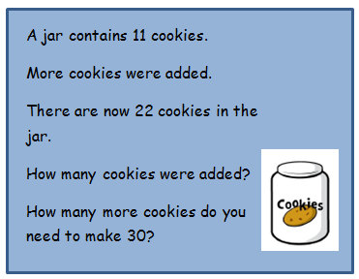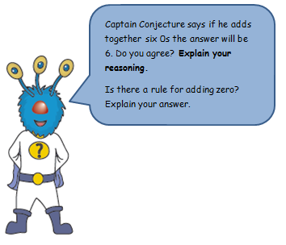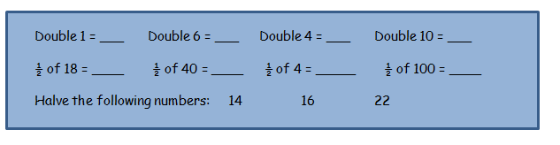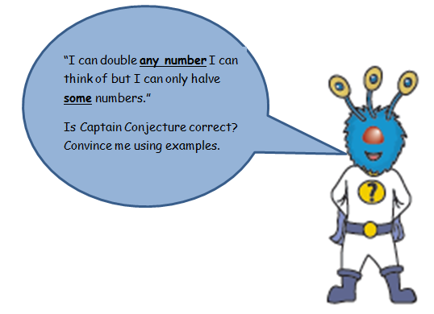

_________________________________________________________________________________________________________________________________________________________________________________________________________________________

_______________________________________________________________________________________________________________________________________________________________________________________________________________________________________

**I can double and halve numbers**

_____________________________________________________________________________________________________________________________________________________________________________________________________________________________________________________________________________________________

____________________________________________________________________________________________________________________________________________________________________________________________________________________________________________________________________________________________________________________________________