|  |
| --- |
| **Maths Home Learning**  **Counting** |
| **Year 1 Learning Booklet** |

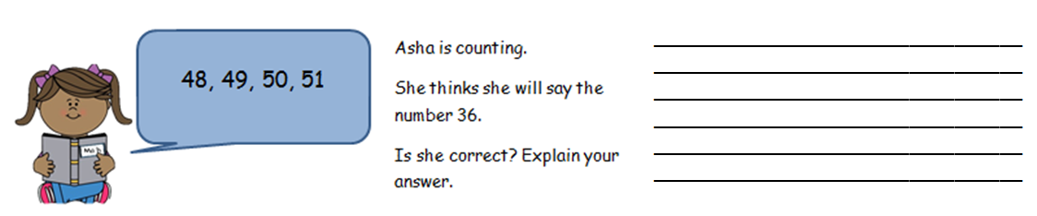

**I can count up to and past 100 from 0, 1 or any given number**

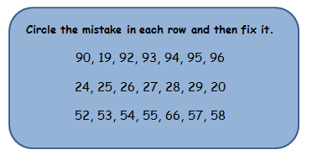

**I can count in multiples of 2, 5 and 10**

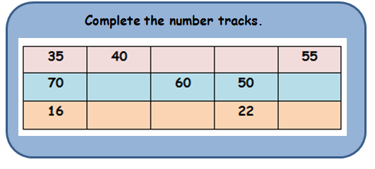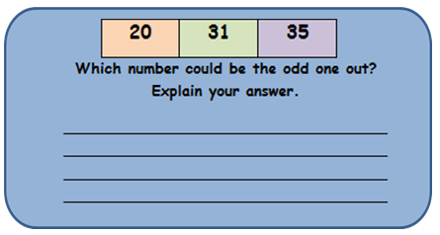

**Will I…?**

I start on 5 and count in 5s. Will I say the number 45?

I start on 10 and count in 2s. Will I say the number 23?

I start on 0 and count in 10s. Will I say the number 100?

I start on 10 and count in 2s. Will I say the number 30?

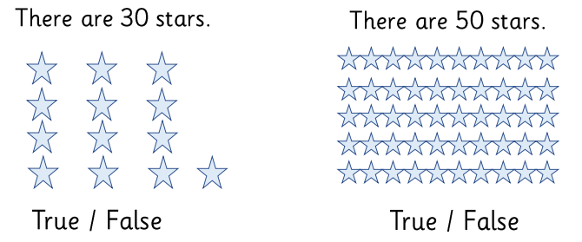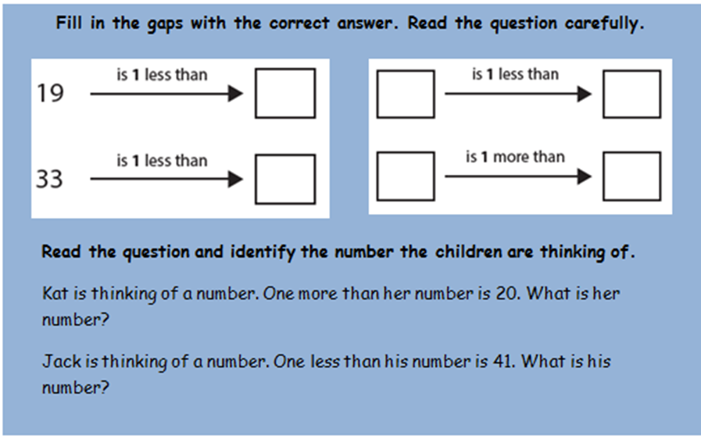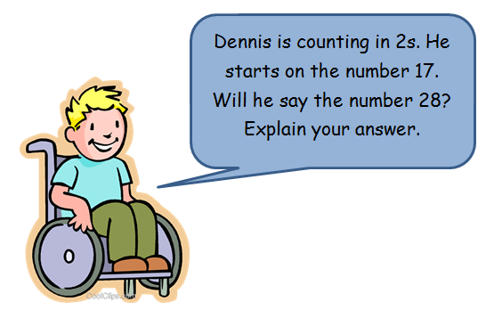

**I can read and write numerals to 100**

**I can use language more than, less than, fewer, greater**

________________________________________________________________________________________________________________________________________________________________________________________________________________________________________________________________________________