|  |
| --- |
| **Maths Home Learning**  **Measurement** |
| **Year 1 Learning Booklet** |

**I know and can identify different values of coins and notes**

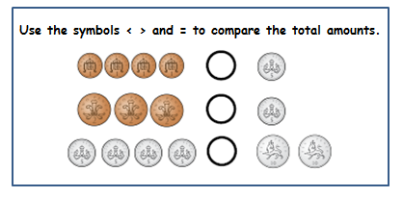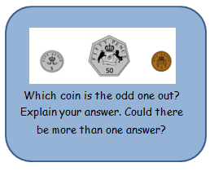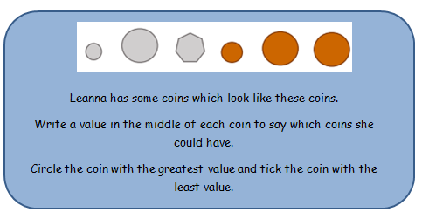

Can you create your own to show you know how to compare amounts of money? Could you use different coins?

________________________________________________________________________________________________________________________________________________________________________________________________________________________________________________________________________________________________________________________________________________________

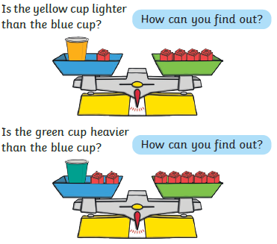 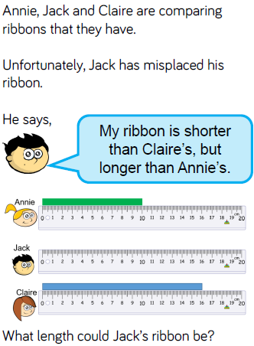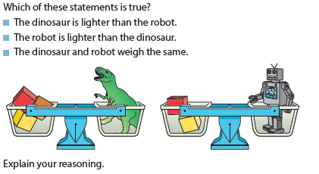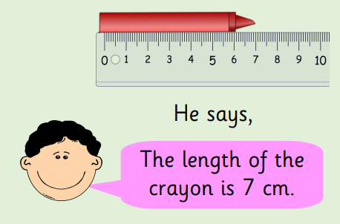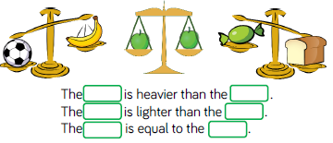

**I can compare 2 quantities using non-standard units of measurement**

____________________________________________________________________________________________________________________________________________________________________________________

Do you agree with him? Explain your answer.

_______________________________________________________________________________________________________________________________________________________________________________________________________________________________________________

**I know and understand key vocabulary including longer, taller, shorter, heavier and lighter**