|  |
| --- |
| **Maths Home Learning**  **Shape** |
| **Year 1 Learning Booklet** |

**I can recognise and name common 2d and 3d shapes**

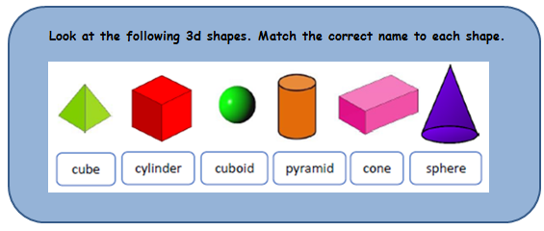

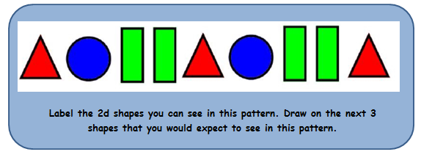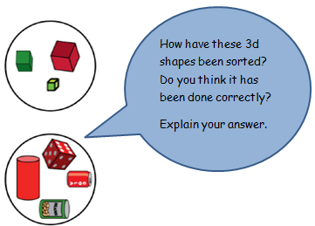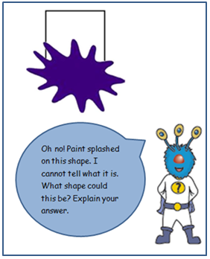

____________________________________________________________________________________________________________________________________________________________________________________________________________________________________________________________________________________

|  |  |  |  |  |  |
| --- | --- | --- | --- | --- | --- |
|  |  |  |  |  |  |
|  |  |  |  |  |  |
|  |  |  |  |  |  |

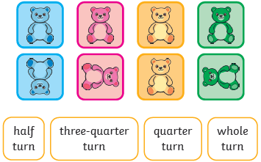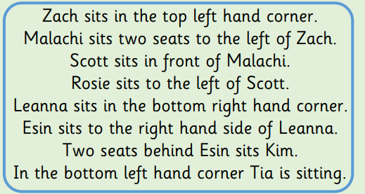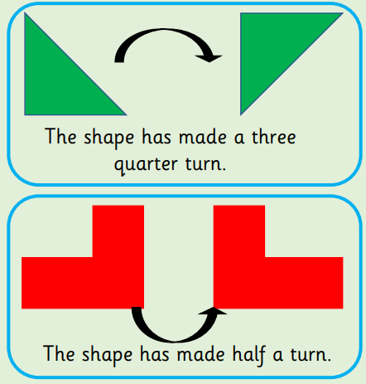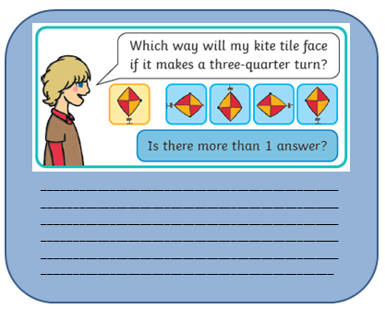

**Match each picture to the correct description of how it has been turned.**

Are these statements correct? Explain how you know.

____________________________________________________________________________________________________________________________________________________________________________________________________________________________________________________________________________________

This table represents some chairs at a theatre. Follow the clues to put the names in the chairs the children will sit in.

Zach Malachi Scott

Rosie Leanna Esin

Kim Tia

**FRONT**

**I can describe position, direction and movement including whole, half, quarter or three quarters**