|  |
| --- |
| **Maths Home Learning**  **Time** |
| **Year 1 Learning Booklet** |

**I can recognise and use language relating to dates such days, weeks, months, years**

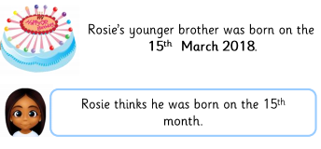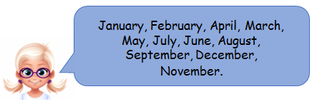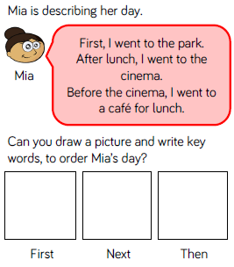

Is Rosie correct? Explain your answer.

________________________________________________________________________________________________

Katy is chanting the months of the year. Has she done it correctly? Fix any mistakes you think she has made.

**I can sequence events such as yesterday, today, this evening, tomorrow**

Can you describe your day like Mia has done?

____________________________________________________________________________________________________

Now draw a picture and write key words to order your day.

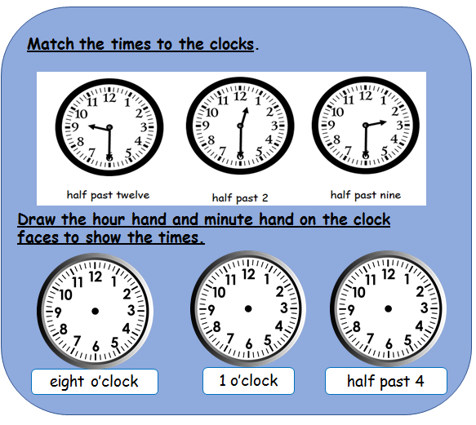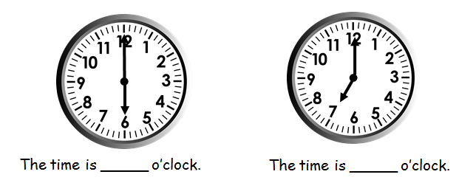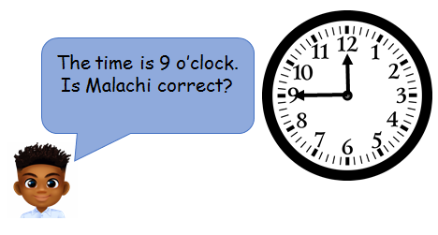

**I can tell the time to the hour and half past and draw hands on a clock**

____________________________________________________________________________________________________________________