|  |
| --- |
| **Maths Home Learning**  **Calculating** |
| **Year 2 Learning Booklet** |

**I can recall and use addition and subtraction facts to 20 fluently, and derive and use related facts up to 100**

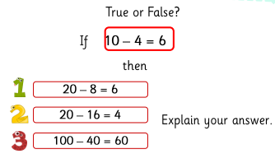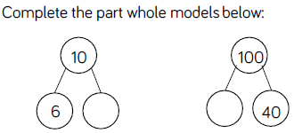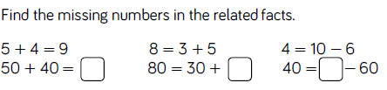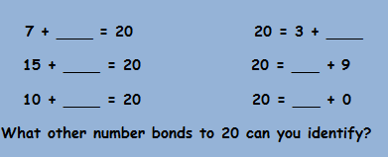

______________________________________________________________________________________________________________________________________________________________________________________________________________________________________________________________________________________________________________________________________________________

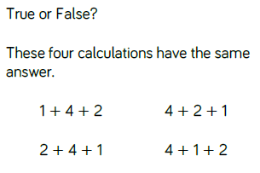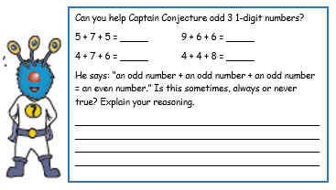

**I can add and subtract numbers using concrete objects, pictorial representations, and mentally**

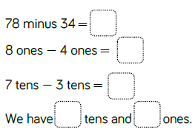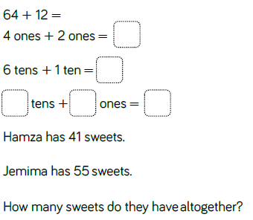

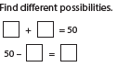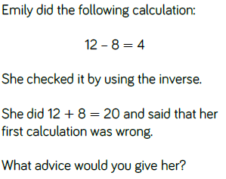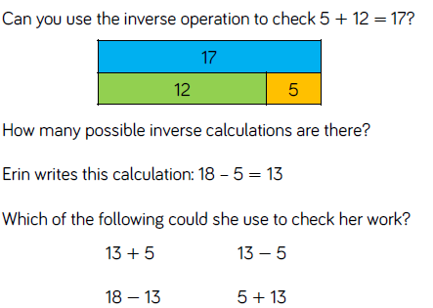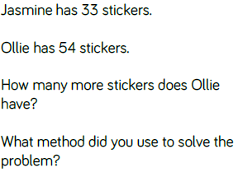

______________________________________________________________________________________________________________________________________________________________________________________________________________________________________________________________________________________________________________________________________________________

**I can recognise and use the inverse relationship between addition and subtraction**

23 + 46 = _____ 29 + 37 = _____ 67 – 24 = ____ 61 – 35 = _____

52 + 44 = _____ 45 + 49 = _____ 88 – 54 = ____ 81 – 56 = _____